

**Reading “Fix-Up” Strategies:**

*When I am assigned reading for class, I should…*

1. Look at the pictures/diagrams/graphs **first**.
2. Read boldface text and vocabulary **second**.

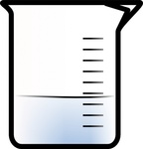

1. **Next**, skim (read quickly) text looking for key concepts/ideas.
2. **Finally**, read for content.

*If something doesn’t make sense while I am reading, I can…*

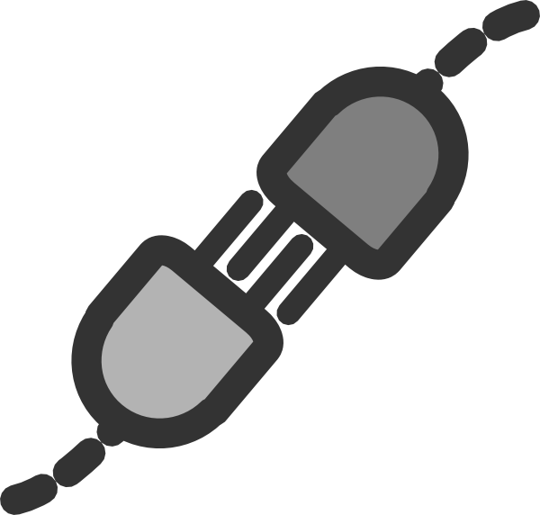

______ Make mental pictures of what is happening in my reading.

______ Connect what I am reading to other things we have done in class.

______ Look for patterns in what I am reading.

______ Ask myself if I understand what I am reading.

______ Highlight/circle new words.

______ Look up words I don’t know.

______ Slow down my reading pace.



______ Reread things to clarify them.

______ Ask for clarification from my instructor.