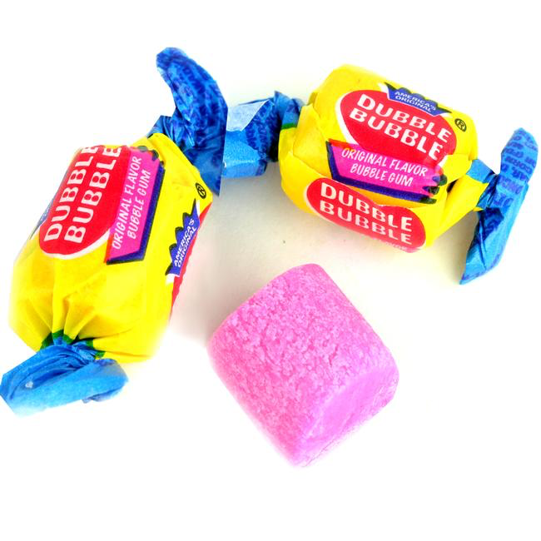

**How many moles of sugar**

**(MM= 342.30 g/mol) are in a piece of bubble gum?**

1. Choose a piece of bubblegum.
2. Unwrap the gum and save its wrapper.
3. Place the wrapper on a balance and zero (tare) the balance. ***Save the wrapper for step 8.***
4. Place the piece of gum onto the balance and record its mass in the data table below.
5. Record the current time in the data table below.
6. Chew the gum until you think all of the sugar has been removed from it.
7. Record the time that you stopped chewing the gum on the table.
8. Place the wrapper on the balance and zero (tare) the balance.
9. Place the chewed piece of gum onto the wrapper and record is final mass in the data table.
10. Subtract the initial mass of gum from the final mass to determine how much sugar was removed from the piece of gum. Write this value in the data table.
11. Subtract the final chew time from the initial chew time to determine total chew time. Record this value in the data table.
12. Using the molar mass of sugar, convert to calculate how many moles of sugar you chewed out of the gum. Record this value in the data table below, as well as on the side board for a class comparison.

|  |  |  |  |
| --- | --- | --- | --- |
| **Initial Mass Gum (g)** | **Final Mass Gum (g)** | **Mass of sugar in gum (g)** | **Moles of sugar in gum (mol)** |
|  |  |  |  |
|  |  |  |  |
| **Initial Chew Time (Hour:Minute)** | **Final Chew Time (Hour:Minute)** | **Total Chew Time (min)** |  |
|  |  |  |  |

**Moles, IRL**

|  |  |  |  |  |
| --- | --- | --- | --- | --- |
| **Compound** | **Common Name** | **Common Use** | **Molar Mass (g/mol)** | **Estimate of Moles in Sample**  **(mol)** |
| SiO2 | Silica gel | Used as a desiccant to absorb water and keep items dry. Often found as small packets in shoe boxes. |  |  |
| CaCO3 | Marble | Used in formal art sculptures such as da Vinci’s *The David*. |  |  |
| H2O | Water | The molecule essential for human life. |  |  |
| Elemental Cu | Copper | Drawn into wires and motors, it conducts both heat and electricity in machinery. |  |  |
| CaCl | Road Salt | The salt applied to road in the winter to lower the freezing point of water. |  |  |
| 7-hydroxyphenoxazone | Otherwise known as a chromophore of a lichen used in making Litmus Blue an acid/base pH indicator. |  | 3300 |  |
| C6H8O7 | Citric Acid | A flavor enhancer added to soda pop to provide tartness and lengthen shelf life . |  |  |
| Elemental S | Sulfur | Used as the propellant in fireworks. |  |  |
| NH2CONH2 | Urea | Metabolizes nitrogen in mammals, main component found in urine. |  |  |