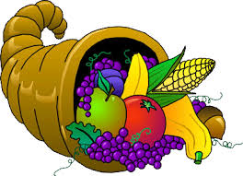

1. The first Thanksgiving Day was celebrated in North America in 1621 following a good harvest. How many seconds ago did that first Thanksgiving take place?
2. Candles, often seen on a Thanksgiving Day table, burn through a physical property change. When a wick is lit, heat melts the fuel source of the candle which then travels up the wick by capillary action and is burned, converting the fuel source to produce light. Make a prediction and record it in the table below: *Can a stick of butter be used as a fuel source to make a candle?*

|  |  |  |  |
| --- | --- | --- | --- |
| **Investigation** |  | **YES** | **NO** |
| **Can a stick of butter be used as a candle?** | **Prediction** |  |  |
| **Can a stick of butter be used as a candle?** | **Experiment** |  |  |

After you have made your prediction, use a lighter to ignite the wick in a stick of butter. Does the butter act as fuel by the wick continuing to burn? Record your answer in the table above.

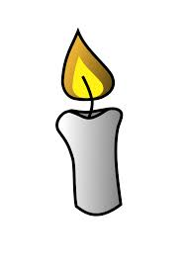

1. Cranberries are the fruit of a low lying shrub often grown in marshes or bogs and wetlands. They ripen at the beginning of the fall and are processed into juice or dried. At harvest time, cranberry fields are flooded to allow for easier removal of the berries. Make a prediction and draw what you think the inside of a cranberry looks like that allows it it float in water. After you have made your prediction, bite a cranberry in half. Draw what the inside of the berry looks like.

|  |  |  |
| --- | --- | --- |
| **Investigation** | **Prediction** | **Actual** |
| Draw a what the inside of a cranberry looks like. |  |  |

What physical property allows cranberries to float? _______________ 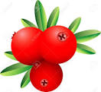

1. The Native Americans taught the Pilgrims how to grow foods that were found in the the New World, most notably, corn. This crop was a staple that was dried and ground into meal used for cooking and baking. Using a mortal and pestle, grind some corn into meal.

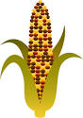 Is the change experienced by the corn being ground a physical or a

chemical process? ______________________________.

1. Corn grown in the Plymouth Colony did not pop well, due to low water content of the kernels, and as a result was not found at the First Thanksgiving. When a kernel of popcorn is heated, the temperature of the water inside rises. Normally, at 100oC water boils and turns to steam. However, the sealed kernel acts like a pressure cooker and the trapped water is superheated to more than 100oC inside the kernel. The vapor pressure of the superheated water rises until the pressure ruptures the kernel. The pressure "pushes" against the hard shell of the kernel until the kernel explodes or "pops". The superheated water converts totally to steam once the kernel is forced open. The volume of the steam will be greater than the volume of the liquid water it comes from at the same temperature. This expanding steam "fluffs" the carbohydrates and starch into the fluffy popcorn we enjoy eating.

Measure out 1/2 cup of popcorn kernels. Using a balance, find the mass of this amount of popcorn. Record this value in box A below. Find the mass of an empty bucket and record this value in box B below. Add the kernels to the air popper at the station. Place the lid on the popper and plug it in. Collect the kernels in a bucket as the popcorn pops. Unplug the popper and empty any remaining kernels into the bucket. Find the final mass of the popped kernels and the bucket and enter it in box D below. Subtract box C from box D to find the total amount of water in the kernels and write this value in box E.

|  |  |
| --- | --- |
| **Initial mass of popcorn** | **A:** |
| **Initial mass of bucket** | **B:** |
| **Initial mass of popcorn + bucket = (A +B)** | **C:** |
| **Final mass of bucket + popped popcorn** | **D:** |
| **Final mass of water = (D - C)** | **E:** |

Using the following formula, calculate what percentage of water is in your sample of popcorn:

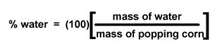

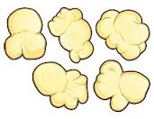

1. Marshmallows, often found on top of casseroles on the Thanksgiving table, are the modern version of the medical plant root that was once sweetened with honey and used to treat sore throats. Today, marshmallows typically consist of sugar, water and gelatin whipped to a spongy consistency, molded into small cylindrical pieces, and are coated with corn starch.

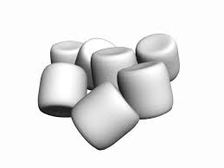

Obtain a marshmallow and place it on a paper plate. Record observations about the marshmallow, including its size, shape, and texture in the table below. Place the paper plate with the marshmallow on it in the microwave it for 20 seconds. Record observations about the marshmallow while it is heating in the table below.

|  |  |
| --- | --- |
|  | **Observations** |
| **Before heating** |  |
| **During heating** |  |
| **After heating** |  |

Remove the plate with the marshmallow on it from the microwave and allow it to cool. Record final observations about the cooled marshmallow in the table above.

What is inside the marshmallow that allows it to shrink and grow? _____________________

What molecule is activated by the microwave that causes this change? _________________