Older students who have some control…..

Hold the Red Circle with both hands and bounce a tennis ball about 5-6 inches in the air 25 times. Keep it on the red circle. Go SLOW and be accurate so you don’t drop it. If you can go to 100, do it!

* 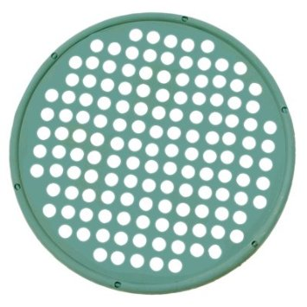

Older students who have some control…..

Hold the Red Circle with both hands and bounce a tennis ball about 5-6 inches in the air 25 times. Keep it on the red circle. Go SLOW and be accurate so you don’t drop it. If you can go to 100, do it!

 