Pedro Noguera’s lecture on “Bringing Equity to Classroom” was full of interesting points, and relevant material to my future career path. As a future special education teacher, I know that I will have a lot of diverse students. I also know that a lot of students from low SES backgrounds, and also, if not both, diverse cultures will be in a special education classroom. Pedro Noguera hit on the topic of diversity in classrooms, and how important it is that become more than just educated on the cultures of our students. He first started his lecture by making the point that change in the schools culturally, diversely, developmentally, academically, and economically cannot happen without being serious about equity of our students. As educators, we need to get a better knowledge of our students and their backgrounds, home lives, and family lives before we can actually structure our classroom and plan our management. Culture is how students make sense of the world, and is a huge resource that teachers should implement in their instruction. I really drew from his discussion on Maslow’s hierarchy of needs for students. If a student is not learning in class, acting out, or being checked out of class, there is a good reason that one of their basic needs from Maslow’s hierarchy is not being met. It is important to find the children’s basic needs that are unmet, and find a way to make their needs be met. The next point that he emphasized that I found very influential to my future is that empathy is just as important as knowledge as an educator. He even said that some children will hold bigger burdens than they can even articulate. That’s a really heartbreaking thought to wrap your mind around, but it is very relevant and prominent in the classroom today.
Other points that Pedro Noguera hit on that I found were very relevant and intriguing were that engaging students in learning is more important than just “teaching.” Often times, teaching is thought of to be just simply talking – however, it is not just talking and meeting standards/test scores! Students should be in control of the learning and be self-controlled, not controlled by the teacher. He also further drove his equity point, by giving us ways to engage students in their culture, further engaging the students in their learning. Experience is a better teacher than listening to a lecture; so engaging students in experiences they are familiar with outside of the classroom in the classroom will only benefit their success academically and developmentally. One quote that really stuck out was that he said that best teachers teach the way students learn, not have the students learn the way teacher’s teach.

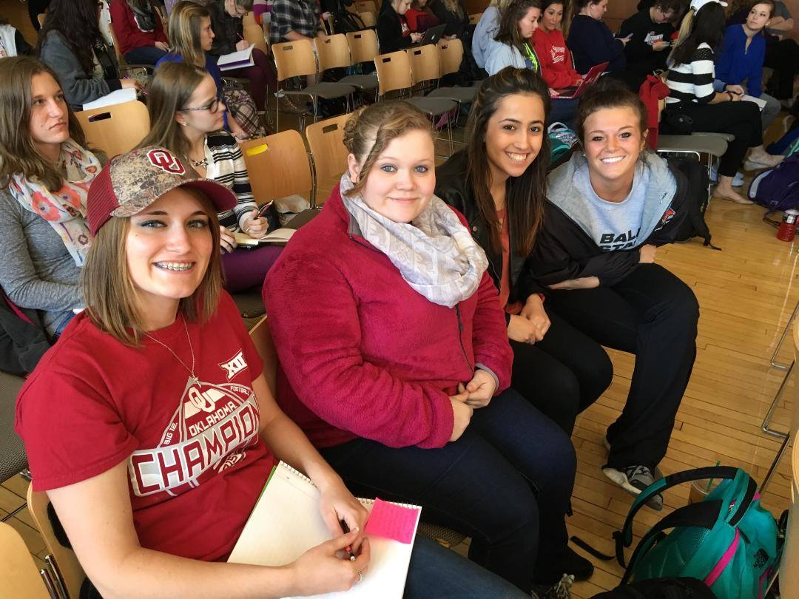
Girls in my class and I at Pedro Noguera’s lecture

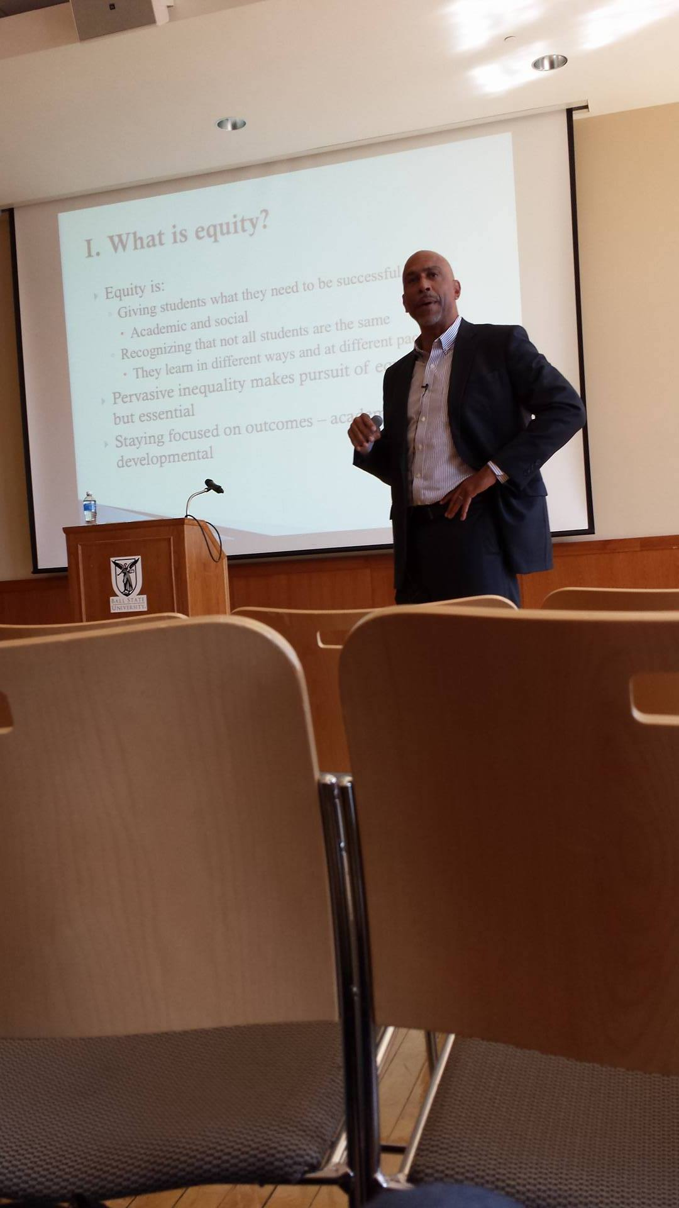
Pedro Nogera giving his lecture, with a PowerPoint in the background discussing equity.

