My Daily Five Station Sheet

Instructions: As you rotate through the Daily Five stations, collect a stamp from each station. Make sure you attend all stations, and only attend each station once.

Today is: __________________________________________________________________

 |  | 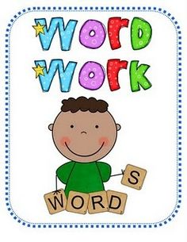 |  | 

Today I learned:

