Description:
This is my Data Dashboard on an Excel spreadsheet for my EDPS 345 course. This spreadsheet is for a class grade book which includes ten students and their test scores, project scores, students totals, graphs, conditional formatting, and a final letter grade.

InTASC Rationale:

My data dashboard relates to InTASC #6 the most. This principle states that teachers will monitor his or her students’ development in the classroom setting. This data dashboard will help me in my future classroom for organizing student data and progress. This will specifically come in handy during conferences with parents about how the student compares to the class average. The graph will be very helpful by acting as a visual aid to see how the student is improving or how the student needs improvement in certain areas. This will also be a great way for me to see as a teacher where I need to improve if the class average scores are low.

Below are screenshots from the Excel spreadsheet
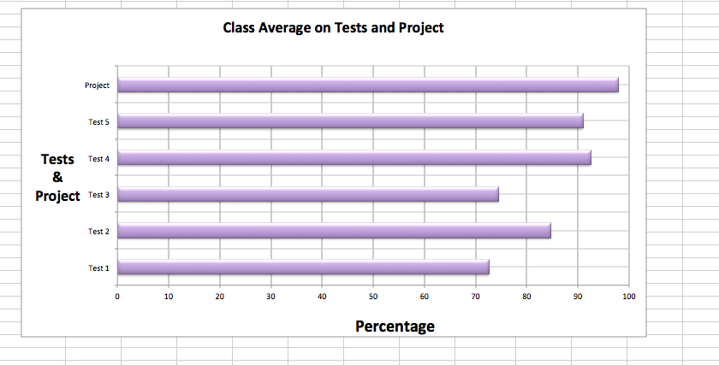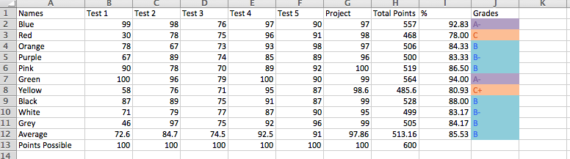

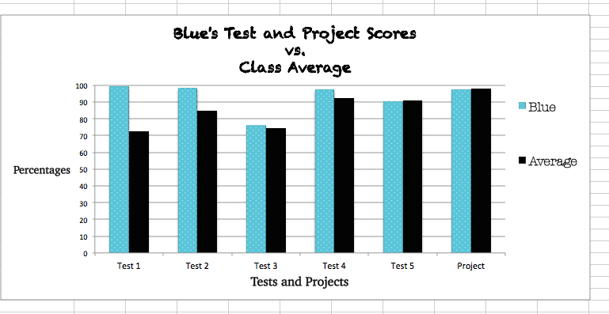
Link to artifact

References

Abbie Christianson
Elizabeth Silvey
Dr. Stuve

This is the data dashboard assignment that I completed in EDPS 345 on an Excel spreadsheet. It acts as a classroom grade book but also has additional data. It’s a very efficient way for my to see where my students are academically. I can also see each student’s own individual grades with separate sheets for each student.

Phase 1
In this phase we focused on just building the frame for our grade book and played around with different functions. We used the “=” “LOOKUP”, “AVERAGE”, AND “SUM” function in this first phase. In this phase all of the students’ grades were calculated by dividing the points possible by the total points the students received. Also, a grade key table was designed to assign letter grades. This was accomplished by using the “LOOKUP” function. The function applies information from other cells to the current cell you are working on to enter other information.

Phase 2
This phase focused on more functions like duplicating student’s pages, inserting meaningful graphs, and working on conditional formatting. In the screenshot below, you can see my master grade book page of all my students, their point totals, and final grades. I used the icon set for my conditional formatting, using the colors blue, orange, and purple. The color purple was assigned to anything that was a 90% and above. The color blue was assigned to anything that was between 89% and 80%. Lastly, the color orange was used for grades that were 79% and below. It allows for teacher, parents, or other administrators to look at the chart in a grouping to see where each student is at in the class. I also included graphs for another visual representation because it is visually pleasing and can be easier to interpret. The graph that I did on the first page is outlining each student’s final percentage compared to the class average percentage. On each of the students’ individual page I also included a graph to show the students percentage on each test compared to the class average for each test score. In this phase I duplicated each students page, kept the formatting, and just changed the name cell by using the “LOOKUP” function and entering in the cell with the students name that I needed. I would then click and drag the cell to the right to fill in all of that student’s individual grades.

Reflection
By working on this grade book, I have realized how simple it is to track your student’s grades, progress, strength, and weaknesses. This will help to see whether I am doing a good job as a teacher with teaching the material and creating a detailed test. A spreadsheet like this would be something to bring to an IEP meeting or a conference. By having conditional formatting and graphs, it allows the person looking at the graph to get an overview. I liked learning about the functions because it is more efficient rather than typing everything in.

