Science 3rd Grade
Teacher’s Copy- With Answers
Jenna Ferguson
- The plant sucks up water from the ground with its: A
- Roots
- Stem
- Petals
- Pollen
- Plants with flowers can produce: C
- Bugs
- Grass
- Fruit
- Candy

- Bees help: A
- Pollinate flower
- Sting children
- Eat plants
- Be mean
- Match the plant part with its function:
- Stem B__ the beginning of a new plant
- Seed A__ Brings water from the roots
- Flower D__ keeps the plant in the ground
- Roots C__ helps the plant reproduce
- True or False: The roots keeps bugs away ____F
- True False: All plants have flowers _____F
- True or False: Leaves help with photosynthesis ____T
- Photosynthesis is the: A
- Energy source of the plant
- Plant’s camera
- The roots of a plant
- The stem of the plant

- Name 2 things that influence plant growth:

- Explain what is happening in this picture.
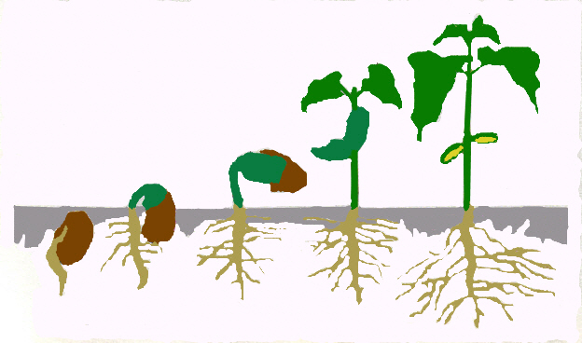

Plant Test- Student
Name: ________________________________________________
- The plant sucks up water from the ground with its
- Roots
- Stem
- Petals
- Pollen
- Plants with flowers can produce
- Bugs
- Grass
- Fruit
- Candy

- Bees help:
- Pollinate flower
- Sting children
- Eat plants
- Be mean

- Photosynthesis is the:
- Energy source of the plant
- Plant’s camera
- The roots of a plant
- The stem of the plant
- Match the plant part with its function:
- Stem __ the beginning of a new plant
- Seed __ Brings water from the roots
- Flower __ keeps the plant in the ground
- Roots __ helps the plant reproduce

Answer these questions true or false:
- The roots keeps bugs away ________
- All plants have flowers __________
- Leaves help with photosynthesis _________
Use complete sentences to answer these questions:
- Name 2 things that influence plant growth:

- Explain what is happening in the picture below.

