AAC Adapted Keyboards

Student Description

Becci, who has cerebral palsy and is of normal intelligence, is eight years old. She is ambulatory but awkward. Becci has been using a scribe for her written work, as she cannot write with pencil and paper. Because her speech is difficult to understand this becomes a problem when her scribe is not familiar with her speech, as it is difficult to understand. SO, she is dependent on someone who is familiar with her speech to write for her. Also, she has extremely poor spelling, due, in part, to never having had to write herself. Becci can reliably press ¾” keys on Intellitools keyboard with her left hand. She gets frustrated when people can’t understand her. Since she is wheelchair bound she does not feel comfortable participating in class, and the overlay board will give her more confidence in participating in class. The communication overlay will help Becci communicate with her teachers and peers, in a way that is comfortable for her and the environment she is in. It will help reduce the difficulties she has using a scribe to communicate her needs. The standardized testing overlay allows her to be more independent while test taking, because it reduces her dependency on other people during a assessment. The game overlay allows her participate in a game that many of her peers play, and stops her from feeling left out. Because Becci has cerebral palsy she requires the assistance of these overlays so that her education is not too different from her peers in general education. Since her education needs are so different than her peers, these overlays help her blend into the general education classroom. The difference between the Intellitools Keyboards that we created and a typical keyboard is that we specialized the boards to meet Becci's individual needs, such as she only has dependable use of her left hand so we made sure that the keys were accessible to that hand. We created these boards to meet Becci’s linguistic needs by allowing her to communicate more independently.

Talking/Communications/Writing/Social Activity Overlay

Test Overlay

We chose this format of Becci’s standardized testing overlay to give her the best chance on her tests. This overlay is still fair to her general education peers, by giving her the accommodations she needs without giving her an advantage in the actual content. We have most of the buttons aligned to the left because of her left dominant motor skills. There is a calculator for her math problems and a stop button for the end of the section. The letter keys are programed to hit the letter and enter, so that the document can be set up to be numbered and for ease of grading and ease of use by
Becci purposes. There is a delete key so she can independently change her mind and her answer. The “I don’t know key” puts 3 question marks so that the question can be flagged for review. There are mouse keys so she can return to questions she is not sure on. This board allows her to be more independent, and be less dependent on an aid. The buttons are large enough to allow her to answer the questions with the answer she wants, and she won’t accidentally hit a different key. The simplified vocabulary and minimal use of pictures helps her be able to understand and communicate her answers effectively.

Becci will be starting to take standardized tests as early as first grade. This board is designed to help her take tests and get used to the format of standardized testing. The board is always a work in progress and her feedback will be very important to making her board best for her. She just needs something to make her answers for the tests known. She has average intelligence so she can take tests proficiently. In preparation for the exam, we will test the board with example questions to see how Becci responds and to help prepare her for the test. Anytime her class does the test practices, she will be able to use her board so that when the time comes, she is comfortable with it. If there is a multiple-choice regular test, she could use this board also. There are many uses for this board in combination with others. This could be modified with a keyboard instead of a calculator to help with essay items.

The laws require as many students as possible to take statewide tests. According to an article “With the most recent reauthorization of the Individuals with Disabilities Education Act (IDEA), students with disabilities must, to the greatest extent possible, be included in all large-scale, state-wide testing programs (Schenker, R., Coster, W. J., & Parush, S. 2005).” In the case of Becci, she would not be able to take the test due to poor motor skills, or her test answers would be compromised. This would reflect badly on the school and her teacher. The choice to use an AAC device is beneficial to both the student and even the school in its entirety. There is also an important social component for Becci to be able to test with her peers. “Researchers have documented that fully included children with disabilities have higher levels of engagement and social interaction, give and receive more social support, and have larger friendship networks than their counterparts in segregated placements (narrower 1999, Farrell 2000) (Schenker, R., Coster, W. J., & Parush, S. 2005).” The inclusion is another reason why we created this overlay. There is a certain comradely about going through something stressful such as standardized testing. In one study they gave multiple children with cerebral palsy certain accommodations and placed them in general education. “With one exception, differences in participation remained significant after adjustment for physical and cognitive/behavioral task performance. In the SC group, participation scores were no
longer significantly different across severity groups after adjustment for physical task performance (Lebeer, Struyf, De Maeyer, Wilssens, Timbremont, Denys, & Vandeveire 2010).” This shows that given certain accommodations, students can perform any desired task or receive a desired outcome. The ways these tests are given are to ensure that there is no unfair advantage given to one student or another. In the case of Becci, these rules and rituals put her at a disadvantage to her peers. The standard way to do things is not always going to work for everyone, “Although the use of standard administration conditions allows comparability across students, the validity of the inferences made on the basis of the outcomes (Messick, 1989) may be suspect if unrelated access skills needed to take the test actually impede performance (Lebeer J., Struyf E., De Maeyer S., Wilssens M., Timbremont B., Denys A., Vandeveire H. 2010).” The implication of this quote is simple, by using the AAC device we are simply leveling the playing field to give our student a fighting chance. With this overlay, we can help pave the way for other accommodations like it. When I was researching ideas on what the overlay should look like, I did not find many options for a standardized testing overlay. In the future, all standardized testing will be on computers or tablets, so in a way we are paving the way for all students, not just those with disabilities.

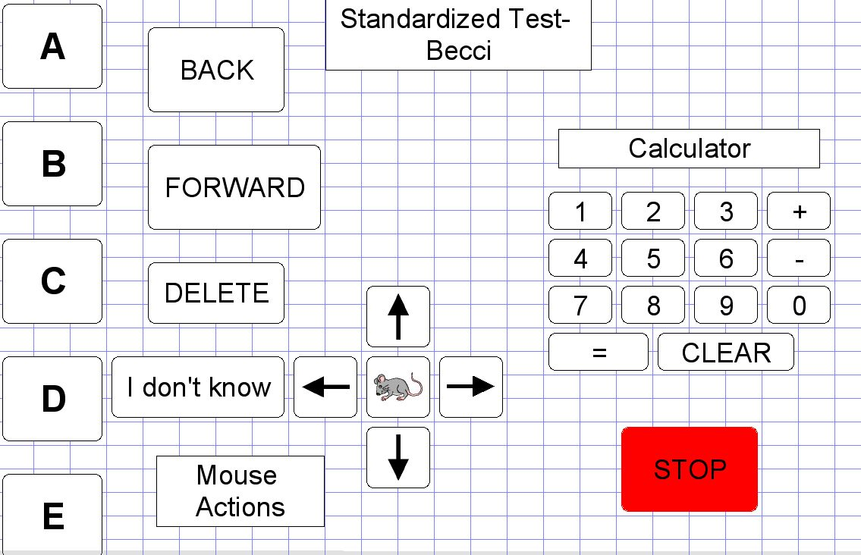
Alternative assessment is a positive thing. It gives a bigger picture of the student as a whole. Many students perform better on alternative assessments rather than traditional ones. Our philosophy of assessment is that every student has the right to showcase his or her knowledge. Alternative assessment is a key way for students to show their knowledge when traditional testing does not serve them well. Researchers have been looking in to this for quite some time “The development of alternative models of assessment and decision making, more attuned to the logical and empirical requirements of intervention design, has been a central theme of school psychology and special education reform (Barnett, & Macmann, 1992).” Developing alternative assessments give teachers the chance to be creative. There are more ways to assess children rather than the paper and pencil. “Traditional assessments originally were thought to provide a broad base of information for educationally related decisions and, thus, part of the solution to the requirement for a "full and fair" evaluation of children with handicaps learning (Barnett, 1992).” These assessments do not provide a full picture of what a student can accomplish. According to an article I read “ Students with disabilities need to show what they have learned and what they are capable of learning; paper pencil standardized testing does not give many of them this chance (Bovino, 2011).” We can do more for students rather than just offering them accommodations. We can create tests for them to showcase all the learning that they have accomplished. Traditional testing can put pressure on student that is unnecessary. Tests should be personalized to some degree to the student or at least the class. We should be doing our best for our students. Creating overlays to help with testing can help us create differentiated instruction for our students. Our current method of testing is backward from out goals. According to Linda Bovino, “This belief that a one size fits all type of assessment is not concurrent with our view of differentiated instruction within the educational system (Bovino, 2011).” Assessment should be to help students and teachers track progress. Teachers should be able to use the information to change and grow. The information should be a true representation of the student’s abilities.

References:
Bovino, L. A. (2011). Evaluating the achievement of elementary students in general
and special education classrooms: An alternative assessment (Order No. 3482736). Available from ProQuest Dissertations & Theses A&I. (910539952). Retrieved from http://search.proquest.com.proxy.bsu.edu/docview/910539952?accountid=8483

Barnett, D. W., & Macmann, G. M. (1992). Decision reliability and validity:
Contributions and limitations of alternative assessment.. Journal Of Special Education, 25(4), 431

Lebeer J., Struyf E., De Maeyer S., Wilssens M., Timbremont B., Denys A., Vandeveire
H. (2010). Identifying special educational needs: Putting a new framework for graded learning support to the test. European Journal of Special Needs Education, 25(4), 375–388

Schenker, R., Coster, W. J., & Parush, S. (2005). Neuroimpairments, activity
performance, and participation in children with cerebral palsy mainstreamed in elementary schools. Developmental Medicine and Child Neurology, 47(12), 808-14. Retrieved from http://search.proquest.com.proxy.bsu.edu/docview/195591957?accountid=8483

Game Activity

The game overlay board that our group made is for Becci’s favorite game, Otto Mattic, a game in which the player is controlling a robot figure who has to run around and save the farmers, as well as shoot down the aliens invading the farm. We created this board using the Overlay Maker program. For the board, we first played the game to fully understand what the objective was and what tasks are needed, as well as what keys need to be pushed for those tasks, for the game. Once those were decided we designed the board in a way that clearly laid out all of the actions that our student would need to use in separate keys in organized columns so it would be easy for her to reach them all and to see where they all were. We specifically laid the keys out all on the left side of the board since our student has predominated use of her left hand. We also made them big enough so that Becci’s hand would be able to touch one key without accidentally touching another and it would be easy for her to aim for the key she had in mind, especially since she can only reliably press 3/4” keys. This board was designed using two colors as well so that it would be easy for our student to differentiate between the arrow keys and the action keys so she wouldn’t be confused on which buttons did what. Playing this game by using this board allows for Becci to develop socially as well as intellectually.

This overlay was mainly created to meet the social and communication needs of our student by providing a way for her to play a game that does not involve verbal communication, which is great for our student because her speech is difficult to understand and with this board you just have to press the button you need, no talking involved. Because we designed a board that allows her to play this game, we are allowing her to also be involved in an activity that her peers are also participating in and it doesn’t make her feel left out because she has the same ability as they do that is necessary to play the game. This type of game is very individualized, which allows the student to focus on her own skills and what she is able to do, and if there is something in the game she can’t quite do yet, it allows her to set goals for herself and internally challenge herself. There is also the possibility that if she doesn’t understand how to do something, that one of her classmates would be able to assist her in figuring it out. Technology, specifically playing games, allows for students individually and collaboratively create their own reflections on their learning and helps represent how they think and approach new ideas or situations. (Hertzog, Klein, 2005). This overlay helps meet alternatives for our student to meet communication and social interaction alternatives because it provides her a way to play a game that doesn’t involve any verbal communication and that her peers also play, allowing her to socially interact with them in a way that they all connect by playing this game. (Kirriemuir & Mcfarlane, 2004). The game that this board was made for supports social skill building because playing games is a way for students to interact with each other that doesn’t necessarily include academics and they are able to have fun and work out concepts in the game together.

We believe that students playing games in the classroom is very helpful and developmental to their education. There are many games out there that have an educational purpose linked to them and that are used by many teachers. Specifically, there are games created to learn how to type, how to learn math facts, and even how to quiz oneself on the definition of a word. Using games to learn can be useful for a student because it allows them to step out of the traditional learning style that they may be bored or irritated with, and lets them learn in a new and exciting way. Games also develop a student’s social skills, as many games require more than one player, meaning students have to interact with each other and often strategize together to win the game they’re playing (Kirriemuir, 2004). When a student is sitting in a desk working on math equations, it’s very hard for them to interact with another student sitting nearby them because they are doing solitude work, possibly working at different paces. However, when students come together to play a game, it’s very easy for them to communicate and work together because they’re all collaborating on the same level and working to achieve the same outcome (Hertzog, 2005).

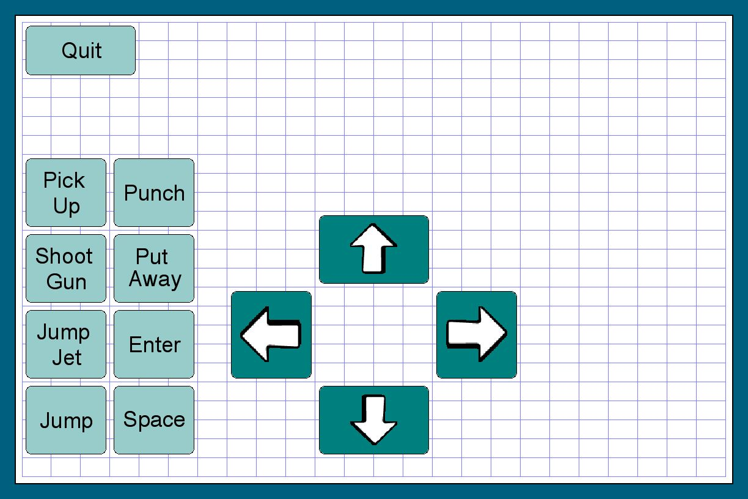

References:

Hertzog, N., & Klein, M. (2005). Gifted Child Today, 28(3), 24-31. Retrieved March 1, 2016.

Kirriemuir, J., & Mcfarlane, A. (2004). Literature Review in Games and Learning. TeLearn, 8. Retrieved March 1, 2016.

Communication Overlay

For Becci’s communication overlay it was made up of many different things. It is made up of ways she feels, things she needs, places she needs to go, and other simple things such as hello and goodbye. To create this board we used the Overlay Maker program. To begin we thought about how to layout the board. At first we did not know if we wanted to use words or pictures for the buttons, but then after reading more about Becci we thought that pictures would be the best. This is because she is only in first grade and since she has a hard time reading and writing we thought it would make it easier for her if we made most of the board out of pictures instead of words. We made the keys big enough for her because since she only has use of her left hand if the keys were too small she would not be able to touch all of them. We made the board pretty colorful just so that Becci would enjoy it more. Since this was something new to her we wanted her to be comfortable using the board. We choose the categories we did because we thought those three categories would be most useful for Becci at school. Being able to express how she feels, what she needs, and where she needs to go are all pretty important when it comes to the school day. We separated each of the categories just so that Becci would not get confused when she went to press the feeling button and etc. Using this board can help Becci with her communication skills and help her talk to not only teachers but also her peers, and help her gain more independence and even confidence.

This board was mainly used to be able to communicate to others through out the school day. This will help Becci with her nonverbal skills because this overlay will allow her to communicate things out loud without having to talk, since the board will say it out loud for her. This also allows Becci’s language skills to improve because using this will allow her to learn more feelings, items, and other things that right now she may not be comfortable saying, or communicating the certain need. This allows Becci to be more independent which is really important in the special education classroom. It is really important for teachers to teach their students to self-advocate (Agoratus, 2014). This really allows her to be more independent and allows her to be more like her peers. It is really important that we focused on what Becci needed to be successful, and what would be most helpful in the communication processes. Yes this is different then typical language use and that is because this has words and phrases formed for her and does not really allow her to say everything she wants.

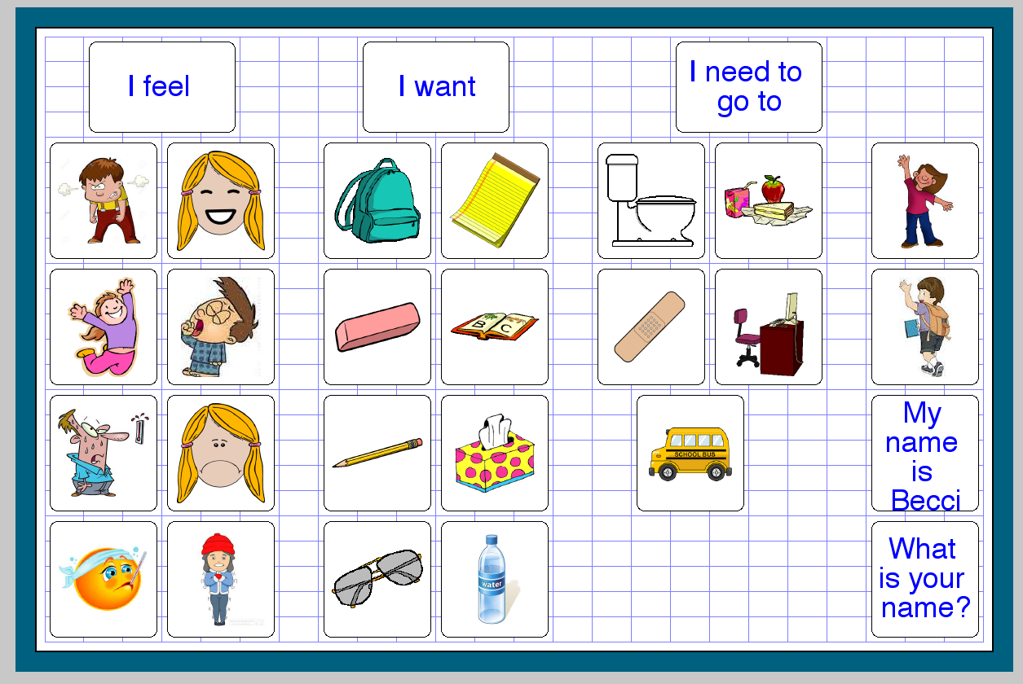
We believe that communication is very important in the classroom and really helps the development of students and their education. The overall goal of students is to find a communication system that meets the current need of students (Dutton, 2011).. And with that being said we thought that this communication board that we created was really useful and really would help Becci’s overall communication. During the creation of this board we really had to think about what would be best for Becci, and what would make her communication better. We wanted Becci to feel just like her peers and this board really would help her in the classroom. Its hard not being able to communicate your wants and needs and how you feel so we thought this board would be a good idea to show all of those.

Sources:

Agoratus, L. (n.d.). Encouraging independence is critical for kids with special needs. Retrieved March 02, 2016, from https://expertbeacon.com/encouraging-independence-critical-kids-special-needs#.VtknFRgTE7I

Dutton, L. (2011, September 8). Giving a voice to those who can’t speak. Retrieved March 02, 2016, from http://www.seenmagazine.us/articles/article-detail/articleid/1660/functional-communication-and-special-education.aspx

Collaboration

In order for the AAC Overlay Project to be successful, we had to collaborate and work together as a group. First we read through the initial description of our student, Becci, to figure out as much as we could about her and come up with a plan of action. We then collaborated and decided what we thought would be best for our student. Our group discussed and assessed the needs of our student both in class and outside of class so that we were able to create the best overlay for our student and created a Google Document that we could add our ideas to. We all contributed our individual ideas and knowledge to complete this project to the best of our ability. Our group worked well together and since we have different majors we all had many ideas to bring to the table. This allowed us to find the best solutions for our student’s individual differences.

Standards Rationales

ISTE-S Standards:
ISTE-S Standard 1-Creativity and Innovation: Students demonstrate creative thinking, construct knowledge, and develop innovative products and processes using technology.

Throughout this project, we worked as a group to create three Intellitool keyboard overlays that were unique and specific to our student. We decided, as a group to create specific overlays that catered to social, academic, and communicational needs of a given student. In order to create overlay boards that specifically fit our student, we had to apply knowledge that we all previously had about technology for disabilities, as well as be able to come up with new ideas based upon this knowledge and the knowledge that we had to gain during the creation of the project. Additionally, we had to develop different processes of creating the overlay boards using technology that none of us had previously used. The technology that we used, specifically Write Out Loud, allowed us to create unique resources for Becci and address the possible problems, solve issues, and create ideas for the overlay (Alnahdi, 2014). We also used our creative thinking by creating the overlays with colorful keys, different sizes, and placed images on the keys based on what our student needs and on the specific overlay. Technology can give students with disabilities the independence they need to succeed in the classroom (Alnahdi 2014). The entire focus throughout this project as a group was to allow Becci to have independence by using Intellitool keyboards to create overlays that she could use by herself (Anastasiou & Keller, 2014). Since our student had cerebral palsy, we implemented the more important keys on his stronger side (Nind, Seale, & Simmons 2013). We worked hard to create overlays that demonstrated our creativity and use of technology in the best way possible.

ISTE-S Standard 2-Communication and Collaboration: Students use digital media and environments to communicate and work collaboratively, including at a distance, to support individual learning and contribute to the learning of others.

In order for this project to be successful, we had to communicate and collaborate. As a group we worked together in a way that required us to communicate with each other and all bring our individual ideas together to create this project to the best of our conjoined abilities. We had to communicate in a way that was effective and contribute to our group to produce original work and solve any problems that we came across when completing this project. By collaborating and working together through technology, we created individualized resources for Becci (Alnahdi, 2014). Using technology gives students the freedom to express their learning and develop further in the classroom, as technology allows for creative and unique learning (Nind, 2013). We included our personal opinions and ideas about what accommodations we should create for Becci and each overlay we created meets on of those accommodations that she needs. It’s important to special education and for working with others that learners adapt their different styles to the group and that they collaborate their ideas together (Anastasiou, 2014).

ISTE-S 5-Digital Citizenship: Students understand human, cultural, and societal issues related to technology and practice legal and ethical behavior.

In order to use technology in the best way for this project, we had to understand the issues that are related to technology, both human and cultural, surrounding our student. We had to make sure that we were using technology in a way that would be safe and legal for our student to use and that we knew all of the information about the technology in order to properly use it. It was also important for us to look at the technology we were using in a positive manner so that we were able to collaborate and use in the most productive way. In order to accommodate Becci’s needs the best way, we had to choose an appropriate and efficient tool that would create an overlay that specifically addressed her needs and would take into account her difficulties both human and culturally (Alnahdi, 2014). We also exhibited leadership for digital citizenship by taking control of the technology we were using and making sure we knew exactly how to use it and used it properly in the best way for Becci (Nind, 2013). Overall, we constantly considered who Becci is and what human, cultural, and societal issues were surrounding her throughout the duration of this project, working hard to make the best outcome (Anastasiou, 2014).

References:
Alnahdi, G. (2014). Assistive Technology in Special Education and the Universal Design for Learning. Turkish Online Journal Of Educational Technology - TOJET, 13(2), 18-23.

Anastasiou, D., & Keller, C. E. (2014). Cross-National Differences in Special Education Coverage: An Empirical Analysis. Exceptional Children, 80(3), 353-367.

Seale, J., Nind, M., & Simmons, B. (2013). Transforming positive risk-taking practices: the possibilities of creativity and resilience in learning disability contexts. Scandinavian Journal Of Disability Research, 15(3), 233-248.

ITSE-T Standards

ISTE- T Standard 1: Facilitate and inspire student learning and creativity
During this project is was really important for us to make sure that the technology that we used and allowed for collaboration, as well as understanding and thinking. This standard inspires creativity in learning and that was important to us during the creation of our boards because we wanted our student to be able to communicate and be creative in the way it happened so she could be more independent. During our creation our goal was to make our student able to participate in the general education classroom more. In one article it said, “The most impressive technology-rich classrooms don't look like classrooms” (Reich, 2012). We did not want to single her out, so all of our boards make it easy for her to communicate, take test, and even play games so she doesn’t seem like she’s any different and that is the great thing about this type of technology. “The student only needs to push the picture on the screen for a voice from the equipment to speak for them”(Humminny, 2014). This makes it easy for our students and is a creative way for our student to learn and communicate. And this standard is about creativity.

ISTE-T Standard 2: Design and develop digital age learning experiences and assessments.
During this project we really had to think outside of the box. None of us were used to using the technology that we used in this project, and as future teachers that are something we will be doing everyday. In this standard it says, “…incorporating contemporary tools and resources to maximize content learning in context and to develop the knowledge skills and attitudes”. We had to make sure that we used different tools to maximize the learning being done on each of the boards that we created. We had to also make sure that we looked at her description and design her boards specifically for her needs and her diverse learning styles. We made sure that we made boards that allow our student to be more independent and be able to communicate or needs and wants, and also to be able to fit in more with her peers. And according to this standard students should be able to participate on their own, and be active in their own education! According to an article called How Special Education Students Benefit from Technology? Stated, “Technology can be the great equalizer in a classroom with diverse learners”(Job, and Zorigian). This we really took in consideration when creating the boards. In the article titled, Inside the Special Education Classroom: How Tech Can Help Students With Special Needs they say, “Some tools make it possible for students with special needs to use the computer just like everyone else” (Huminny, 2014). This standard is really focusing on assessments and learning with digital age learning. And this quote is very accurate because when making the boards we wanted her to be just like her classmates, or as close as we could.

ISTE-T Standard 5 Engage in professional growth and leadership.
Standard 5 was important during this project for us because it is all about promoting and demonstrating effective use of digital tools and resources. We had to use all of our resources to and everything we knew to make the best boards for our student. We had to do research on our student and on what would work best for her during this project. And in this standard it talks about using existing digital tools and resources to support a student in learning and that is what we did. Technology has advanced so much, “Students now have access to assistive capabilities on technologies that are smaller, more mobile, more integrated and inexpensive” (Sacena, 2014). This article connected to what we did because we had to do research on new and old technology and this article talked about how technology is today, and that was very important during our project. We had to grow as leaders and in a professional way to make sure our boards fit our student in the best way possible. Since most students can benefit from technology in the classroom (Job). We used all of our skills to make sure that our student would benefit from the technology, by providing 4 boards with different uses so she has different boards for every need.

Sources:

Humienny, S. (2014, December 4). ​Inside the Special Education Classroom: How Tech Can Help Students With Special Needs. Retrieved March 02, 2016, from https://www.edsurge.com/news/2014-12-15-inside-the-special-education-classroom-how-tech-can-help-special-needs-students

Reich, J. (2012, May 23). Use Technology to Upend Traditional Classrooms. Retrieved March 02, 2016, from http://www.edweek.org/ew/articles/2012/05/23/32reich.h31.html

Saxena, S. (2015, January 5). Integrating Technology in a Special Education Classroom. Retrieved March 02, 2016, from http://edtechreview.in/news/855-integrating-technology-in-a-special-education-classroom

Zorigian, K., & Job, J. (n.d.). How do special education students benefit from technology? Retrieved March 02, 2016, from http://www.learnnc.org/lp/pages/6917?ref=search

State Academic Standards:

We made four overlays to help a first grade student, Becci. An academic standard we chose was the Reading and Vocabulary standard. The standard states “Use words, phrases, and strategies acquired through conversations, reading and being read to, and responding to literature and nonfiction texts to build and apply vocabulary” (IDOE Academic Standards, 2008). One of our communication boards is strictly using vocabulary to build sentences for communication. We have the board separated into pictures with the button programed to help her communicate and to assist with good communications skills. A sub-point of the standard is “Writing complete simple declarative, interrogative, imperative, and exclamatory sentences in response to prompts (IDOE Academic Standards, 2008).” This board lets her build simple sentences to communicate with her peers and others. Another sub-point of this standard is “Writing sentences that include common and proper nouns and personal pronoun (IDOE Academic Standards, 2008).” All the places that she can say she wants to go are nouns, proper or regular. As the teacher it is important to use the board as a teachable moment.
A CommonCore standard is “With guidance and support from adults, demonstrate understanding of word relationships and nuances in word meanings (CommonCore, 2016).” She has a board that is used to learn the days of the week and months of the year. She could use this board to understand the meaning of the words like “today or date”. A sub-point of this standard is “Use personal, possessive, and indefinite pronouns (e.g., I, me, my; they, them, their, anyone, everything) (CommonCore, 2016).” Her basic communication board uses the conventions and with guidance from adults she can learn the relationship of all these words. The board shows her how to build basic sentences in the correct context. Another feature of her communication board is a built in sub-point “Sort words into categories (e.g., colors, clothing) to gain a sense of the concepts the categories represent (CommonCore, 2016). “ We have different categories color-coded on her communication board. It will be important to explain to her why they are separated.

With her talking board she can showcase this standard “Listen actively and adjust the use of spoken language (e.g., vocabulary) to communicate effectively with a variety of audiences and for different purposes (IDOE Academic Standards, 2008).” The board is designed for her to make appropriate choices when communicating. She can also use the date board to make appropriate choices when communicating. This sub-point is something that is made possible for Becci by her talking boards “Speaking audibly and using appropriate language, recite poems, rhymes, songs, and stories, with careful attention to sensory detail when describing people, places, things, and events (IDOE Academic Standards, 2008).” She can now effectively speak audibly and use appropriate language. This accommodation gives her so much freedom. The boards give her a chance to learn these standards and present them in her own way. Her boards are already set up with pictures to help present these standards to her. A point made about the Academic standard was the student should be able to add pictures or other visuals to clarify their point (IDOE Academic Standards, 2008). We have modeled those on her boards by using pictures to help her communicate.

The last standard that our board is affiliated with is a CommonCore standard. With all of her boards she could carry on a conversation with a peer and use appropriate words. The standard states “Participate in collaborative conversations with diverse partners about grade 1 topics and texts with peers and adults in small and larger group (CommonCore, 2016).” She can use her talking board to create many sentences to have full conversations with her peers. This is important for her social development. Since she has not been able to communicate well she does not know the rule of speaking. A sub-point of this standard is “Follow agreed-upon rules for discussions (e.g., listening to others with care, speaking one at a time about the topics and texts under discussion) (CommonCore, 2016).” This is very important for Becci to learn because before this she has been frustrated trying to communicate and often has not been taught the rules on conversation. One of the freedoms of the boards is this expectation Produce complete sentences when appropriate to task and situation (CommonCore, 2016). It is amazing that this is easy for other students when Becci has struggled. The talking boards and the date board make this sub-point possible for Becci. Boards have given her the possibility of being compared to the standards just as her peers are.

Jenna Ferguson InTASC:
The boards are all made to give Becci the best education. She had needs that were not being met by other services, and this AAC device is a viable solution. As it related to the InTASC standards, I believe that the boards are a good representation of InTASC 3 and 8. These standards are a backbone of what I need to be as a teacher. Using this assistive technology is a way to give the future students a better understanding of our world.
InTASC 3 states, “The teacher works with others to create environments that support individual and collaborative learning, and that encourage positive social interaction, active engagement in learning, and self motivation (InTASC, 2011).” With these types of technology, Becci has an improved learning environment. Working with my fellow pre-service teachers, we collaborated to make 4 boards for Becci. These dispositions are important in the teaching world, to give the students an appropriate education. This models a Universal Design of Learning, to allow Becci to be included in the classroom at a much higher rate. Hitchcock and Stahl pointed out that “A universally designed curriculum is one that has been designed, from the outset, to achieve results (Hitchcock & Stahl, 2003).” We designed this especially for Becci. We could use these boards and modify them for other students. A sub- point that this project meets almost perfectly is “3(g) The teacher promotes responsible learner use of interactive technologies to extend the possibilities for learning locally and globally (InTASC, 2011).” This technology gives the freedom to children who cannot operate the traditional computer. They can now connect with information that was not previously available to them. The use of technology gives the teacher more options to enhance the curriculum. In the Journal of Special Education Technology state that “The use of technology provides clear advantages to those who wish to provide flexible, supportive, and adjustable learning and productivity experiences to all learners (Hitchcock & Stahl, 2003). The boards are a prime example of using technology to enhance a student’s life and education. Reaching this standard is important to give students what they need in their education.
InTASC 8 states “The teacher understands and uses a variety of instructional strategies to encourage learners to develop deep understanding of content areas and their connections, and to build skills to apply knowledge in meaningful ways (InTASC, 2011).” Assistive technology allows for new instructional strategies to be developed all the time. The AAC keyboard is an example of a new instructional strategy to help the student learn. In the performances it states that teachers can adapt the instruction to include the child. When the class learns the days of the week, Becci has a board that is adapted to her specific needs. When making one of the boards I did a lot of research to make sure that it would be right. I collaborated with my peers to edit and reedit the board to make it the best it could be. I read this about collaboration “When professionals have time together, and share a focused purpose (i.e., developing AT knowledge and skills), collaboration typically unfolds within the context of the User Group session and an engaged learning community emerges (Parette, H., & Stoner, J., 2008)”.
I read an article about people with disabilities who only dreamed of being able to have a job and participate in adult life like other people. This article spoke to me because with projects such as these I am helping prepare a student for adult life. The article states “AAC technologies have enabled individuals with severe physical and communication disabilities to successfully participate in the community, as well as in academic and vocational settings (McNaughton, D., Symons, G., Light, J., & Parsons, A., 2006).” This is the reason we adhere to the standards. We want students to grow into adults that can do whatever their heart’s desire.
Reference:
Hitchcock, C., & Stahl, S. (2003). Assistive technology, universal design, universal design for learning: Improved learning opportunities. Journal of Special Education Technology, 18(4), 45-52. Retrieved from http://search.proquest.com/docview/228483843?accountid=8483
InTASC Model Core Standards, (2011). Council of Chief State School Officers.

McNaughton, D., Symons, G., Light, J., & Parsons, A. (2006). "My dream was to paytaxes": The self-employment experiences of individuals who use augmentative and alternative communication. Journal Of Vocational Rehabilitation, 25(3), 181-196
Parette, H., & Stoner, J. (2008). Benefits of Assistive Technology User Groups for Early Childhood Education Professionals. Early Childhood Education Journal, 35(4), 313-319. doi:10.1007/s10643-007-0211-6

Jenna Ferguson CEC-
The Council for Exceptional Children is a high respected entity of the special education world. When looking at their standards you must choose wisely because there are so many great ones, and eventually I hope to have covered them all. I chose 3 standards to align this project with. The first one is about creating a conducive learning environment. CEC Preparation Standard 2 states “Beginning special education professionals create safe, inclusive, culturally responsive learning environments so that individuals with exceptionalities become active and effective learners and develop emotional well being, positive social interactions, and self-determination (Council for Exceptional Children, 2014). “ This project helps initialize inclusion. The student can now successful communicate with people in a way that she could not previously. This will help her social development as well as her self-determination. Luckner and Sebald wrote, “Research in special education has demonstrated the benefits of promoting self-determination in achieving positive adult outcomes (Luckner & Sebald, 2013).” Self-determination is an important factor in living a healthy life. It all filters in to preparing students for adult life. With this project, the student can now develop some independence and learn how to fulfill her own needs. This is important because the goal is to have children be as independent as they can. “Individuals who are self-determined act from awareness of personal preferences and needs, make effective choices and decisions, set goals and work toward them, regulate their behavior and thoughts to solve problems, advocate for themselves on the basis of self-knowledge and awareness of strengths and limitations, and regularly evaluate and adjust their performance (Luckner & Sebold, 2013).” The creation of the AAC for the student, makes it possible to set goals and to make her aware of her needs. She now has a device that can help her self advocate and have a hand in her own education.
The next standard I chose that fit this project is the one about using knowledge to adapt the curriculum to the students. CEC Preparation Standard 3 states, “Beginning special education professionals select, adapt, and use a repertoire of evidence-based instructional to advance learning of individuals with exceptionalities (Council for Exceptional Children, 2014).” The AAC is an evidence-based system; it has been proven to help students with language difficulties. Along with her scribe, she now can use an AAC device. Many students need more than one type of accommodation to have a full benefit. These accommodations can help advance Becci’s learning. “The use of instructional strategies that have a strong empirical foundation supporting their effectiveness is proposed as an important factor in improving the educational outcomes of students in both general and special education (Kutash, Dunkowski, & Lynn, 2009).” We did our own research on making the boards, so they would give the maximum benefit. The selection of buttons we chose was based on the information we had been given about Becci. We used that knowledge to customize the boards to her needs. She can use her left hand more proficiently than her right so on her standardized test board the majority of the buttons are on the left. They are big enough for her to touch without difficulty. We made sure to do this on all the boards to give her complete accessibility. One of the sub-points was about using assistive technology to take tests, with our standardized test board we have done that.
The last standard I chose to represent this project is a standard on collaboration. Without the help of my partners, these overlays would not have been as good as they are. Collaboration in the education world is so important. Everyone in our group had different majors so we all could contribute different ideas from our educational backgrounds. We are also from different towns, so we have different cultural backgrounds. A great article I read about co-teaching states, “Each teacher brings important knowledge and skills to the classroom, and they learn from each other without trying to be interchangeable (Friend, 2015).” This is the model I felt we used in our process to do this project. We all used our unique backgrounds to give the project a personal flair. The CEC Preparation Standard 7 states, “Beginning special education professionals collaborate with families, other educators, related service providers, individuals with exceptionalities, and personnel from community agencies in culturally responsive ways to address the needs of individuals with exceptionalities across a range of learning experiences (Council for Exceptional Children, 2014).” Collaboration with my professor was also important during this process. The critique we received was invaluable. There were things that none of us had thought about, that she had learned from her years of experience in the field. “The aim of co-teachers is to create a classroom culture of acceptance, in which learning variations and strategies to address those variations are the norm (Friend, 2015).” With these strategies we can create a better classroom for Becci. This standard is about collaborating to reach a common goal. I believe we did that. We collaborated to make Becci a more functional part of the classroom, for her social and academic growth.

References:
Council For Exceptional Children, (2016). Preparation standards. Council For Exceptional Children.

Friend, M. (2015). Welcome to Co-Teaching 2.0. Educational Leadership, 73(4), 16-22

Kutash, K., Duchnowski, A. J., & Lynn, N. (2009). The use of evidence-based
instructional strategies in special education settings in secondary schools: Development, implementation and outcomes. Teaching and Teacher Education, 25(6), 917-923

LUCKNER, J. L., & SEBALD, A. M. (2013). PROMOTING SELF-DETERMINATION OF STUDENTS WHO ARE DEAF OR HARD OF HEARING. American Annals Of The Deaf, 158(3), 377-386.

