Social Studies: Grade 4
Topic: Civil War
State Standards
4.1.7 Explain the roles of various individuals, groups, and movements in the social
conflicts leading to the Civil War.
4.1.8 Summarize the impact of Abraham Lincoln’s presidency on Indiana and
describe the participation of Indiana citizens in the Civil War.
4.RL.4.2 Compare and contrast the treatment of similar themes and topics and
patterns of events in stories, myths, and traditional literature from different cultures.

Brief description
Students are to know a brief history of the Civil War. This unit will include groups such as the Quakers, the African Americans, the North and South and the political leaders. The movements will include the abolition movement as well as, states rights. This will also include the causes and things leading up to the Civil War. We will go into detail about Indiana’s stance and how Abraham Lincoln and the Civil War affected Indiana.

Learning Objectives

Objective | Bloom’s Level | Questions | Standard
Students can state the causes of the Civil War. | Remembering the causes of the Civil War. | Pre-Assessment: 4  PBA: 2,3  Unit Test: 8, 10 | 4.1.7 Explain the roles of various individuals, groups, and movements in the social conflicts leading to the Civil War.
Students know what role Indiana played in the Civil War | Analyzing the part that Indiana played in Civil War. | Pre-Assessment: 5  PBA: 2,3  Unit Test: 9 and 10 | 4.1. 8 Summarize the impact of Abraham Lincoln’s presidency on Indiana and describe the participation of Indiana citizens in the Civil War.
Social Conflicts and People of the War | Analyze the conflicts of the war and determine how they contributed to the conflict. | Pre-Assessment: 2, 3  PBA:2,3  Unit Test: 1-4, 7 | 4.1.7 Explain the roles of various individuals, groups, and movements in the social conflicts leading to the Civil War.  4.1.8 Summarize the impact of Abraham Lincoln’s presidency on Indiana and describe the participation of Indiana citizens in the Civil War.
Civil War literature and relationship to Civil War | Understanding the relationship between the literature written during the Civil War and the conflicts going on during that time. | Pre-Assessment: 6  PBA: 4, 6  Unit Test: 5 and 6 | 4.1.7 Explain the roles of various individuals, groups, and movements in the social conflicts leading to the Civil War.  4.RL.4.2  Compare and contrast the treatment of similar themes and topics and patterns of events in stories, myths, and traditional literature from different cultures.
Short, Nicole (2010) “Civil War Unit Plan”. Manchester University.
The source was a 9 weeklong lesson plan on 4th grade Civil War. It has all the lessons planned out by the week. I found this source and used parts and pieces of her goals of her students to help make mine. I modified the source’s objectives to better fit with the scope of my lesson.
I also got inspiration from Hanna Rose’s assignment shown in class. I really enjoyed the table she made so I made a table also. I like the organized look of the table.

Name:__________________________
Pre- Assessment: Civil War
- How interested are you in the Civil War?
1-10 1 being not at all and 10 being very interested: ____________
- Do you think the Civil War is important to you life? Yes or No? _________
- Name one project or subject that you would like to see or learn about:
________________________________________________________________________________
- What is the definition of an abolitionist?

- What is the Underground Railroad?

- Who was Abraham Lincoln?

- Why did the Civil War start?

- True or False: Indiana was a slave state during the Civil War.

- What is the main idea in the book Little Women?
Answer Key:
- Someone against slavery
- A passage that slaves used to get to the North
- The president that set the slaves free and signed the Emancipation Proclamation
- Because of the violation of the states rights, slavery, and political differences
- False
- It is a story about women during the Civil War surviving and thriving among a country in turmoil.
Performance Based Assessment
Description:
Students will get into groups of 2 and imagine they are campaign managers for one these prominent Civil War leaders: Abraham Lincoln, Jefferson Davis, Harriet Tubman, or General Robert E. Lee. Students will be required to make a poster, and an online pamphlet, video or presentation supporting their candidate. Students should include the following information:
- What party they were in or would have been in
- Information that would appeal to Indiana voters
- Solution to bring the nation back together/End the Civil War
- That candidates solutions to the problems the Civil War presented
- Plan for Reconstruction
- Little Women Reference or included
The final product should include a small 5-7 minute presentation on why your candidate should be president. There should be a campaign poster and an online presentation, flyer or video. The teacher will help those wanting to do a video and class time will be given to work on these projects.
Rubric
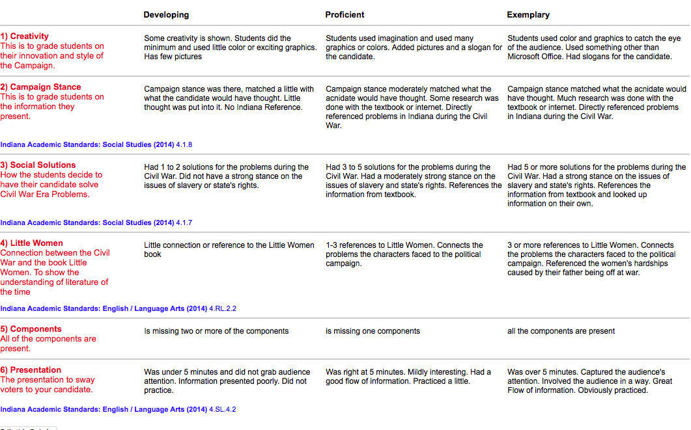

Name:___________________________
Civil War Unit Test
Matching- Match these people to their accomplishments
1) Harriet Tubman______ a. 16th President of the United States of America
2) Abraham Lincoln_____ b. General in the Confederate Army
3) Jefferson Davis_____ c. Conductor on the Underground Railroad
4) Robert E. Lee_____ d. President of the Confederate States of America
Multiple Choice- Pick one letter for each question
5) Why was it hard for the sisters and the mom in Little Women to make money?
a. Because they were slaves
b. Their father was off at war
c. Their mother was terminally ill
d. They were robbed
6) Where did the ladies live in the beginning of the book?
a. Germany
b. The North East
c. The South
d. Florida

7) What document did Abraham Lincoln sign in September of 1862, that freed the slaves in the Confederacy?
a. States rights
b. Union
c. Emancipation Proclamation
d. Siege

8) What was the Underground Railroad?
a. A train used by slaves
b. A place slave owners went to get new slaves
c. A vast network of people, safe houses, & routes all used to help fugitive d. slaves escape to the north, Canada, and Mexico
e. An underground railway used by slave owners to transport their wares

9) Indiana was a state in the Civil War?
a. Slave
b. Happy
c. Free
d. Flower

10) Many people in Indiana ___________ the Civil War?
a. Supported
b. Loved
c. Controlled
d. Were against

Constructed Response Questions- Answer these questions with complete sentences

11) Name 3 different causes of the Civil War.
_____________________________________________________________________________
______________________________________________________________________________
______________________________________________________________________________
______________________________________________________________________________
______________________________________________________________________________
12) What is a major battle that soldiers from Indiana participated in? Did people from Indiana believe in the cause of the Civil War? Connect those 2 ideas with readings from class.
_____________________________________________________________________________
_____________________________________________________________________________
_____________________________________________________________________________
_____________________________________________________________________________
____________________________________________________________________________

Answer Key:
- C
- A
- D
- B
- B
- B
- C
- C
- C
- A
- Slavery, State’s rights, The Missouri Compromise, Secession
- They participated in Antietam and Gettysburg. They were mostly against war and in a soldier’s diary from Indiana. He said that he didn’t know why they were fighting. This could cause low moral and deserters.

