IDOE Standards
B.4.4 Use a model to illustrate the role of cellular division (mitosis) and differentiation in producing and maintaining complex organisms.
Student Learning Objectives
- Define the process of mitosis and meiosis.
  - Bloom: Knowledge
- Define the cell cycle.
  - Bloom: Knowledge
- Differentiate between the phases of mitosis and the cell cycle.
  - Bloom: Analysis
- Explain what processes in the body are associated with cell reproduction.
  - Bloom: Comprehension
- Sketch the phases of the cell cycle and their associated processes.
  - Bloom: Application
- Label the parts of a cell that is undergoing mitosis.
  - Bloom: Knowledge
- Sketch the phases of mitosis and visualize the process that is occurring in each phase.
  - Bloom: Application
Cell Reproduction Test
Name ____________________________ Date _______________

- (2 points) The process of the cell cycle where the nucleus divides to create two identical nuclei is called __________.
  - mitosis
  - meiosis
  - mutation
  - interphase
SLO 1
- (2 points) Somatic cells reproduce by ______________ , while sex cells reproduce by ______________ .
  - meiosis; mitosis
  - mitosis; mitosis
  - mitosis; meiosis
  - meiosis; meiosis
SLO 1
- (2 points) The final step in the mitosis process for animal cells is _________.
  - interphase
  - chromosome
  - centriole
  - telophase
SLO 3
- (2 points) Which of these is the part of the cell that contains hereditary material?
  - centriole
  - chromosome
  - centromere
  - cytoplasm
SLO 6
- (2 points) Cellular reproduction is involved in ALL of the following processes EXCEPT which?
  - development
  - cell maintenance
  - sexual reproduction
  - protein degradation
SLO 4
- (3 points) What is the cell cycle? Answer in 2-3 sentences.

SLO 2
- (6 points total; 1 point each) Match the following mitoses phases with important events which occur during that phase:
HINT: A word bank is provided. Words may be used ONCE or TWICE, but ALL words will be used.
Word Bank:
A. interphase
B. telophase
C. prophase
D. anaphase
E. metaphase
____ Nuclear membranes disappear.
____ Chromosomes condense from chromatin.
____ Centromeres break.
____ New nuclear membranes form.
____ G1, S & G2 phases occur here.
____ Chromosomes align along metaphase plate.
SLO 3

- (8 points total) Label the phases of the cell cycle and their associated processes on the following diagram.
HINTS: The wedges are approximately proportional to the length of each phase. A word bank is provided and words may be used ONCE, TWICE, or NOT AT ALL.
Word Bank
G₂ phase
S phase
G₁ phase
prophase
telophase
mitosis
meiosis
cell growth
DNA replication
cell division

SLO 5

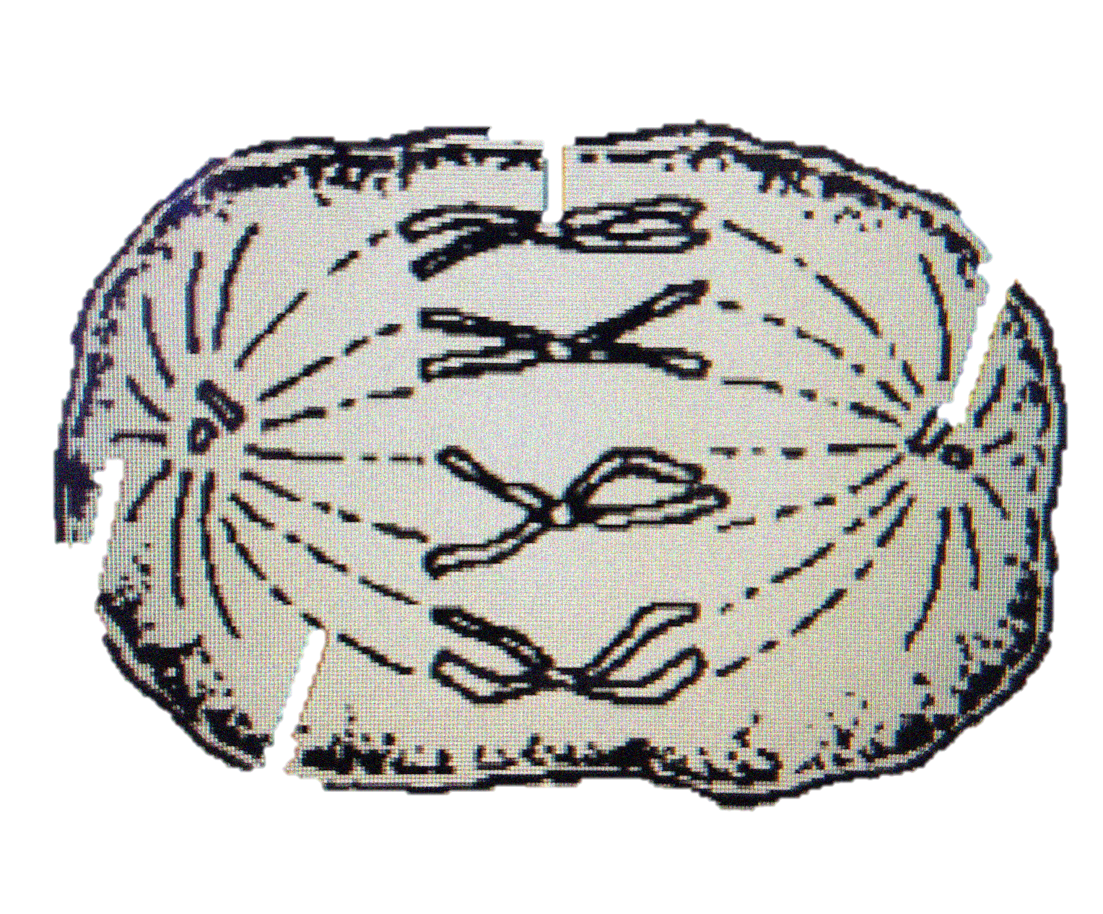
- (5 points total) Color in the following parts of the cell:
Spindle fibers – red
Chromosomes – blue
Centrioles – green
Cytoplasm – yellow
Cell membrane - orange

SLO 6
- (10 points) Sketch the stages of mitosis and label them. Include what the chromosomes are doing in each stage using drawings and captions for each stage. You may use the space below and the back side of this page.
HINT: There are FIVE stages total.

SLO 7

Citations:
Q1 & Q3-5 were retrieved from http://www.sparknotes.com/biology/cellreproduction/review/quiz.html and alterations were made to the questions.
Q2 was retrieved from http://anthro.palomar.edu/practice/bioquiz2.htm
Q6 was retrieved from http://www.biology-questions-and-answers.com/cell-division.html
Q7 & 9 were retrieved from http://chsweb.lr.k12.nj.us/mstanley/other/exam%20review/l2exams/Midterm%20Materials/Cell%20Division%20Exam.pdf and alterations were made to the questions.
Q8 & 10 were developed by J. R. Fromholz-Smith.

