Learning Assessment Model Project (LAMP)

Northside Middle School
Muncie, Indiana
Grade 7 General Science
Topic: Plate Tectonics, Earthquakes, and Volcanos
Duration: 4 weeks

Jessica R. Fromholz-Smith
Woodrow Wilson Teaching Fellow
Ball State University
February and March 2017

Table of Contents

Purpose of the Unit……………………………………………………………………………………………........... 2

Objectives Aligned to Indiana State Standards…………………………………………………………………… 2

Vocabulary…………………………………………………………………………………………………………...... 3

Timeline………………………………………………………………………………………………………………... 4

Resources……………………………………………………………………………………………………………... 5

Letter to Students and Their Families……………………………………………………………………………… 5

Display Area………………………………………………………………………………………………………….. 6

Student Project with Rubric………………………………………………………………………………………….. 7

Technology…………………………………………………………………………………………………………. . 10

Lesson Plans………………………………………………………………………………………………………… 11

Differentiation/Accommodations…………………………………………………………………………………… 20

Authentic Real-Life Applications………………………………………………………………………………… 21

Pre- and Post-Tests……………………………………………………………………………………………….. 21

Data…………………………………………………………………………………………………………………… 28

Narrative Statements and Reflection……………………………………………………………………………… 29

Purpose of Unit

The purpose of this unit is to explore the Theory of Plate Tectonics and its relationship to the occurrence earthquakes and volcanoes as Alfred Wegener describes it. The Theory of Plate Tectonics is described as the slow drifting of the plates that make up Earth’s crust due to the forces of convection currents inside the mantle. I worked to pull from students’ prior knowledge and expand on the details of these phenomena in relation to their lives outside of the classroom. My goal was to make the learning experience fun, relatable, and meaningful.

Objectives Aligned to Indiana State Standards

Upon completion of this unit, students will be able to…
- Describe and apply the Theory of Plate Tectonics to explain natural phenomena.
- Compare and contrast the land features that may result from plate movement.
- Compare and contrast earthquakes and volcanoes.
- Apply their knowledge of earthquakes and volcanoes to address safety issues associated with both phenomena.

The Indiana State Standards that were being address in this unit were the following:

7.2.4 Explain how convection currents in the mantle cause lithospheric plates to moving causing fast changes like earthquakes and volcanic eruptions, and slow changes like creation of mountains and formation of new ocean floor.

7.NS.1 Make predictions and develop testable questions.

7.NS.8 Analyze data, using appropriate mathematical manipulation as required.

7.NS.11 Communicate findings using models.

Vocabulary

- Continental Drift: Wegener’s idea that the continents slowly moved over Earth’s surface
- Pangaea: supercontinent or singular landmass that is believed to have existed about 300 million years ago
- Fossil: any trace of an ancient organism that has been preserved in rock
- Mid-Ocean Ridge: Seam of tectonic plates that formed mountain ranges that ran along the middle of some ocean floors
- Sea-Floor Spreading: Adds more crust to the ocean floor; at the same time, older strips of rock move outward from either side of the ridge
- Deep-Ocean Trench: part of the ocean floor that has sunk back down into the mantle
- Subduction: the process by which the ocean floor sinks beneath a deep-ocean trench and back into the mantle
- Plate: broken pieces of Earth’s crust
- Divergent Boundary: where the plates move apart, or diverge, from each other
- Convergent Boundary: where the plates come together, or converge, on each other
- Transform Boundary: where the plates slip past each other
- Plate Tectonics: the theory that states Earth’s plates are in slow, constant motion, driven by convection currents in the mantle
- Fault: breaks in Earth’s crust where rocks slipped past each other
- Rift Valley: a valley formed when pieces of Earth’s crust diverge on land
- Stress: forces created by plate movement
- Tension: the stress force that pulls on the crust and thins rock in the middle
- Compression: the stress force that squeezes rock until it folds or breaks
- Shearing: the stress force that pushes a mass of rock in two opposite directions
- Normal Fault: when rock splits and the hanging wall of the fault slides down while the footwall slides up; occurs where two plates diverge
- Reverse Fault: when rock splits and the hanging wall of the fault slides up while the footwall slides down; occurs where two plates converge
- Strike-Slip Fault: the rocks on either side of the fault slip past each other sideways with little up or down motion
- Plateau: a large area of flat land elevated high above sea level
- Earthquake: the shaking and trembling that results from movement of rock beneath Earth’s surface
- Focus: the area beneath Earth’s surface where rock that was under stress begins to break or move
- Epicenter: the point on the surface directly above the focus
- P Wave: seismic waves that compress and expand the ground like an accordion
- S Wave: seismic waves that can vibrate from side to side
- Surface Wave: move more slowly than P and S waves but can produce severe ground damage
- Seismograph: an instrument that records and measures an earthquake’s seismic waves
- Modified Mercalli Scale: rates the amount of shaking from an earthquake
- Magnitude: a single number that geologists assign to an earthquake based on the earthquake’s size
- Richter Scale: the scale for measuring the magnitude of an earthquake
- Moment Magnitude Scale: the scale used to rate the total energy an earthquake releases
- Seismogram: the pattern of line produced from a seismograph to show the strength of seismic waves
- Volcano: a mountain that forms in Earth’s crust when molten material, or magma, reaches the surface
- Magma: a molten mixture of rock-forming substances, gases, and water from the mantle
- Lava: what magma is called when it reaches the surface
- Ring of Fire: a major belt of volcanoes along plate boundaries
- Island Arc: a string of islands that formed from volcanoes
- Hot Spot: an area where material from deep within Earth’s mantle rises through the crust and melts to form magma
- Magma Chamber: where magma collects
- Pipe: a long tube that extends from Earth’s crust to the top of the volcano
- Vent: where molten rock and gas leave the volcano
- Lava Flow: the spread of lava as it pours out of a vent
- Crater: a bowl-shaped area that may form at the top of a volcano around the central vent
- Silica: a material found in magma that forms from the elements oxygen and silicon
- Pyroclastic Flow: the mixture of hot gases, ash, cinders, and bombs that flow down the sides of a volcano when is erupts explosively
- Dormant: a volcano that scientists expect to awaken in the future and become active
- Extinct: a volcano that is unlikely to ever erupt again

Timeline

Monday | Tuesday | Wednesday | Thursday | Friday
2/13 | 2/14 | 2/15 | 2/16 | 2/17
 |  |  | Drifting Continents Puzzle | Drifting Continent Puzzle & Discussion
2/20 | 2/21 | 2/22 | 2/23 | 2/24
No school for President’s Day | Notes: Drifting Continents | Quiz for Drifting Continents | Notes: Sea-Floor Spreading | Quiz for Sea-Floor Spreading
2/27 | 2/28 | 3/1 | 3/2 | 3/3
Theory of Plate Tectonics | Quiz for Theory of Plate Tectonics | Notes: Forces in Earth’s Crust | Forces Worksheet | Notes: Earthquakes & Seismic Waves
3/6 | 3/7 | 3/8 | 3/9 | 3/10
Notes: Monitoring Earthquakes | Earthquake Quiz & Introduction Volcanoes | Volcanoes Video Clip & Discussion | Notes: Volcanoes & Plate Tectonics | Notes: Volcanic Structure
3/13 | 3/14 | 3/15 | 3/16 | 3/17
Notes: Volcanic Eruptions | Notes: Volcanic Landforms | Review of Unit | Unit Post-Test Assessment

Resources

Teacher: 7th grade Science textbook, computer, electronic projector with audio capabilities, notes, assignments available on Schoology and paper copy, colored pencils, glue, and scissors.

Student: 7th grade Science textbook, ipad or other electronic device, notes, and assignments on Schoology or paper copy.

Letter to Students and Their Families

February 13, 2017

Greetings, students and families of students in 7th grade general science with Mr. Choate and Mrs. Fromholz-Smith.

In the next few days, we will begin discussing plate tectonics, earthquakes, and volcanoes in class. The forces that interact to create these phenomena will be discussed in detail. A pre- and post- assessment will be given for this material to measure growth and learning of the material. The pre-assessment is merely meant to help guide me in my instruction of the content. If an answer is incorrect or left blank on this assessment, it will not affect the student’s grade. However, this assessment will be used again at the end of the unit to determine if the unit was successful in its objectives.

We will begin the unit using an inquiry activity to engage us in the new material. There will be a lot of group/partner work within this unit, so it is important that I have knowledge of any grouping or pairings that may be ineffective. Families, if you have any concerns about your child working in a group or partnership, please let me know immediately. Additionally, the project for this unit is to construct a volcano diagram. The volcano is not required to erupt, though that is a fun experience for the students. Due to lack of material and the cost of building a model, this project will be extra credit if a student chooses to complete it but will prove very helpful for studying for the assessment.

Students will be provided with follow-along notes so that they may spend a small amount of time writing and more time discussing and listening with the class. Students will only be provided with one copy of the notes, so they are expected to be responsible and keep track of these handouts. If there are any special accommodations outside of those already provided to the school, please let me know. I encourage you, the student and your family to discuss the interesting things we will be learning about these phenomena. Maybe one of your relatives has lived through an earthquake or volcano and they can give you first-hand accounts of the experience they had.

I am looking forward to driving deep into this topic and connecting it to our daily lives! I am always available to discuss any questions that may arise throughout this unit and encourage you to ask questions and seek answers, as any good scientist would do!

Mrs. Jessica Fromholz-Smith, jrfromholz@bsu.edu
Woodrow Wilson Teaching Fellow – Ball State University

Display Area
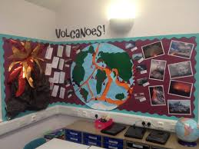
Diagram of volcanoes and earthquakes display:
Narrative of display: For this display, Mr. Choate and I used some informative and colorful posters to give students a visual aid to look at throughout the unit. Given lack of materials for creating a more complex display, I opted to keep it simple in this moment. However, I have included an example that I would like to try in the future below.
Pangaea & Continent Drift
Poster
Earthquake Scales
Poster
Part of an Earthquake
Poster
Types of Volcanoes
Poster
Part of a Volcano
Poster

Student Project with Rubric
This project idea is from Penn Sauken. Due to the ISTEP schedule for our school, we were not able to provide enough scaffolding for this project to be assigned and completed.

Technology

Technology was the major tool I chose to implement for this unit. Prior to this unit, we had only grazed the surface of using our Learning Management System (LMS) Schoology. In this unit, I worked to incorporate making more assignments available electronically, as well as access to PowerPoint Presentations, videos, Quizlet flashcards, and other electronic resources. Here is a list of the technology that was included in this unit:
- EPSON Projector – used to project presentations and other materials off of a computer; has audio capabilities
- Microsoft PowerPoint – used to project images and notes during lecture-discussion notes
- Student devices (iPad or other) – used to give students access to completing assignments on Schoology and research information for assignments
- Videos and songs from a variety of sources (Untamed Science, Crash Course, Bill Nye) – used to give students difference explanations and visuals of the content being addressed
- Quizlet – used to create flashcards for simple, quick studying

Additionally, there are numerous systems I would like to explore and implement in the future including the following:
- Kahoot
- Socrative
- Google Classroom & other associated applications
- Remind

Lesson Plans

Lesson Plan Thursday, February 16, 2017 – Friday, February 17, 2017

Overview
For this lesson, students will complete an inquiry puzzle of Pangaea (Puzzle Me, Pangaea!). Using the key/legend provided, students will analyze the pieces of their puzzle (the tectonic plates) and put them together as if they were puzzle pieces. There is only one correct way the puzzle fits together and this activity will require them to examine all of the evidence to get the correct product. Students will work in pairs to solve the puzzle of our landmasses. Each pair will have a cut and color activity sheet to work with to put the landmasses together in the correct order. Students will be asked not to glue the pieces to the globe until the teacher has approved them to do so.

Objectives
Students will…
- Develop an understanding of how the continents were originally joined together in one supercontinent called Pangea

Co-Teaching Strategy
One teach, one assist

Procedures
- Introduction to the activity and how to be successful in its completion (15 minutes)
- Work in groups to complete the activity and handout questions (30 minutes)
- Discussion of the results and reveal of the correct puzzle formation (15 minutes)
- Questions and collection of completed activities (5 minutes)

Resources/Materials
- PowerPoint & projector
- Handouts (approx. 70)
- Scissors
- Glue
- Colored pencils

Assessment/Evaluation
The assessment for this lesson is the completed student handout.

Accommodations:
Special Needs:
Student can relay information via explaining to teacher or assistant.
Student can have extended time with the activity and can reattempt activity.
Enrichment:
Student can read ahead into the next section.
Student can create a visual summary of the lesson.

Lesson Plan Tuesday, February 21, 2017 – Wednesday, February 22, 2017

Overview
In this lesson, students will take notes over Wegener’s idea about drifting continents. Prior knowledge of hypotheses and theories will be tied into this new material. Students will also participate in a activity to get them moving and also help them to remember Wegener’s theory.

Objectives
Students will be able to…
- Explain Alfred Wegener’s hypothesis about the continents, evidence supporting the hypothesis, and why the hypothesis was rejected.

Co-Teaching Strategy
One teach, on assist

Procedures
- Discuss hypotheses and theories in relation to what was learned from the previous activity with Pangaea.
- Give students notes and additional information about this concept.
- Have students watch the Sid Shuffle from the Ice Age movies and then have the students preform the dance and talk about how it relates to the concept of continental drift.
- Assign worksheet for completion.
- Give quiz upon completion of the worksheet.

Resources/Materials
- PowerPoint & projector
- Student’s science notebooks
- Student’s devices
- Review 10-1 hardcopies
- Sid Shuffle video

Assessment/Evaluation
- Informal checks for understanding throughout lesson
- Review 10-1
- Quiz for 10-1

Accommodations
Special Needs:
Student can relay information via explaining to teacher or assistant.
Student can have extended time with the assignment and can reattempt assignment.
Enrichment:
Student can read ahead into the next section.
Student can create a visual summary of the lesson.

Lesson Plan Thursday, February 23, 2017 – Friday, February 22, 2017

Overview
In this lesson, students will take notes over sea-floor spreading and the different structures that can develop on the ocean floor. Student will also be working on parts of their vocabulary assignment, making visual images of the terms that they are learning. Students will watch a short video explaining and showing sea-floor spreading.

Objectives
Students will be able to…
- Define and describe mid-ocean ridges.
- Explain how sea-floor spreading affects Earth’s crust.
- Explain deep-ocean trenches and the process of subduction.

Co-Teaching Strategy
One teach, one assist

Procedures
- Access prior material about convection currents and tie to the new material through an informative video about sea-floor spreading.
- Give students notes on the different sea-floor features and processes that occur.
- Assign worksheet for completion.
- Give quiz upon completion of the worksheet.

Resources/Materials
- PowerPoint & projector
- Student’s science notebooks
- Student’s devices
- Review 10-2 hardcopies
- Convection and the Sea-Floor video

Assessment/Evaluation
- Informal checks for understanding throughout lesson
- Review 10-2
- Quiz for 10-2

Accommodations
Special Needs:
Student can relay information via explaining to teacher or assistant.
Student can have extended time with the assignment and can reattempt assignment.
Enrichment:
Student can read ahead into the next section.
Student can create a visual summary of the lesson.

Lesson Plan Monday, February 27, 2017 – Tuesday, February 28, 2017

Overview
In this lesson, students will take notes over the theory of plate tectonics. This lesson will tie together what is known about continent drift and what causes the drifting. Wegener’s hypothesis was rejected simply because he could not explain how it all happened. This will be tied into how important it is to have plenty of evidence and support when one makes a scientific or general claim.

Objectives
Students will be able to…
- Explain the theory of plate tectonics.

Co-Teaching Strategy
One teach, one assist

Procedures
- Students will discuss how convection currents and continental drift are related until they conclude that one causes the other. The teacher will act as a guide to lead them to that conclusion.
- Give students notes over this theory and emphasis the importance of the evidence that supports the theory.
- Students will work to complete this chapter’s vocabulary and it will be given an informal check for progress. Answer any questions or give ideas for visuals that could depict some of the terms.
- Assign worksheet for completion.
- Give quiz upon completion of the worksheet.

Resources/Materials
- PowerPoint & projector
- Student’s science notebooks
- Student’s devices
- Review 10-3 hardcopies

Assessment/Evaluation
- Informal checks for understanding throughout lesson
- Review 10-3
- Quiz for 10-3

Accommodations
Special Needs:
Student can relay information via explaining to teacher or assistant.
Student can have extended time with the assignment and can reattempt assignment.
Enrichment:
Student can read ahead into the next section.
Student can create a visual summary of the lesson.

Lesson Plan Wednesday, March 1, 2017 – Friday, March 2, 2017

Overview
In this lesson, the students will discuss forces within Earth’s crust. Students will take notes and act-out the different stress forces the Earth’s crust experiences as a result of the plate movement via convection currents. They will also learn about what stress force occurs at which type of fault, the parts of a fault, and the land features that may result from these faults and their forces. They will be asked to draw visual representations of each fault and describe what happens and results at each for comparing and contrasting.

Objectives
Students will be able to…
- Explain how stress in the crust changes Earth’s surface.
- Describe three major types of faults.
- Compare and contrast the land features that result from plate movement.

Co-Teaching Strategy
One teach, one assist

Procedures
- Students will take detailed notes about each fault and stress type. The teacher will use models to help students visualize what occurs at these faults. The teacher will also provide images of example land features and GIF images to show movement of the plates and their interactions.
- Students will participate in a movement activity to show the direction of plate movement to create each type of stress. Two volunteers will make a “human fault” to show their peers what the different types of fault do.
- Assign worksheet for completion.
- Give quiz upon completion of the worksheet.

Resources/Materials
- PowerPoint & projector
- Student’s science notebooks
- Student’s devices
- Fault and stress models
- Review 11-1 hardcopies

Assessment/Evaluation
- Informal checks for understanding throughout lesson
- Review 11-1
- Quiz for 11-1

Accommodations
Special Needs:
Student can relay information via explaining to teacher or assistant.
Student can have extended time with the assignment and can reattempt assignment.
Enrichment:
Student can read ahead into the next section.
Student can create a visual summary of the lesson.

Lesson Plan Friday, March 3, 2017 – Tuesday, March 7, 2017

Overview
This lesson is rather large because it includes all of the information for 7th grade science on earthquakes. Students will use follow-along notes to help guide their learning and give ample time for demonstrations. Students will watch a video on earthquakes to help them visualize what it is like to experience one, as many have not. Any students that have experienced an earthquake will be encouraged to share how they felt in that moment. Students will create their own seismogram with their partner to aid in understanding how a seismograph measures the intensity of an earthquake.

Objectives
Students will be able to…
- Describe how the energy of an earthquake travels through Earth.
- Identify the scales used to measure the strength of an earthquake.
- Explain how scientists locate the epicenter of an earthquake.
- Explain how seismographs work.
- Explain the patterns that seismographic data reveal.

Co-Teaching Strategy
One teach, one assist

Procedures
- Students will take detailed notes about earthquakes and watch a short video to experience the various parts of an earthquake.
- Lead students to discuss ideas on why earthquakes occur in relation to what they have been learning.
- Have students work with a partner to create their own seismograph and see who creates the strongest “earthquake” with their desk.
- Assign worksheet for completion.
- Give quiz upon completion of the worksheet.

Resources/Materials
- PowerPoint & projector
- Earthquake video
- Earthquake follow-along notes
- Student’s devices
- Cleared off desks for the seismogram activity
- Review 11-2 and 11-3 hardcopies

Assessment/Evaluation
- Informal checks for understanding throughout lesson
- Review 11-2 and 11-3
- Earthquake Quiz

Accommodations
Special Needs:
Student can relay information via explaining to teacher or assistant.
Student can have extended time with the assignment and can reattempt assignment.
Enrichment:
Student can read ahead into the next section.
Student can create a visual summary of the lesson.

Lesson Plan Wednesday, March 8, 2017 – Tuesday, March 14, 2017

Overview
In this lesson, students will learn all about volcanoes at a 7th grade science level. We will address several types of volcanoes and how they occur. They will be given the opportunity to create their own volcano (in this case, as extra credit due to time constraints; this would be an assignment in future lessons). They will need to label the time of volcano and explain how the volcano works. Students will also watch a short video that takes them to real life locations of different volcano types and explains their formation in depth.

Objectives
Students will be able to…
- Identify where volcanic regions and hot spot volcanoes are found on Earth’s surface, and why they are found there.
- Explain what happens when a volcanic erupts and the two different types of eruptions that can occur.
- Describe the stages volcanic activity.
- List the landforms that lava and ash create.
- Explain how magma that hardens beneath Earth’s surface creates landforms.

Co-Teaching Strategy
One teach, one assist

Procedures
- Students will watch the volcano video to be virtually transported to some of the different volcano types.
- Give notes to students having them label the volcano types on their notes while comparing and contrasting them. Students may also choose to use colored pencils to add some color to their diagrams.
- Have students that created volcanoes demonstrate their eruption types and explain how an eruption takes place.
- Assign worksheet for completion.
- Give quiz upon completion of the worksheet.

Resources/Materials
- PowerPoint & projector
- Volcano follow-along notes
- Student’s devices
- Volcanoes designed by students
- Review 11-4, 11-5 and 11-6 hardcopies

Assessment/Evaluation
- Informal checks for understanding throughout lesson
- Review 11-4, 11-5, and 11-6
- Volcano Quiz
- Extra credit volcanoes and posters

Accommodations
Special Needs:
Student can relay information via explaining to teacher or assistant.
Student can have extended time with the assignment and can reattempt assignment.
Enrichment:
Student can read ahead into the next section.
Student can create a visual summary of the lesson.

Lesson Plan Wednesday, March 15, 2017

Overview
Students will work to complete the designed study guide. Students will be assigned into intentional groupings based on achievement in the class. This will provide the teach with the ability to focus energies on struggling groupings while higher-level students may quickly finish and work on other work if necessary.

Objectives
Student will…
- Review material in preparation for the exam.

Co-Teaching Strategy
One teach, one assist

Procedures
- Provide students with hardcopies of the study guide.
- Assign students to intentional groupings and spread them out throughout the room and greenhouse.
- Circulate the classroom, providing guidance as need with focus on checking in with groups that may have trouble understanding the material or questions.

Resources/Materials
- Hardcopies of study guide, with option to complete electronically or with resource assistance
- Textbooks
- Notes

Assessment/Evaluation
- Completed study guide
- Completed vocabulary assignment
- End of unit assessment

Accommodations
Special Needs:
Student can relay information via explaining to teacher or assistant.
Student can have extended time with the assignment and can reattempt assignment.
Enrichment:
Student may complete assignments from other classes or read AR book.

Differentiation and Accommodations
Throughout my lesson plans, there are several basic accommodations made for students as follows:

Accommodations
Special Needs:
Student can relay information via explaining to teacher or assistant.
Student can have extended time with the assignment and can reattempt assignment.
Enrichment:
Student may complete assignments from other classes or read AR book.
Student can read ahead into the next section.
Student can create a visual summary of the lesson.

For special needs students, the directions and specific requirements of their IEPs are always followed. In the general education track at my placement, my classes contain numerous students with IEPs so I often make prior changes to a lesson to ensure that all of my students get the help that they need. Some examples of requirements in IEPs that are most common are extended time on assignments and assessment, access to the resource room upon request, allowing for a scribe or verbal answers, preferential seating, or working in small groups.

For enrichment activities for students that are advancing more quickly than others, they have the choice to move ahead in the material or look more deeply at the current material by researching information or sharing with the class. This gives students some freedom with what they learn and an opportunity for them to be leaders in the classroom.

With differentiation, I use numerous informal checks for understanding to see which students has understood what we are discussing. I often use the thumbs-up methods with their eyes closed to maintain confidentiality of the students’ responses. I also liked to ask students to explain their understanding of concepts to help give all of the students various perspectives as far as how to understand the material. If I see that there are students struggling to grasp the material, I will attempt to reword my explanations or seek out additional sources for explanation to help them develop their understanding.

In order to account for differentiation in advance, I like to utilize Universal Design for Learning (UDL) strategies. In preparation for a lesson, I made lesson material available in hardcopy and electronic copy. This took extra time and work, but was very fruitful for my students. I have learners that do best with one option or the other. I also made sure to include materials that appealed to visual, auditory, and kinesthetic learning styles. Technology has been a very useful aid in this endeavor.

Authentic Real-Life Applications
In each of my lessons, I included a real-life tie in example or scenario. I took time to find materials that may transport my students into the real-life situation of being in an earthquake or near a volcano. I also continued to emphasize the importance of having evidence to support a claim and how this logic makes many careers and aspects of life directly related to science and scientific thinking. When discussing the various stress forces that Earth’s crust experiences, I related it to how the students feel when they are stressed. This aided the students in remembering the different types and what can result from them.
With the earthquakes section, I have found an activity that I would use in future teaching of this lesson. There is a prompt that is read like a story. The teacher has the students act-out the experience of an earthquake including lights flickering, desks shaking, objects falling, doors slamming, and so on. This activity was completed in another science class and is one that I will implement in the future as it gives students the opportunity to experience all of the feelings that an earthquake can kindle.

Pre- and Post-Tests

Pre-Test with Answers/Rubrics and Detailed Question Information

Multiple Choice
1. What did Wegener think happens during the continental drift?
- continents move
- continents freeze
- the mantle warms
- convection stops
ANS: A PTS: 1 DIF: easy REF: 363 STA: 7.2.4 BLM: knowledge

2. What is one piece of evidence that caused Wegener to think that continents moved?
- He found an old map of the world that showed movement.
- He found similar fossils on different continents that are separated by oceans.
- He proved his hypothesis by going back in time like Marty.
- He observed the continents moving with his own eye using an elapsed time camera.
ANS: B PTS: 1 DIF: easy REF: 363 STA: 7.2.4 BLM: knowledge

3. In which areas does subduction of the ocean floor take place?
- rift valleys
- the lower mantle
- mid-ocean ridges
- deep-ocean trenches
ANS: D PTS: 1 DIF: easy REF: 363 STA: 7.2.4 BLM: knowledge

4. How many large plates form the outer shell of the earth?
- 5
- 7
- 2
- none
ANS: B PTS: 1 DIF: easy REF: 357 STA: 7.2.4 BLM: knowledge

5. According to plate-tectonic theory where is new oceanic crust being formed?
- rift valleys
- the lower mantle
- mid-ocean ridges
- deep-ocean trenches
ANS: C PTS: 1 DIF: easy REF: 363 STA: 7.2.4 BLM: knowledge

6. At which boundary do two plates pull apart?
- convergent
- transformers
- divergent
- mantle-crust
ANS: C PTS: 1 DIF: easy REF: 364 STA: 7.2.4 BLM: knowledge

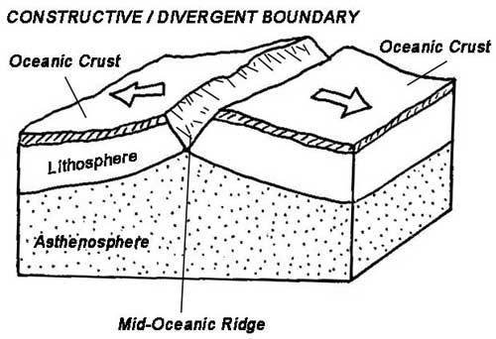
7. What statement best describes the process in the diagram above?
- converging plates form mountains
- converging plates form volcanoes
- diverging plates form mountains
- diverging plates form a rift valley
ANS: C PTS: 1 DIF: medium REF: 365 STA: 7.2.4 TOP: BLM: analysis

8. Which force squeezes Earth’s crust to make the crust shorter and thicker?
- tension
- The Force
- friction
- compression
ANS: D PTS: 1 DIF: easy REF: 413 STA: 7.2.4 BLM: knowledge

9. In which type of location is an earthquake risk the greatest?
- at plate centers
- on big plates
- at plate boundaries
- At Lady Gaga’s half-time show
ANS: C PTS: 1 DIF: easy REF: 413 STA: 7.2.4 BLM: knowledge

10. What do we call a volcano that has not erupted in a long time, but that scientists believe may erupt sometime in the future?
- dormant
- active
- extinct
- undead
ANS: A PTS: 1 DIF: easy REF: 413 STA: 7.2.4 BLM: knowledge

11. Which of the following can cause damage days or months after a large earthquake?
- The arrival of surface waves
- He-Who-Shall-Not-Be-Named
- A tsunami
- An aftershock
ANS: D PTS: 1 DIF: easy REF: 413 STA: 7.2.4 BLM: knowledge

12. Earthquakes…
- Are caused by rupture of land
- Are generated in the focus
- Release energy in the form of seismic waves
- Occur whenever tectonic plates move
- All of the above
ANS: E PTS: 1 DIF: easy REF: 380 STA: 7.2.4 BLM: knowledge

Fill-in-the-Blank
13. Please fill in the missing labels.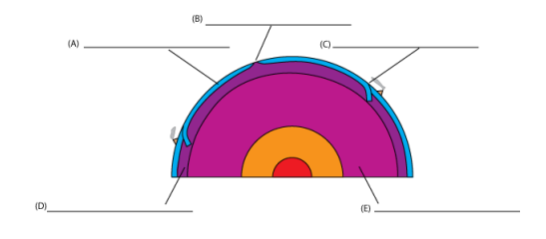
ANS:
(A) Lithosphere
(B) Mid-ocean ridge or divergent margin
(C) Trench or convergent margin
(D) Asthenosphere
(E) Mantle
PTS: 5 DIF: medium STA: 7.2.4 BLM: knowledge

14. The continents were thought to have once been joined together in a supercontinent that was called ________.
ANS: Pangaea PTS: 1 DIF: easy REF: 363 STA: 7.2.4 BLM: knowledge

15. A mid-ocean ridge is a _____________.
ANS: A long chain of mountains PTS: 1 DIF: medium REF: 363 STA: 7.2.4 BLM: knowledge

16.Rocks on either side of a ____________ fault slip past each other with little up and down motion.
ANS: strike-slip PTS: 1 DIF: easy REF: 413 STA: 7.2.4 BLM: knowledge

17. Label the parts of the volcano in this diagram.
Word bank: ash cloud, conduit, crust, lava, magma chamber, side vent, vent
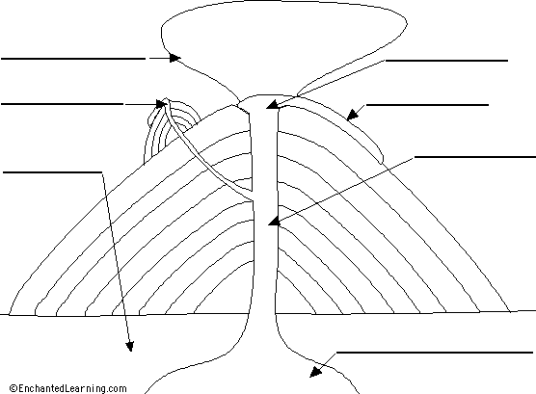
1
4

5
2

6
3

7

ANS:
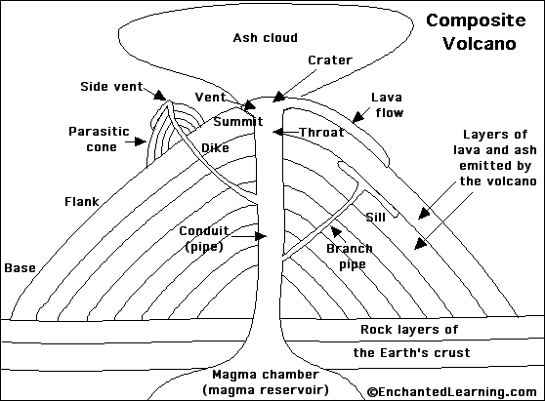

PTS: 7 DIF: medium REF: 399 STA: 7.2.4 BLM: knowledge
Matching
18. The image shows North America and Africa. Circle the parts of the coastlines of the two continents that were joined in Pangea.

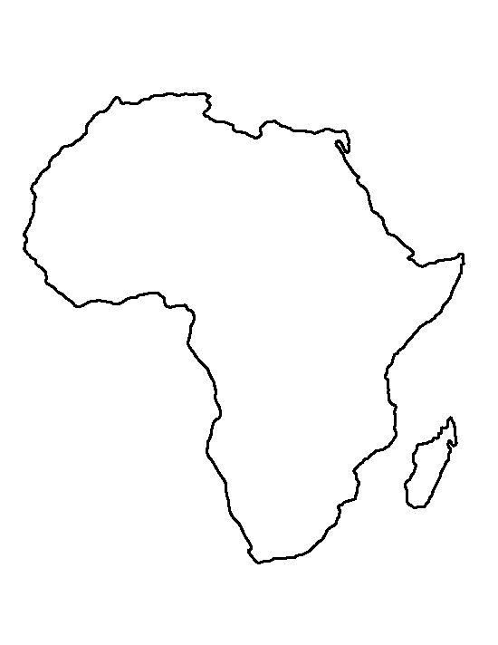
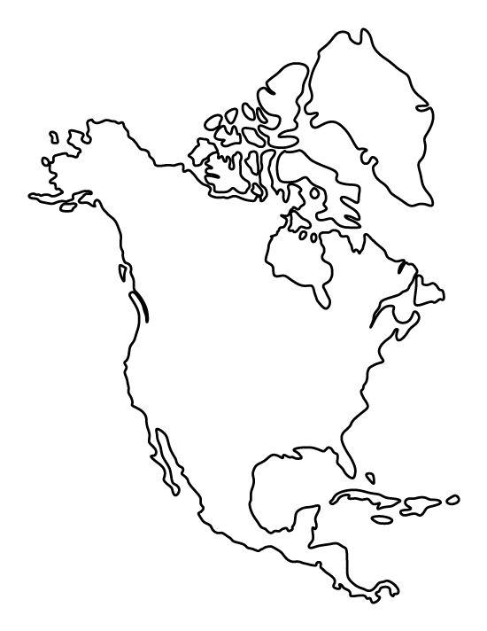
H
A
E

G
B
D

F

C

PTS: 2 DIF: medium REF: 363 STA: 7.2.4 BLM: comprehension

19. Place the following steps of sea-flooring spreading in their correct sequence.
- The molten material cools and hardness, forming a strip of rock along the ocean floor
- The strip of rock moves away from the ridge.
- Molten material from inside Earth rises to the ocean floor at a mid-ocean ridge.
ANS: C, A, B PTS: 3 DIF: medium REF: 363 STA: 7.2.4 BLM: comprehension

Short Answer
20. List at least TWO of the major lithospheric plates of our planet.
ANS: North American, South American, African, Eurasian, Indian-Australian, Antarctic, Pacific
PTS: 2 DIF: medium REF: 363 STA: 7.2.4 BLM: knowledge

21. Describe Wegener’s hypothesis about the continents.
ANS: Wegener’s hypothesis was that all the continents were once joined together in a single landmass and have since drifted apart.
PTS: 2 DIF: medium REF: 363 STA: 7.2.4 BLM: comprehension

22. How do moving plates change Earth’s crust?
ANS: Moving plates add new crust at mid-ocean ridges. They also cause oceanic crust to be destroyed at deep-sea trenches. They also squeeze continental crust into mountains and pull the crust apart at rift valleys.
PTS: 3 DIF: hard STA: 7.2.4 BLM: comprehension

23. List TWO types of landforms that could result from convergent plate movement.
ANS: Mountains and volcanoes PTS: 2 DIF: easy REF: 363 STA: 7.2.4 BLM: knowledge

24. Apply what you know about volcanoes to answer the following question: How might a volcano be hazardous for plants and animals that live nearby?
ANS: Plants and animals could be killed by ash, lava flows, and pyroclastic flows.
PTS: 3 DIF: easy REF: 413 STA: 7.2.4 BLM: application

Essay
25. There is a high risk of earthquakes along the San Andreas fault in California. What is happening in earth’s crust along the fault to cause this high earthquake risk? Use the theory of plate tectonics in your answer.
ANS:
Scoring Rubric | Score 4 | Score 3 | Score 2 | Score 1
How stress and faults cause earthquakes | Explains correctly & in detail how stress and faults cause earthquakes | Correctly explains how stress & faults cause earthquakes | Incorrectly explains how stress & faults cause earthquakes | Does not explain how stress & faults cause earthquakes
How plate movement causes faults | Explains correctly & in detail how plate movement causes faults | Correctly explains how plate movement causes faults | Incorrectly explains how plate movement causes faults | Does not explain how plate movement causes faults
PTS: 8 DIF: hard REF: 413 STA: 7.2.4 BLM: application

26. Compare & contrast volcanoes and earthquakes.
ANS:
Scoring Rubric | Score 4 | Score 3 | Score 2 | Score 1
Compares volcanoes & earthquakes | Student thoroughly & correctly compares volcanoes & earthquakes | Student only partially compares volcanoes & earthquakes | Student incorrectly compares volcanoes & earthquakes | Student does not compare volcanoes & earthquakes
Contrasts volcanoes & earthquakes | Student thoroughly & correctly contrasts volcanoes & earthquakes | Student only partially contrasts volcanoes & earthquakes | Student incorrectly contrasts volcanoes & earthquakes | Student does not contrast volcanoes & earthquakes
PTS: 8 DIF: hard REF: 413 STA: 7.2.4 BLM: analysis

Post-Test with Answers/Rubrics and Detailed Question Information
The post-test that was given included same questions and structure as the pre-test.

Data

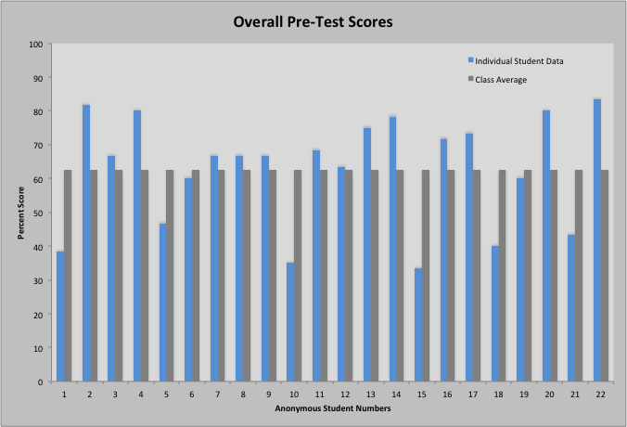

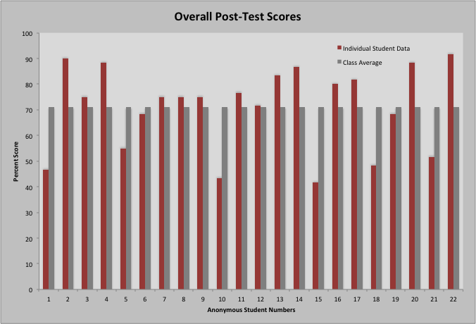
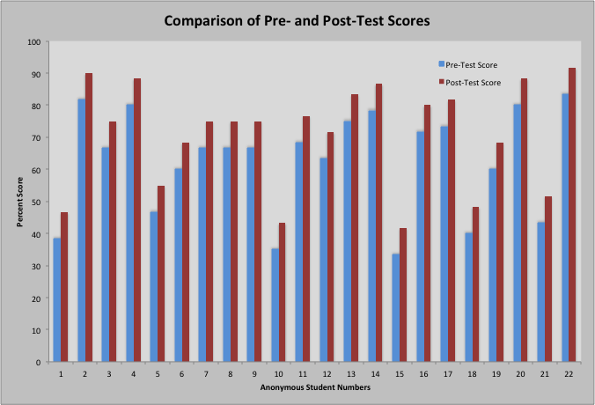

Comparison of Scores on Standard 7.2.4
Each of the questions covered on the pre- and post-test only covered the Indiana State Standard 7.2.4, therefore the graphs for that data already used at the same as what the graphs for this standard would look like for this for each student.

Narrative Statements and Reflection

- Unit Narratives
  - Content standards:
    - 7.2.4 Explain how convection currents in the mantle cause lithospheric plates to moving causing fast changes like earthquakes and volcanic eruptions, and slow changes like creation of mountains and formation of new ocean floor.
  - Ancillary standards:
    - 7.NS.1 Make predictions and develop testable questions.
    - 7.NS.8 Analyze data, using appropriate mathematical manipulation as required.
    - 7.NS.11 Communicate findings using models
  - Accommodations:
    - For special needs students, the directions and specific requirements of their IEPs are always followed. In the general education track at my placement, my classes contain numerous students with IEPs so I often make prior changes to a lesson to ensure that all of my students get the help that they need. Some examples of requirements in IEPs that are most common are extended time on assignments and assessment, access to the resource room upon request, allowing for a scribe or verbal answers, preferential seating, or working in small groups.
    - For enrichment activities for students that are advancing more quickly than others, they have the choice to move ahead in the material or look more deeply at the current material by researching information or sharing with the class. This gives students some freedom with what they learn and an opportunity for them to be leaders in the classroom.
    - With differentiation, I use numerous informal checks for understanding to see which students has understood what we are discussing. I often use the thumbs-up methods with their eyes closed to maintain confidentiality of the students’ responses. I also liked to ask students to explain their understanding of concepts to help give all of the students various perspectives as far as how to understand the material. If I see that there are students struggling to grasp the material, I will attempt to reword my explanations or seek out additional sources for explanation to help them develop their understanding.
    - In order to account for differentiation in advance, I like to utilize Universal Design for Learning (UDL) strategies. In preparation for a lesson, I made lesson material available in hardcopy and electronic copy. This took extra time and work, but was very fruitful for my students. I have learners that do best with one option or the other. I also made sure to include materials that appealed to visual, auditory, and kinesthetic learning styles. Technology has been a very useful aid in this endeavor.
  - Authentic real-life critical thinking and problem solving skills developed:
    - In each of my lessons, I included a real-life tie in example or scenario. I took time to find materials that may transport my students into the real-life situation of being in an earthquake or near a volcano. I also continued to emphasize the importance of having evidence to support a claim and how this logic makes many careers and aspects of life directly related to science and scientific thinking. I made connections to the critical thinking skills that are needed in the workforce and how problems are solved through asking numerous questions and seeking out the answers.
  - Instructional strategies:
    - Lecture-discussion notes
    - Follow-along notes
    - Class discussions
    - Hands-on examples and manipulatives
    - Audio-Video simulations/recordings
    - Visual representations
  - Technology integrated:
    - Technology was the major tool I chose to implement for this unit. Prior to this unit, we had only grazed the surface of using our Learning Management System (LMS) Schoology. In this unit, I worked to incorporate making more assignments available electronically, as well as access to PowerPoint Presentations, videos, Quizlet flashcards, and other electronic resources. Here is a list of the technology that was included in this unit:
    - EPSON Projector – used to project presentations and other materials off of a computer; has audio capabilities
    - Microsoft PowerPoint – used to project images and notes during lecture-discussion notes
    - Student devices (iPad or other) – used to give students access to completing assignments on Schoology and research information for assignments
    - Videos and songs from a variety of sources (Untamed Science, Crash Course, Bill Nye) – used to give students difference explanations and visuals of the content being addressed
    - Quizlet – used to create flashcards for simple, quick studying
- Assessment Narratives
  - Accommodations:
    - Students with special needs were accommodated by the assistants in the resource room and were also given extended time on the assessments.
- Project Narratives
  - Not applicable because of time restrictions with ISTEP testing
- Project Rubric Narratives
  - Not applicable because of time restrictions with ISTEP testing
- Evaluation of Student Learning Narratives
  - Pre-test performance:
    - As shown in the pre-test graphs, approximately half of the students scored below 60% correct. The numbers for the pre-test were encouraging to know that students had some familiarity with the topic, allowing for a more detailed range of coverage of the material. Only one student got more than 80% of the questions correct, showing that there is room for growth.
  - Changes according to the pre-test results:
    - After seeing how many of my students were achieving significant passing scores on the pre-test, I made a slight adjust to cover more details about the material. Although, no major changes were made to the lesson plans themselves as there was still room for growth for each student.
  - Project performance:
    - Not applicable because of time restrictions with ISTEP testing.
  - Post-test performance:
    - I was very pleased to see the growth that occurred for each of my students on the post-test. All 22 students improved by 5 points or more between the pre- and post-tests. There were only 4 out of 22 students that earned under 50% correct on the post-test. Although this does not meet my goal of having 100% passing rate, it does reach my goal of ensuring that all students show some level of growth in their achievement. The class average went from 62% to 70% correct on the test. This is a significant 8% difference from beginning to end. I certainly plan to make greater strides in future assessments and teachings as I gain knowledge and experience in my career.
  - Strengths and weaknesses of instructional approaches:
    - Strengthes
- I think that my use multimodal strategies and technology significantly aided my ability to keep my students engaged in the material and gave them access to a variety of resources. Giving a variety of opportunities to demonstrate mastery through test, quizzes, and worksheets was beneficial to the diversity of learners in my classroom.
    - Weaknesses
- As with anyone, I have numerous areas in which I can improve. In this unit, I was disappointed in my use of lab investigations or other hands-on activities. I used one short inquiry activity at the beginning but I was limited in hands-on learning throughout the rest of the unit. I was not familiar with the material and resorted to my comfort zone as a result. In the future, I intend to make a greater effort to think outside of the box and seek out more ideas from more experienced colleagues so that I can incorporate more innovative activities and lessons into this unit.

