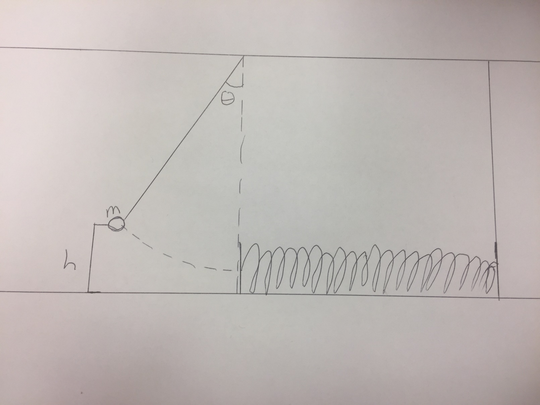
A system is set up as shown above. The pendulum that has mass m attached to it is elevated from equilibrium by an angle $θ$ to a height h. A relaxed spring with spring constant k is placed at the pendulum’s equilibrium point.
- If the mass is released from height h, how far will the spring be compressed? Express your answer in terms of known variables and universal constants

- What is the maximum velocity that the pendulum can reach? At what position is this? Explain why you think this is the correct position.

- From when the mass contacts the spring to the point when the spring is fully compressed, what is the average acceleration experienced by the mass?

- What is the force exerted on the mass by the spring when the spring is fully compressed?

- From your answer in d, what is therefore the acceleration on the pendulum’s mass caused by the spring AT the point where the spring is fully compressed?

- Compare your answers for parts c and e. Do your answers make sense? Explain your answer.

