LAMP Project
Senior AP PHysics 1: Current and Electricity: 15 day unit
Kristian Stephens
[Year]
2. Table of Contents
1. Title Page
2. Table of Contents
3. Purpose of the Unit
4. Specific Skill Objectives
5. Vocabulary List
6. Timeline or Outline
7. Resources
8. Letter to the Parents
9. Display Area and/or Bulletin Board
10. Student Project and Rubric
11. Technology
12. Detailed Lesson Plans
13. Differentiation and/or Accommodations
14. Authentic Real-life Application
15. Pre and Post-Tests
16. Pre and Post-test Graphs
17. Narrative and Reflection.

3. Purpose of the Unit:
One of the main concepts that students believe they have a fair bit of experience with before starting the unit is electricity. Since they use it in their daily lives they tend to believe they have a fairly good handle on it. However as most academic literature will tell you, there are few units with as many preconceptions held at the beginning as there are in electricity. In this unit I strive to break the general misconceptions held by students over the following standards. LO 5.B.9.1-3, LO 5.C.3.1-3,
4. Specific Skill Objectives:
Content Objective: Student can evaluate potential difference across a resistor in series and/or in parallel
AP Standard: AP Big Idea 5B
Indicator: LO 5.B.9.3
The student is able to apply conservation of energy (Kirchhoff’s loop rule) in calculations involving the total electric potential difference for complete loops with only a single batter and resistors in series and/or in, at most, one parallel branch
How will the skill be assessed?
Pre and Post-testing, homework problems, lab assessments
Content Objective: Students can determine how the current of a circuit changes between 2 resistors in series compared to two resistors in parallel
AP Standard: AP Big Idea 5C
Indicator: LO 5.C.3.3
The student is able to use a description or schematic diagram of an electrical circuit to calculate unknown values of current in various segments or branches of the circuit.
How this objective will be addressed:
Pre and Post-testing, homework assessments, lab assessments.

5. Vocabulary List:
Circuit: A continuous conducting path that is connected between the terminals of a battery
Electric Current: Any flow of charge
Ampere: The unit for current defined as C/s.
Open Circuit: When a circuit path has a break so that the path is no longer continuous
Closed Circuit: A continuous circuit path in which a current can flow
Ohm’s Law: Defined simply as V = IR where V is the potential difference, I is the current, and R is the resistance of either the circuit or the component being evaluated
Resistance: A quality of any given electrical component in which the electrons progress is impeded by atomic collisions measured in Ohms
Resistor: An electrical component specifically designed to cause resistance in the circuit
Potential/Voltage Drop: The decrease in total potential difference that occurs when electricity passes through an electrical component.
Resistivity: A quality defined in wires that is a material property of the wire. The resistance is directly proportional to the resistivity
Electrical Power: The rate at which energy is used in an electrical circuit. Defined as J/s also known as Watts.
Series: When two or more electrical components are connected end to end on a branch of a circuit, they are said to be connected in series
Parallel: When the electricity from a battery can be split into multiple different paths in which difference electrical components reside, the electrical components are said to be in parallel
Kirchhoff’s Rules: The set of rules that all circuits must obey which contains both the Loop Rule and the Junction Rule
Loop Rule: The sum of the changes in potential difference within a loop of a circuit must be zero
Junction Rule: The current into any given junction must equal the sum of the currents out of that junction and vice versa
6. Timeline or Outline:
Day 0: Pre-assessment given at the end of day of the previous unit.
Day 1: Introductory lesson using the analogy of water flowing down a mountain to open the students up to the ideas of potential difference, resistance, and current. Discussed the very beginnings of batteries and students built voltaic piles.
Day 2-4: Resistivity inquiry lab. This lab uses some concepts such as resistance from the first lesson. At the end of day 4 we discussed results and the lab report that was to be turned in.
Day 5: Circuit Inquiry Simulation Activity. Students used a computer simulation to play around with different configurations of lightbulbs in a single battery circuit. There were inquiry elements involved in this simulation as well as guided elements. This was to help the students gain some instinct when it comes to the arrangements of resistors in a circuit.
Day 6-7,8: Resistor Inquiry Lab with practice. Students were tasked with determining how resistors combine in series and parallel using only resistors and a multimeter. At the end of the second day of this lab when students inevitably get stuck we then got into direct notes about resistors and Ohm’s Law. 8) Review from the previous days by using practice problems to enforce concepts learned through direct instruction and through the labs.
Day 9: Review of how problems were solved previously. Students were then given direct instruction on Kirchhoff’s Loop Rules and how to use them to solve complicated circuit problems
Day 10-12: Students were given circuit kits and asked to build several types of circuits involving bulbs and asked to make observations. They were asked to create a schematic from a real life circuit and asked to create a circuit from a schematic. They were then asked to compose their own circuit. Through their observations, students were able to draw some conceptual understanding about the notion of power. Students were then given direct instruction about power, reviewing concepts they had observed in the last period.
Day 13: Students were given practice problems to work on dealing with power as well as reviewing the other concepts covered in the unit such as finding current, potential difference, and resistance.
Day 14: Overall review/practice day. Students were told to bring in questions they had about the unit. Students also worked on some more practice problems
Day 15: Post Assessment given. Due to ISTEP we only had time for the post assessment that day.

7. Resources:
Teacher Resources:
- D. Giancolli; Physics: Principles with Application AP 7th Edition. Chapters 18-19
- Circuit Building Simulation Found at http://www.physicsclassroom.com/Physics-Interactives/Electric-Circuits/Circuit-Builder/Circuit-Builder-Interactive
Student Resources:
- D. Giancolli; Physics: Principles with Application AP 7th Edition. Chapters 18-19
- Circuit Building Simulation Found at http://www.physicsclassroom.com/Physics-Interactives/Electric-Circuits/Circuit-Builder/Circuit-Builder-Interactive
8. Letter To Students and Parents:
Dear Students and Guardians,
In this coming unit we will be covering electrodynamics or, more simply, electricity in motion. I am very excited for this unit because it will be taking us through some of the most challenging yet rewarding content we have covered thus far in our class. We will be covering what it means for electrons to be moving through a circuit, what is required for a circuit to actually work, and actually create circuits of our own. We will be learning to find various quantities within circuits such as resistance, current, and voltage. The great part about this unit is that we will have a ton of labs and activities. We will be doing several labs in which we will be testing the resistance and resistivity of wires, forming rules for circuit building, and actually deriving mathematical expressions from the data we find. This whole unit will be culminating into a project on electrical power in the household. The students will be creating an energy pamphlet in which they find and calculate the power usage of various items in your household and also find how much money each appliance is costing you per month. They will create the pamphlet from the standpoint of a person trying to spread information about energy consumption. This unit is going to be very work intensive as well so here are some things that you, the guardian, can do to help your student, and you , the student, can do to help yourself. Make sure that you are keeping up with the readings. The readings for this unit are out of chapters 18 and 19 in Giancoli. Also, stay ahead on your work. This unit will require a lot of lab work and therefore there will be a few write-ups involved in the course of this unit. There will also be several homework assignments so it is imperative that you keep up with your homework as you go. Guardians a simple reminder here and there to see if your student is keeping up on the reading and homework assignments would do wonders because I know how incredibly easy it is to forget about small things like that. I would be happy to answer any questions that you may have concerning this unit or anything else in the classroom that may pop up. It has been a great joy to teach your students up to this point and I can’t wait to continue to move forward.
Sincerely
Kristian Stephens
9. Display Area and/or Bulletin Board
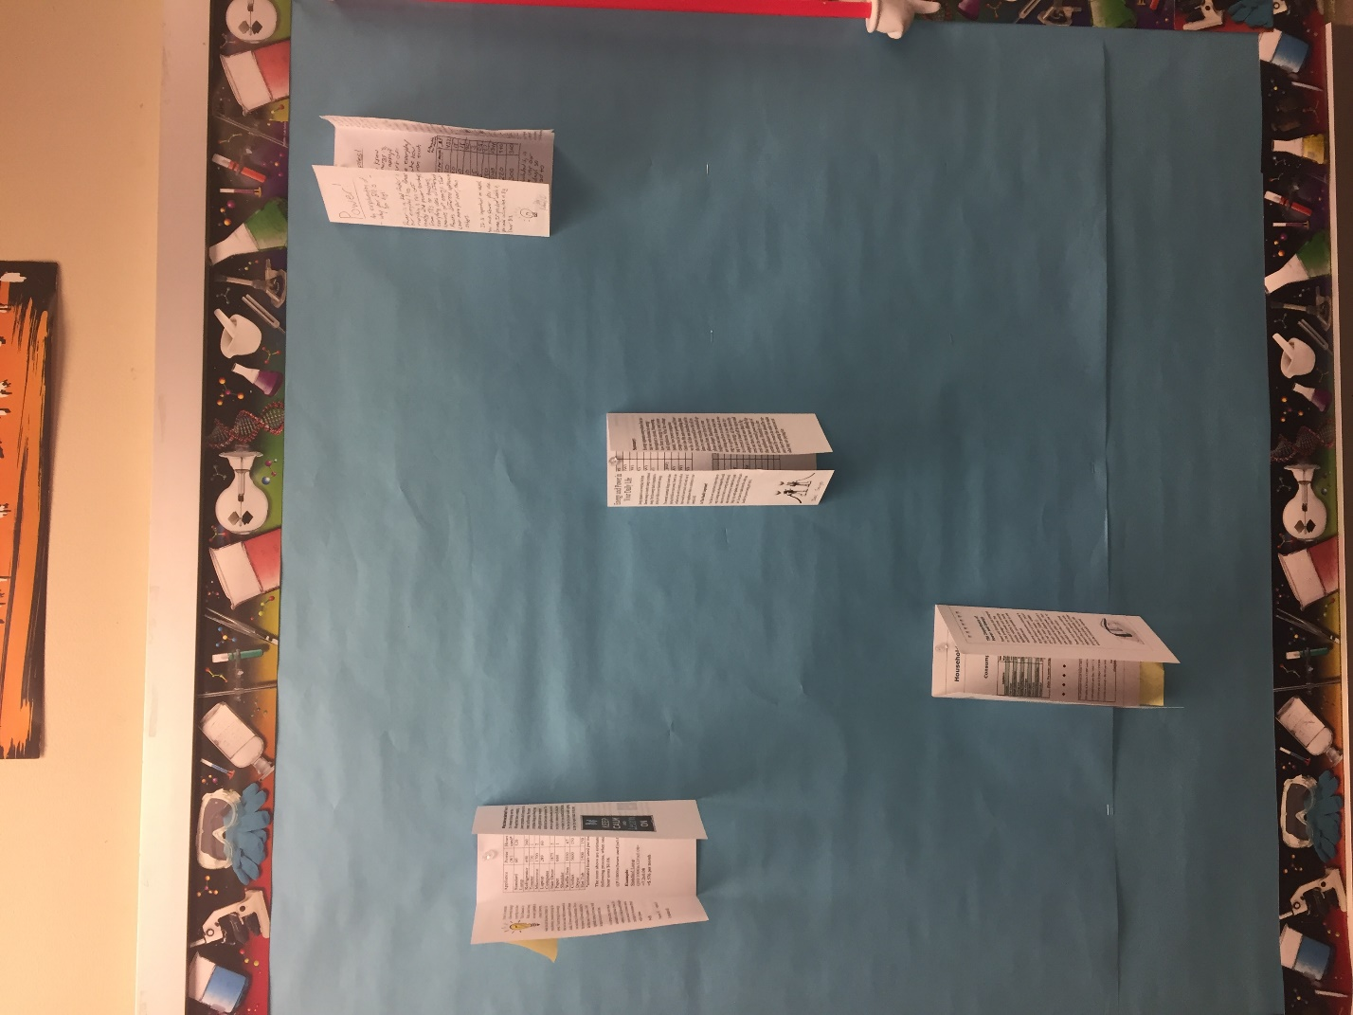
This display board was not created for my AP students in this unit but rather BY them using the projects they created in order to show the rest of the classes what they had been working on.
10. Student Project and Rubric:
Below I am inserting the project description that I gave my students and then the rubric in which I graded their projects off of.
In our everyday lives we consume power and energy. I’m sure you’ve heard more than once from your guardian, “Do you want to pay for electricity? No? Then turn off the lights when you walk out of your room.” This was a statement that I at least heard all throughout childhood. This left me wondering just how much energy does it take to run a light bulb for a month? What about the microwave? Toaster? Hair Dryer? This is the main questions that you’ll be answering for this assignment.
For this assignment, you will be creating a three-fold informational pamphlet. The pamphlet should contain:
- 6 total pages of information
- The first page should be an introduction to power and energy and where they appear in our everyday lives. Why is it important for us to care about this subject? The front page should always be an attention getter
- Pages 2-4 should contain the more technical “dry” stuff. Here explain how power and energy are rated (such as Watts and kW*hr) and what do those things actually mean?
- Explain how power is calculated in a simple circuit.
- Now for the meat and potatoes of this project. You are to choose ten or more household objects that use electricity. Find what they are rated in in watts. Then estimate how much time each object is used per month. Using these quantities, calculate how much energy each object consumes per month. This should include:
  - A table compiling all the data
  - A sample calculation of one of the objects to show the reader that the way you came up with the estimate is legitimate.
- Unless you somehow already know, in order to calculate power consumption you will have to research what the local power company charges per kW*hr. Your guardian may know this but more than likely you’ll need to find this one through research.
- You should interpret the data for the consumer. What do all of these numbers mean? What are some objects that maybe take more energy than most people (aka you) would expect?
- 5th page should be the conclusion to the project. Bring everything that you’ve been talking about together and wrap it up nicely with a bow.
- 6th page should include any references that you used to find any information for this project in general. You should have at least 2 resources that you used because I’m sure you’ll have difficulty in find the power rating for some of the objects that you choose.
- You may include pictures on every page if you wish with the exception of the data page which should already include the data table.

This project is worth 40 points in total
- 5 points for writing mechanics. Spelling, capitalization, punctuation, and sentence structure are all fair game.
- 5 points for design: Fairly simple, I don’t want this to be all boring text for 6 pages. Make it look cool, exciting, or interesting and these points will be easy to get.
- 5 points for the data table: The data table should be useful and easy to read. Make sure your data is organized in an easy to read fashion. Also, label your table with a caption. This table should be referenced in the text at some point.
- 20 points for accurate content: Your statements are all backed up by good science. All of your calculations are accurate and your train of thought is logical. This part is for overall accuracy within your project. This is the part I will be grading the hardest and therefore these will be the hardest points to come by. Triple check your facts and your calculations and you should be just fine
- 5 points for the conclusion: Wrap it up nicely with a bow. Bring all the facts that you gathered together just like you would do in a lab report. The conclusion should be comprehensive so it should span all of the content covered. How does everything relate?
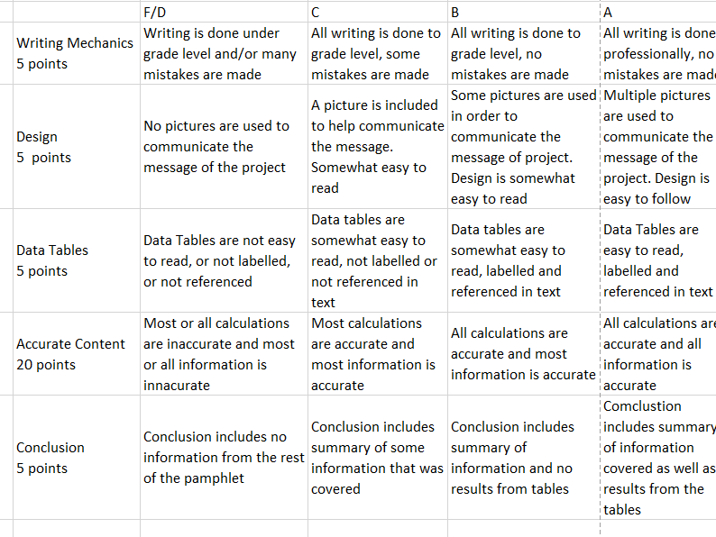

11. Technology:
In this unit we used the IPads in which our school is actually one-to-one. The IPads were used to take data in labs, graph the data that was taken, run calculations, and was used in one of the assignments to actually run a computer simulation. Students had the choice of turning in almost every assignment either through canvas or on paper.
12. Detailed Lesson Plans:
Electrical Currents Intro Lesson Plan
Kristian Stephens
Key Concept: Basics of Electricity/ Intro to Batteries
Standards: LO 5.B.9.1-3, LO5.C.3.1-3
Objective: Students will create voltaic piles to create an understanding of the basics of batteries
Essential Question: Why can a potato light a light bulb?

Engage: The lesson begins with a conversation about what students know about electricity in general. After some understanding of preconceptions is gained, I will use an analogy of water flowing down a mountain in order to give some physical meaning to the terms potential difference, current, and resistance in the context of a circuit. We then begin a discussion of batteries and how they came about. Particularly our focus is drawn to Volta and his pile that he created using zinc, copper, and a conductive fluid

Explore: Students were tasked to work in groups and try to create the most powerful voltaic possible given pennies, zinc disks, cereal boxes, and salt solution. They are also given multimeters to test the potential created by their batteries.

Teacher Support: In this portion I essentially aided them in troubleshooting their setups if something was going wrong, as well as providing feedback on ideas they were generating.

Explain: After students finished we debriefed about what they saw and why we don’t see this type of pile used as battery in the present

Extend: This activity was an intro activity and so students were not asked to extend anything from this lesson other than carrying some of the concepts we learned over into the following units.
Differentiation Considerations:
Students will be broken up into purposeful groups

Resistor Inquiry Lab
Kristian Stephens

Key Concept: That no wire is perfectly conductive
Standards: LO 5.B.9.1-3, LO5.C.3.1-3
Objective: Students will attempt to determine how resistors combine in series and parallel
Essential Question: How do resistors combine in different configurations?

Engage: I start the lesson by showing students what a physical resistor looks like and explaining how their colored bands are an indicator for their resistance. I then pose the question to the students “How do you believe these combine when they are place in series or in parallel?”

Explore: Students are tasked with determining the mathematical relationship of resistors combining in series and in parallel using nothing more than a few resistors and a multimeter. They are broken up into groups of three where they will attempt to solve the problem at hand.

Teacher Support: This lab is much more of an inquiry lab so students tend to have a lot of questions involving techniques for setting up and testing that I will assist with. Also any technical difficulties that they experience I will attempt to help with.

Explain: After students inevitably throw in the towel (they usually find the series combination easily but almost never find the parallel combination), we dive into the directed notes in which we discuss their findings, what they theorize the equations are, and what the equations actually are. This also leads to a more comprehensive conversation about Ohm’s law and how to solve simple circuit problems. We then work on a couple of practice problems in order to give students more of an idea of how to solve simple problems.

Extend: Students are required to generate a formal lab report for this lab which requires a lot of reflective thought and application of interdisciplinary skill in order to effectively write the lab report. We also will practice these concepts for another day before moving on

Teacher Support: I was able to assist wherever necessary with calculation issues as well as general questions about the write up

Differentiation Considerations:
Students will be broken up into purposeful groups
Students could turn reports in either online or on paper

Circuit Inquiry Simulation LP
Kristian Stephens
Key Concept: Bulbs in parallel and series will light differently
Standards: LO 5.B.9.1-3, LO5.C.3.1-3
Objective: Students will be able to qualitatively define the effects of placing bulbs in parallel and series
Essential Question: What is the difference between two bulbs in series and two bulbs in parallel?

Sub Plan: This was a student driven activity due to the fact that I was gone for Marzano training this day. Students were asked to make predictions about various configurations of bulbs and then to test their predictions on a computer simulations. They were also asked what their conceptions of parallel and series circuits were. These preconceptions were either confirmed or corrected through the process of this activity. The students had a worksheet to complete which guided them through their activity. I was available through email should any questions arise.
Differentiation Considerations:
Students could turn assignments in either online or on paper

Resistor Inquiry Lab
Kristian Stephens
Key Concept: Resistors combine differently in series and in parallel
Standards: LO 5.B.9.1-3, LO5.C.3.1-3
Objective: Students will attempt to determine how resistors combine in series and parallel
Essential Question: How do resistors combine in different configurations?

Engage: I start the lesson by showing students what a physical resistor looks like and explaining how their colored bands are an indicator for their resistance. I then pose the question to the students “How do you believe these combine when they are place in series or in parallel?”

Explore: Students are tasked with determining the mathematical relationship of resistors combining in series and in parallel using nothing more than a few resistors and a multimeter. They are broken up into groups of three where they will attempt to solve the problem at hand.

Teacher Support: This lab is much more of an inquiry lab so students tend to have a lot of questions involving techniques for setting up and testing that I will assist with. Also any technical difficulties that they experience I will attempt to help with.

Explain: After students inevitably throw in the towel (they usually find the series combination easily but almost never find the parallel combination), we dive into the directed notes in which we discuss their findings, what they theorize the equations are, and what the equations actually are. This also leads to a more comprehensive conversation about Ohm’s law and how to solve simple circuit problems. We then work on a couple of practice problems in order to give students more of an idea of how to solve simple problems.

Extend: Students are required to generate a formal lab report for this lab which requires a lot of reflective thought and application of interdisciplinary skill in order to effectively write the lab report. We also will practice these concepts for another day before moving on

Teacher Support: I was able to assist wherever necessary with calculation issues as well as general questions about the write up

Differentiation Considerations:
Students will be broken up into purposeful groups
Students could turn reports in either online or on paper

Kirchhoff’s Loop Rules
Kristian Stephens
Key Concept: Kirchhoff’s Loop Rules in Application
Standards: LO 5.B.9.1-3, LO5.C.3.1-3
Objective: Students will be able to analyze complicated circuits using Kirchhoff’s Loop Rules
Essential Question: How do we solve a complicated circuit where our previous methods fail?

Engage: Students are shown a picture of a complicated circuit and asked how they would try and analyze that circuit using methods we had used previously

Explore: Students break into table groups and attempt to devise a plan for solving the problem at hand.

Explain: After ideas are discussed, direct instruction is given over Kirchhoff’s loop rules and how said rules can be used when solving more complicated circuit systems.

Extend: Students are given an assignment where they are asked to apply the concepts we’ve learned over the past few days to solve 4 circuits requiring multiple steps of analysis.

Teacher Support: I am available for assistance on circuit analysis whenever needed

Differentiation Considerations:
Students will be broken up into purposeful groups
Students could turn reports in either online or on paper

Circuit Exploration Lab and Power Notes LP
Kristian Stephens
Key Concept: Power changes depending on the circuit configuration
Standards: LO 5.B.9.1-3, LO5.C.3.1-3
Objective: Students will experiment with a circuit kit in order to gain some conceptual understanding of power

Essential Question: How does the brightness of a lightbulb change as the configuration of the circuit changes?

Engage: Students are shown the several components of a circuit kit in order to familiarize students with what will be made available to them.

Explore: Students are given a handout in order to help guide their exploration with the circuit kits. They are asked to create real life circuits from schematics and vice versa. They are also asked to make circuits of their own and make predictions about them. They will be asked to make observations about what they believe power is in the circuit

Teacher Support:
I was actually not here for the lab portion of this lesson. However Dustan was available for any questions and technical support. He also walked around and asked questions that sparked critical thinking

Explain: After the lab has been completed, there will be direct instruction on Power covering the observations that students made in their lab activity. They will be asked to derive the equations of power through unit analysis.

Extend: Students are given the Power Pamphlet assignment after this lesson and thus will be working to use the concepts covered to finish their project

Teacher Support: I am available for clarifications on the project as well as guidance.

Differentiation Considerations:
Students will be broken up into purposeful groups
Students could turn projects in either online or on paper

Review/Practice Days
Kristian Stephens
Key Concept: Practice is essential for students to gain understanding of the concepts covered in this unit
Standards: LO 5.B.9.1-3, LO5.C.3.1-3
Objective: Students will be able to analyze a circuit schematics for power, current, potential difference across multiple different branches of a circuit

Essential Question: What is a type of question you want more practice with or have questions about?

Plan for the day: This is a practice/review day. Students are asked to bring in a question or two for me to answer and hopefully clear up some conceptual confusions. After that is done we then use the rest of the time over the next two days to practice various types of problems from the unit. Some of the questions are worked by me at the board to help them gain some insight into how I go about solving more complicated problems. Some problems are solved in groups so that they can work collaboratively, and then some problems are solved individually and then presented. This gives a variety of the students to take in order to better understand how to solve problems from this unit.

13. Differentiation and/or Accommodation:
This particular class has only six students and none of them required any accommodations. However any assignment that was turned in could be turned in through both canvas or on paper depending on student preference. However since this was a very lab heavy unit there wasn’t much student choice that could be made in the production of presentables. In the unit ending project I tried to create some more space for creativity with the pamphlet but I had some specific requirements for the various pages.
14. Authentic Real-life Application:
In any unit I teach I always try to provide some real-life application that they can take home with them and use in their everyday life. Even if that knowledge is just a small snippet of something. In this particular unit the entire project was actually based around the real life application of calculating energy costs in their own homes. Also they learned the fundamentals of reading wiring diagrams which can help them in home improvement scenarios. This unit actually has more real-life application than most units for AP Physics.

15. Pre and Post-Test:
Student Copy: The test was delivered electronically so answer possibilities were randomized on actual student copies.
Question 1 1 pts
Are charges used up in a light bulb, being converted to light?
No, charge is conserved. Charges moving through the filament produce "friction" which heats up the filament and produces light.
No, charge is conserved. It is simply converted to another form such as heat and light

Yes, charges moving through the filament produce "friction" which heats up the filament and produces light
Yes, charges are emitted

Flag this Question
Question 2 1 pts
How does the power delivered in resistor A change when resistor B is added as shown in circuits 1 and 2 respectively?
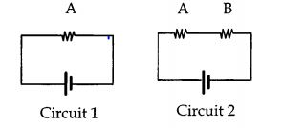
Decreases
Increases

Stays the same

Flag this Question
Question 3 1 pts
Consider the following circuits shown below. Which circuit or circuits have the greatest energy delivered to it per second.
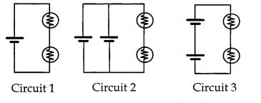
Circuit 3
Circuit 2

Circuit 2 = Circuit 3
Circuit 1 = Circuit 2

Circuit 1

Flag this Question
Question 4 1 pts
Consider the following circuits. Which circuit(s) above represent(s) a circuit consisting of two light bulbs in parallel with a battery?
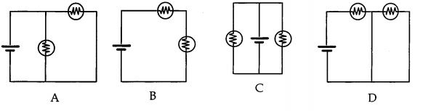
A and C
B

A
C

A, C, and D

Flag this Question
Question 5 1 pts
Compare the resistance of branch 1 with that of Branch 2. A branch is a section of a circuit. Which has the least resistance?
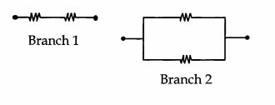
Branch 2
Branch 1

Neither, they are the same

Flag this Question
Question 6 1 pts
Rank the potential difference between points 1 and 2, points 3 and 4, and points 4 and 5 in the circuit shown below from highest to lowest
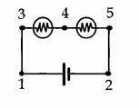
1 and 2; 3 and 4 = 4 and 5
1 and 2; 4 and 5; 3 and 4

1 and 2; 3 and 4; 4 and 5
3 and 4; 4 and 5; 1 and 2

3 and 4 = 4 and 5; 1 and 2

Flag this Question
Question 7 1 pts
Compare the brightness of the bulb in circuit 1 with that in circuit 2. which bulb is brighter?
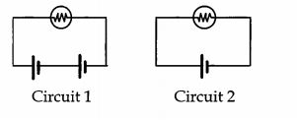
Bulb in Circuit 1
Bulb in circuit 2

Neither, They are the same

Flag this Question
Question 8 1 pts
Compare the current at point 1 with the current at point 2. Which point has the larger current?
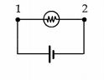
Neither, they are the same
Point 1

Point 2

Flag this Question
Question 9 1 pts
Which circuit(s) will light the bulb?
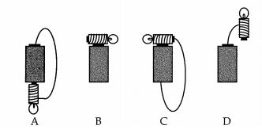
A and C
C

A
D

B and D

Flag this Question
Question 10 1 pts
Compare the brightness of bulbs A and B in circuit 1 with the brightness of bulb C in circuit 2. Which bulb or bulbs are the brightest?
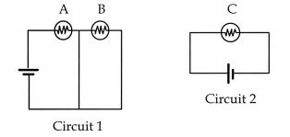
A = C
B

A
C

A = B

Flag this Question
Question 11 1 pts
Why do the lights in your home come on almost instantaneously?
Charges are already in the wire. When the circuit is completed, there is a rapid rearrangement of surface charges in the circuit.
Charges store energy. When the circuit is completed, the energy is released

Charges in the wire travel very fast
The circuits in a home are wired in parallel. Thus, a current is already flowing

Flag this Question
Question 12 1 pts
Consider the power delivered to each of the resistors shown in the circuits below. Which circuit or circuits have the least power delivered to it?
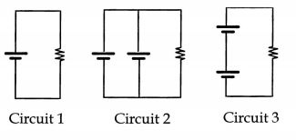
Circuit 1 = Circuit 2
Circuit 1

Circuit 2
Circuit 3

Circuit 1 = Circuit 3

Flag this Question
Question 13 1 pts
Which schematic diagram best represents the realistic circuit below?
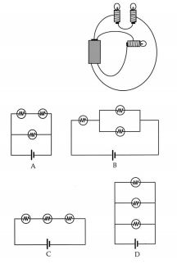
A
B

C
D

None of the above

Flag this Question
Question 14 1 pts
How does the resistance between the endpoints change when the switch is closed?
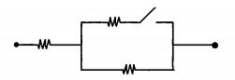
Decreases
Increases

Stays the Same

Flag this Question
Question 15 1 pts
What happens to the potential difference between points 1 and 2 if bulb A is removed?
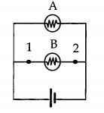
Stays the same
Increases

Decreases

Flag this Question
Question 16 1 pts
Rank the currents at points 1,2,3,4,5, and 6 from highest to lowest
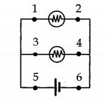
5=6, 1=2=3=4
5=6, 3=4, 1=2

1=2=3=4=5=6
5, 3, 1, 4, 2, 6

5, 1, 3, 2, 4, 6

Teacher Copy: Answers Highlighted
Question 1 1 pts LO 5.B.9.3
Are charges used up in a light bulb, being converted to light?
No, charge is conserved. Charges moving through the filament produce "friction" which heats up the filament and produces light.
No, charge is conserved. It is simply converted to another form such as heat and light

Yes, charges moving through the filament produce "friction" which heats up the filament and produces light
Yes, charges are emitted

Flag this Question
Question 2 1 pts LO 5.C.3.3
How does the power delivered in resistor A change when resistor B is added as shown in circuits 1 and 2 respectively?
Decreases
Increases

Stays the same

Flag this Question
Question 3 1 pts LO 5.C.3.1, LO 5.C.3.3
Consider the following circuits shown below. Which circuit or circuits have the greatest energy delivered to it per second.
Circuit 3
Circuit 2

Circuit 2 = Circuit 3
Circuit 1 = Circuit 2

Circuit 1

Flag this Question
Question 4 1 pts LO 5.C.3.1-3
Consider the following circuits. Which circuit(s) above represent(s) a circuit consisting of two light bulbs in parallel with a battery?
A and C
B

A
C

A, C, and D

Flag this Question
Question 5 1 pts LO 5.C.3.1
Compare the resistance of branch 1 with that of Branch 2. A branch is a section of a circuit. Which has the least resistance?
Branch 2
Branch 1

Neither, they are the same

Flag this Question
Question 6 1 pts LO 5.B.9.2-3
Rank the potential difference between points 1 and 2, points 3 and 4, and points 4 and 5 in the circuit shown below from highest to lowest
1 and 2; 3 and 4 = 4 and 5
1 and 2; 4 and 5; 3 and 4

1 and 2; 3 and 4; 4 and 5
3 and 4; 4 and 5; 1 and 2

3 and 4 = 4 and 5; 1 and 2

Flag this Question
Question 7 1 pts LO 5.C.3.1
Compare the brightness of the bulb in circuit 1 with that in circuit 2. which bulb is brighter?
Bulb in Circuit 1
Bulb in circuit 2

Neither, They are the same

Flag this Question
Question 8 1 pts LO 5.C.3.3
Compare the current at point 1 with the current at point 2. Which point has the larger current?
Neither, they are the same
Point 1

Point 2

Flag this Question
Question 9 1 pts
Which circuit(s) will light the bulb?
A and C
C

A
D

B and D

Flag this Question
Question 10 1 pts LO 5.B.9.2-3 5.C.3.2-3
Compare the brightness of bulbs A and B in circuit 1 with the brightness of bulb C in circuit 2. Which bulb or bulbs are the brightest?
A = C
B

A
C

A = B

Flag this Question
Question 11 1 pts
Why do the lights in your home come on almost instantaneously?
Charges are already in the wire. When the circuit is completed, there is a rapid rearrangement of surface charges in the circuit.
Charges store energy. When the circuit is completed, the energy is released

Charges in the wire travel very fast
The circuits in a home are wired in parallel. Thus, a current is already flowing

Flag this Question
Question 12 1 pts LO 5.B.9.2-3
Consider the power delivered to each of the resistors shown in the circuits below. Which circuit or circuits have the least power delivered to it?
Circuit 1 = Circuit 2
Circuit 1

Circuit 2
Circuit 3

Circuit 1 = Circuit 3

Flag this Question
Question 13 1 pts
Which schematic diagram best represents the realistic circuit below?
A
B

C
D

None of the above

Flag this Question
Question 14 1 pts LO 5.C.3.1
How does the resistance between the endpoints change when the switch is closed?
Decreases
Increases

Stays the Same

Flag this Question
Question 15 1 pts LO 5.B.9.3
What happens to the potential difference between points 1 and 2 if bulb A is removed?
Stays the same
Increases

Decreases

Flag this Question
Question 16 1 pts LO 5.C.3.3
Rank the currents at points 1,2,3,4,5, and 6 from highest to lowest
5=6, 1=2=3=4
5=6, 3=4, 1=2

1=2=3=4=5=6
5, 3, 1, 4, 2, 6

5, 1, 3, 2, 4, 6

16: Pre/Post-Test Graphs:
Pretest
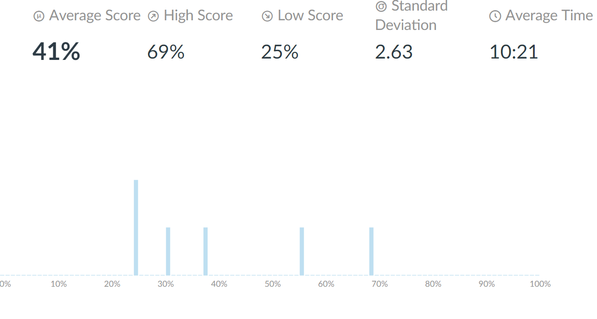
Post Test
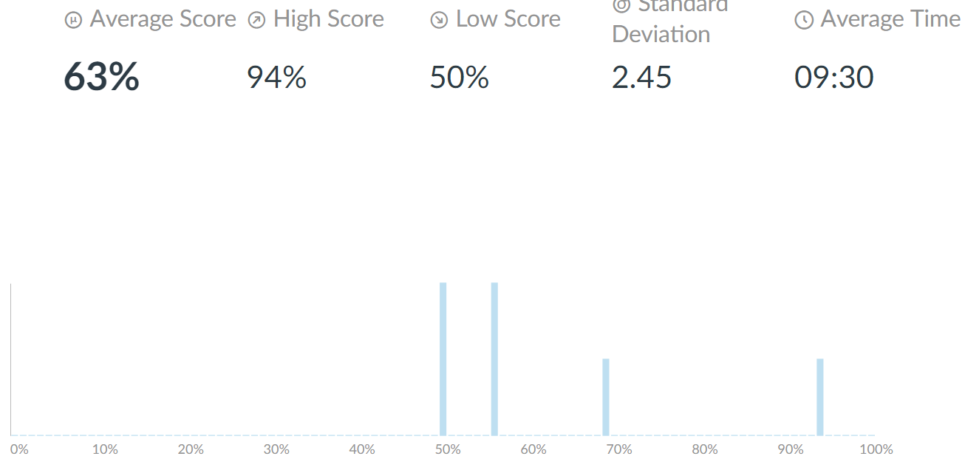
17. Narrative Statements and Reflection Questions:
- Unit Narratives
- List of content standards addressed in the unit
- Big Idea 5 (LO 5.B.9.1-3, LO 5.C.3.1-3)
- List of ancillary standards addressed
- None
- Brief Narrative addressing students of different abilities
- I generated several different types of assignments for students of different learning styles including, but not limited to: labs, standard homework, and a creative project
- For students who would possibly have issues with either pencil and paper homework or electronic homework, the option was given to submit either electronically or via paper.
- Brief narrative explaining what authentic (real-life) critical thinking and/or problem-solving skills students are developing through your unit.
- Physics is all about gaining those problem solving skills that are necessary for the real world. While students may not ever use the math again outside of the classroom, they will surely take the critical thinking skills they develop in the classroom out into the real world.
- All topics in the unit are connected to real life scenarios so that students can gain some application from the theoretical content they are learning
- The project is centered around a real life situation that involves the topics from the unit.
- Brief bullets listing different instruction strategies used in the unit
- Lecture/Discussion Notes
- Labs
- Class discussion
- Simulations
- Visual Representations
- Brief narrative describing technologies/media integrated in the unit
- In this unit we used the IPads in which our school is actually one-to-one. The IPads were used to take data in labs, graph the data that was taken, run calculations, and was used in one of the assignments to actually run a computer simulation. Students had the choice of turning in almost every assignment either through canvas or on paper.
- Assessment Narratives
- Brief narrative explaining any accommodations you made for differing needs of the students in your assessment
- No accommodations needed
- Project/Rubric Narrative
- I generated a rubric for use on this project covering power consumption in the household. Students were given a breakdown of points before the project however they were not given the full rubric. I outlined the project for them and gave them the assignment description. They were to create a six page pamphlet over power consumption in the household. They were given 3 school days (including the weekend) to complete the assignment which they then turned in. All students completed their projects and honestly exceeded my expectations.
- Evaluation of Student Learning Narratives
- Brief narrative explaining, based on the graph information, how students performed collectively and individually on the pretest
- As shown in the pre-assessment graph, students severely struggled around the misconceptions that they brought in. A score of 9/16 was the highest for the pretest and a score of 4/16 was the lowest. Students significantly struggled with the concepts of changes of resistance and their influence on current and power.
- Brief narrative explaining, based on the graph information, how students performed collectively and individually on the post-test?
- As can be seen from the post test graph, all students showed significant growth. The lowest student went from a 4/16 to a 8/16, and the highest student missed one question overall. Every student showed improvement and the class improved overall with the average moving from a 41% to a 63%
- Brief narrative explaining, based on graph and performance information, the strengths and weaknesses of instructional approaches used during the unit.
- Overall I wish I would’ve had more time in this unit. This is a tough unit because there are so many misconceptions to tackle that if not given enough time and attention, you will surely miss some. Students struggled overall with understanding how current flows through a circuit and part of that was because I asked them to start solving too hard of a problem too quickly. This led to a lot of confusion that ended up being a road block to them truly learning. Next time I would be much more careful with my scaffolding of topics and make sure that my students mastered the base level content before trying to combine it all together and into more complex series.

