Name:___________________________ Enzyme Quick Quiz

- A metalloenzyme is an enzyme which...
  - breaks down metal
  - is made of only metal atoms
  - has a metallic shine when viewed under a magnifying glass
  - has a metal atom incorporated into the enzyme

- On the graph below, which curve represents the enzyme-catalyzed reaction?

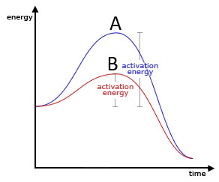
a. Curve A
b. Curve B

- Which most accurately describes an enzyme-catalyzed reaction?
  - substrate + enzyme → enzyme-substrate complex → product
  - substrate + enzyme → enzyme-product complex → product
  - substrate + enzyme → magic explosion → product
  - subtraction + enzyme → confusion → enzyme-product

- Which is NOT a factor that affects the rate of an enzyme-catalyzed reaction?
  - pH
  - Temperature
  - Color of your socks

- An enzyme always breaks down molecules.
  - True
  - False

Name:___________________________ Enzyme Quick Quiz

- A metalloenzyme is an enzyme which...
  - breaks down metal
  - is made of only metal atoms
  - has a metallic shine when viewed under a magnifying glass
  - has a metal atom incorporated into the enzyme

- On the graph below, which curve represents the enzyme-catalyzed reaction?

a. Curve A
b. Curve B

- Which most accurately describes an enzyme-catalyzed reaction?
  - substrate + enzyme → enzyme-substrate complex → product
  - substrate + enzyme → enzyme-product complex → product
  - substrate + enzyme → magic explosion → product
  - subtraction + enzyme → confusion → enzyme-product

- Which is NOT a factor that affects the rate of an enzyme-catalyzed reaction?
  - pH
  - Temperature
  - Color of your socks

- An enzyme always breaks down molecules.
  - True
  - False

