NASA Fuel Systems Testing
Apollo 2016

This notebook belongs to:_________________________

Team name:____________________________________

Background info:
Today you’ve got a big problem. You’re on the fuel systems engineering team for NASA’s Apollo 2016 Lunar Mission, and launch day is tomorrow. Everything is ready to go, but you’ve just found out that due to an incoming storm, you have to get the rocket off the ground as fast as possible (while still maintaining a controlled launch, of course). You can’t change your fuel source because you already have that on site, but you can change anything else about the fuel system. Brainstorm with your group about things you might be able to change, then test your ideas!

Your Mission:
Change something about the rocket’s fuel system to make it blast off faster, test it to be sure that it works!

Brainstorm:
Use this space to brainstorm with your team about things you might change in your fuel system.

What did you decide to change? How will you change it?

Hypothesis:
Write your hypotheses - Why do you think your change will result in a faster launch?

Data Design:
1. How many times will you test your launch?

2. What variables will you measure?

3. What variables will you change?

4. What variables will you keep the same?

Experiment Design:
Sketch a picture of your test set-up:

Data Collection:
Use this table to collect your data.
In the first row, describe EXACTLY what you will be changing about your fuel system for each test. Record your results using the correct units of measurement. There are probably more rows and columns than you need, you don’t need to fill them all in.

Describe your tests here →
Trial 1
Trial 2
Trial 3
Trial 4
Trial 5

Observations:
Use this space to note any patterns you see in your data. Will your change to the fuel system make the rocket blast off faster or slower?

Graphing your data:
You need to convince your supervisors that your solution will work, and the best way to do that is with a graph. Fill in this blank one with your data so that you can show people that your hard work is paying off!
Be sure that you label your x- and y-axes, and that you give your graph a name on the “Title” line!

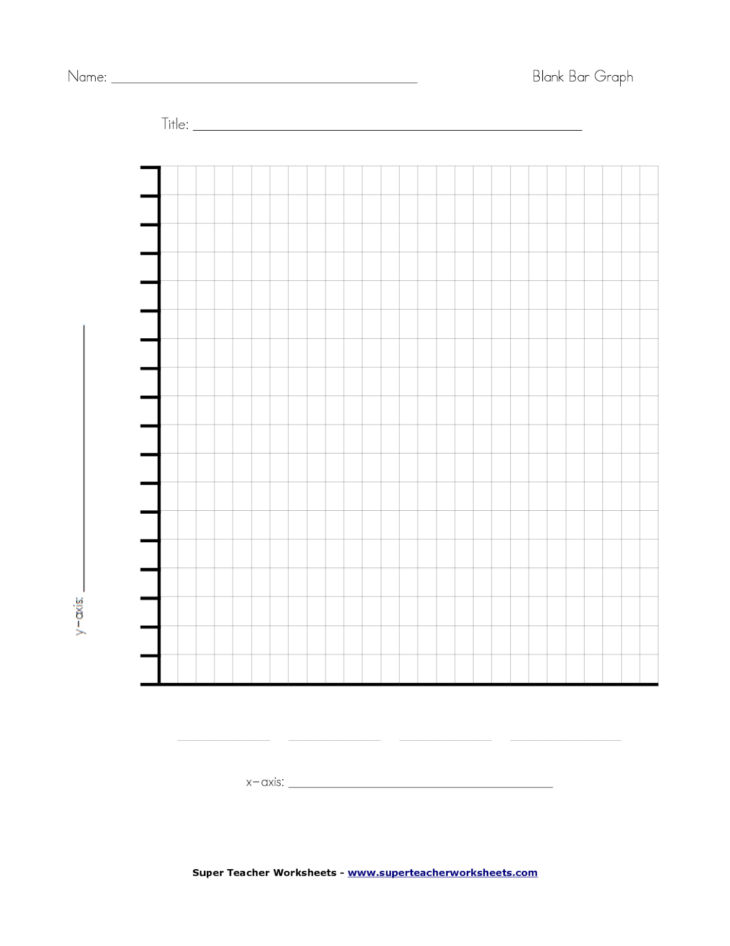

DON’T DO THIS PART UNTIL AFTER DISCUSSION!!
Scientific explanation:
After talking with your team mates, why do you think the changes you made to your fuel system worked or didn’t work? Is there anything you might want to change for launch day tomorrow?

