Name:_________________________________ Protein Structure Quiz

- Proteins are made of twisted and folded up
  - Polysaccharides
  - Polypeptides
  - Polynucleotides
  - Polycarbonates

- Which is the simplest structural form of a protein in which disulfide bonds play a role?
  - Primary structure
  - Secondary structure
  - Tertiary structure
  - Quaternary structure

- Which of the following is a carboxyl group?
  - –CH₃
  - –COOH
  - –NH₂
  - –OH(CO)

- The non-essential amino acids:
  - Are not present in animal proteins
  - Do not occur in nature
  - Are synthesized by the body
  - Are the only amino acids present in plants

- The formation of a peptide bond is the result of a(n):
  - Hydration reaction
  - Dehydration reaction
  - Ionic reaction
  - Nuclear reaction

- Label the following amino acids as polar, non-polar, charged acidic, or charged basic (4pts):
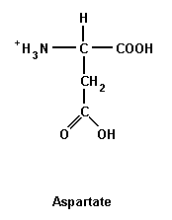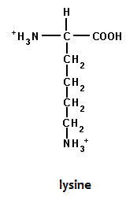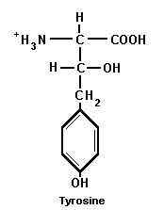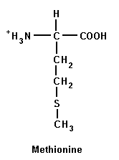

______________ ______________ ______________ ______________

- Circle the areas of these molecules that will combine to form a dipeptide, and use an arrow to indicate the expelled product(s) of the reaction. Below, draw the newly-formed dipeptide. (4pts)

