Name:______________KEY______________ Test #3: Protein Structure

Multiple choice (2pts each, 12 pts total):

- Proteins are made of twisted and folded up
  - Polysaccharides
  - Polypeptides
  - Polynucleotides
  - Polycarbonates

- Proteins can be found in which of the following foods?
  - Lettuce
  - Beef
  - Rice
  - All of the above

- Which is the simplest structural form of a protein in which disulphide bonds play a role?
  - Primary structure
  - Secondary structure
  - Tertiary structure
  - Quaternary structure

- Which of the following is a carboxyl group?
  - –CH₃
  - –COOH
  - –NH₂
  - –OH(CO)

- The non-essential amino acids:
  - Are not present in animal proteins
  - Do not occur in nature
  - Are synthesized by the body
  - Are the only amino acids present in plants

- The formation of a peptide bond is the result of a(n):
  - Hydration reaction
  - Dehydration reaction
  - Ionic reaction
  - Nuclear reaction

Short answer (19 pts total):

- Circle the R groups in this chain (3pts):
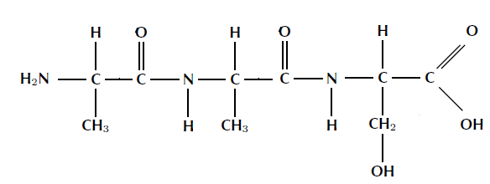

- Label the following amino acids as polar, non-polar, acidic, or basic (4pts):
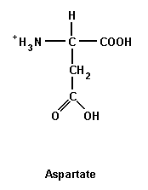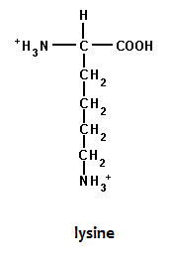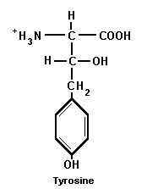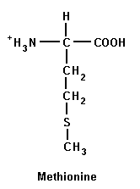

____ acidic____ ____ basic______ _____polar____ ____non-polar____

- Circle the areas of these molecules that will combine to form a dipeptide, and use an arrow to indicate the expelled product(s) of the reaction. Below, draw the newly-formed dipeptide. (4pts)

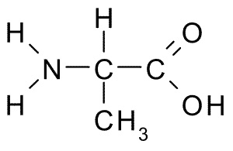
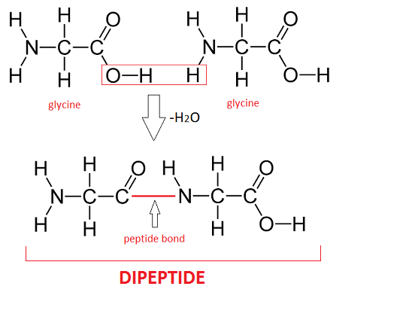
- Assess the statement below, circling what is correct and crossing out with a single line what is incorrect. Make a new statement that includes the correct information and corrects what is wrong in the first one. (8pts)

Proteins are made up of polysaccharides which are made up of amino acids. There are 25 amino acids, 9 of which are considered essential. Proteins look like long straight chains and they often interact with other proteins to form large protein complexes. Proteins can be found in animal cells, but not in plant cells.

Proteins are made up of polypeptides which are made up of amino acids. There are 20 amino acids, 9 of which are considered essential. Proteins look like a knotted up ball of yarn, and they often interact with other proteins to form large protein complexes. Proteins can be found in both plant and animal cells.

