LEARNING ASSESMENT MODEL PROJECT
7th Grade Science
Introductory Cell Unit
27 March – 7 April 2017 (10 school days)
Cassidy Richard

TABLE OF CONTENTS

Statement of Purpose………………………………………………………………………..... 3
Standards and Objectives………………………………………………………………….…. 3
Vocabulary……………………………………………………………………………………… 4
Timeline.……………………………………………………………………………………..…. 5

Resources…………………………………………………………………………………….... 5

Letter to Parents……………………………………………………………………………….. 6

Bulletin Board…………………………………………………………………………………... 7

Student Project and Rubric………………………………………………………………….... 8

Technology……………………………………………………………………………………... 9

Lesson Plans…………………………………………………………………………...…. 9 - 17

Cell Diagrams……………………………………….…… 11

Cell Notes………………………………………….... 12 - 13

Relay Review Game Questions……………………..…. 15

Differentiation and Accommodations………………………………………………………. 18

Authentic Real-life Applications………………………………………………………….…. 18

Pre and Post-tests………………………………………………………………………. 19 - 20

Test Data……………………………………………………………………………….... 21 - 22

Narrative Statements and Reflection Questions…………………………………….. 22 - 24
Statement of Purpose:
Cells are the basic unit of life, and understanding what they are and the fundamentals of how they function is foundational in the Life Sciences. In the 7th grade, students have not yet been formally introduced to the idea of cells, so this unit will lay the groundwork for much of what they will learn in their next few years of schooling in the life sciences. My goal in this unit is to provide the students with a strong foundation for their future studies of life sciences, and as is the goal in all of life science, to help students better understand the living things around them, including the inner workings of their own bodies.

Standards and Objectives:
The Indiana Academic Standards for Science covered in this unit will be…
7.3.1 Explain that all living organisms are composed of one cell or multiple cells and that the many functions needed to sustain life are carried out within cells.
7.3.2 Understand that water is a major component within all cells and is required to carry out many cellular functions.
7.3.4 Compare and contrast similarities and differences among specialized sub cellular components within plant and animal cells (including organelles and cell walls that perform essential functions and give cells shape and structure).

By the end of the unit students will be able to…
• Explain that living things are made up of one cell or multiple cells.
• Identify various organelles in plant and animal cells and discuss the cellular functions that each one serves.
• Compare and contrast the structure of plant cells and animal cells.
• Construct a physical model of a plant or animal cell with appropriate cellular structures such as organelles.

Vocabulary:
Cell – The basic unit of structure and function in living things. Like the “bricks” that make up a building.
Cell Membrane – The outer layer of the cell which lets certain things in and out, but keeps other things from going through. Like “border patrol” at the edge of a country.
Cell Wall - The hard outer shell of plant cells that serve as support and structure. Animal cells DO NOT have cell walls.
Centriole – The cell organelle which provides a light support structure for animal cells. This organelle provides a sort of “skeleton” for the animal cell.
Chloroplast – The cell organelle that allows plants to make food and energy from sunlight. Like the “solar panel” of a plant cell.
DNA – The basic form of genetic material in the nucleus. Holds the “recipe” for cells and life, but is not readable until it forms chromatin.
Chromatin – Partially coiled-up DNA. This is the usable form of genetic material. This is what is read for instructions on cell functions.
Chromosome – Fully coiled-up chromatin or genetic material. Usually these take the shape of and are illustrated as an X or a V. The instructions are not readable in this form.
Endoplasmic Reticulum (ER) – The organelle that surrounds the nucleus of the cell, and is like a “factory” that uses the instructions from the nucleus to make its products.
Rough ER – Area of the ER with ribosomes attached.
Smooth ER – Area of the ER with no ribosomes attached.
Golgi Apparatus – Like the “shipping center” of the cell. Takes cell products and transports them to where they need to go either inside the cell or out of the cell.
Vessicle – The “shipping trucks” or “mailmen” of the cell. The Golgi produces them, giving them instructions on where to take things.
Lysosome – Like “recycling centers” of the cell. They take in substances and old cell parts and recycle them into things that can be used to build new things.
Mitochondria – like the “power plant” of the cell. Take in materials from food like sugars and converts them into energy for the cell.
Nucleus – Like the “brain” of the cell. Holds the genetic information or instructions for the cell.
Nucleolus – Sits inside the nucleus and is like a special factory just for ribosomes.
Ribosome – Another type of “factory” in the cell, but only produces one type of thing called proteins. Some are attached to the ER, others float around the cell.
Vacuole – A large organelle in the plant cell that stores water and a few other substances.
Timeline:
Day 1 (3/27) – Pre-test, Informal cell discussion
Day 2 (3/28) – Organelle notes with model pillows and Mr. W’s Cell Song
Day 3 (3/29) – Continue organelle notes
Day 4 (3/30) – Finish organelle notes
Day 5 (3/31) – Organelle review game (open notes) Introduce Cell Modelling project
Day 6 (4/3) – Work day for cell modelling project
Day 7 (4/4) – Work day for cell modelling project
Day 8 (4/5) – Final work day for cell modelling project
Day 9 (4/6) – Present cell models, review for test
Day 10 (4/7) – Post-test, wrap-up unit, brief discussion about mitosis

Resources:
Teacher resources: Smart board, Mr. W’s Cell Song (YouTube), Cell Pillows (Instructables.com)

Student resources: Cell structure notes, Cell diagrams, Mr. W’s Cell Song (YouTube), Cell Pillows (Instructables.com), iPads.

One of the main resources used in this unit was a manipulative pillow cell model. Instructions for the pillows were found at http://www.instructables.com/id/Plush-Cell-Model/ . I had both plant and animal cell pillows, and these proved to be a lot of fun for the students. Not only were these large, 3D models which were handy to use to point out various structures at the front of class, but it could also be safely thrown across the room for students to point out organelles as well. After talking about each organelle and taking notes on it, I would indicate the organelle on the pillow, show the class, then throw the pillow to a student and have them point to it for the class. I would then have the first student throw to another student to do the same, and have at least 3-5 students do this for each organelle. The students enjoyed this, and having something flying around the classroom really perks them up!

Another big resource used was a song posted as a YouTube video. It’s called Mr. W’s Cell Song and can be found at https://www.youtube.com/watch?v=rABKB5aS2Zg. This video covered most of what I wanted to talk about with my students, and gave good imagery for the organelles in a catchy song. I used this video as an engaging platform on which to take notes on the organelles, and I embedded a QR code for the link on the students’ note sheets so they could easily access this video on their devices while studying. Many students said this song was a great help to them as they worked on remembering all of the organelles and their functions.


Southside Middle School
Principal Kelli Turner

March 27, 2016

Dear students and guardians,

We will soon begin our study of the life sciences in our 7th grade science classes! This is a part of the year I’ve been very much looking forward to as my specialty is Biology, and I’m excited to introduce you to some of the amazing things that make life possible. Our first unit will be over cells which are the basic unit of life; they make up you and me and all the living things around us. My first studies of cells amazed me, I had no idea that there were such complex things going on inside of me all the time! I hope that in sharing my enthusiasm for this topic with you, I might also transfer to you an interest or at least a greater understanding of the living world.

In our first few weeks, we will be learning about the basic structure of cells and creating cell models which will help us to understand the basics of how cells function. In later weeks we will be taking samples of cells from onions and even cells from our own bodies to observe in the lab using microscopes! Don’t worry, obtaining your cell sample won’t hurt! In doing these activities along with a handful of other things in the classroom, I expect that you will finish the unit with a strong foundation on which you will build your future life science studies in the 8th grade and in high school.

As always, I welcome any extra questions you may have about this topic, and would love to sit down and discuss things further outside of our regular class time if you have a particular interest in cells and life science. Additionally, I’m always available if you have any concerns about anything going on in the classroom.

Kind regards,
Miss Cassidy Richard, crichard@muncieschools.org
Woodrow Wilson Teaching Fellow - Ball State University

Student Work Board:
Throughout the unit I used my cell pillows to stimulate interest in cell structure, and I decided to make my board at the end of the unit with these models along with all of the pictures of students and their cell models. I decided to title the board “#Cell-fie” which the students thought was funny or at least they thought it was silly enough to laugh at.

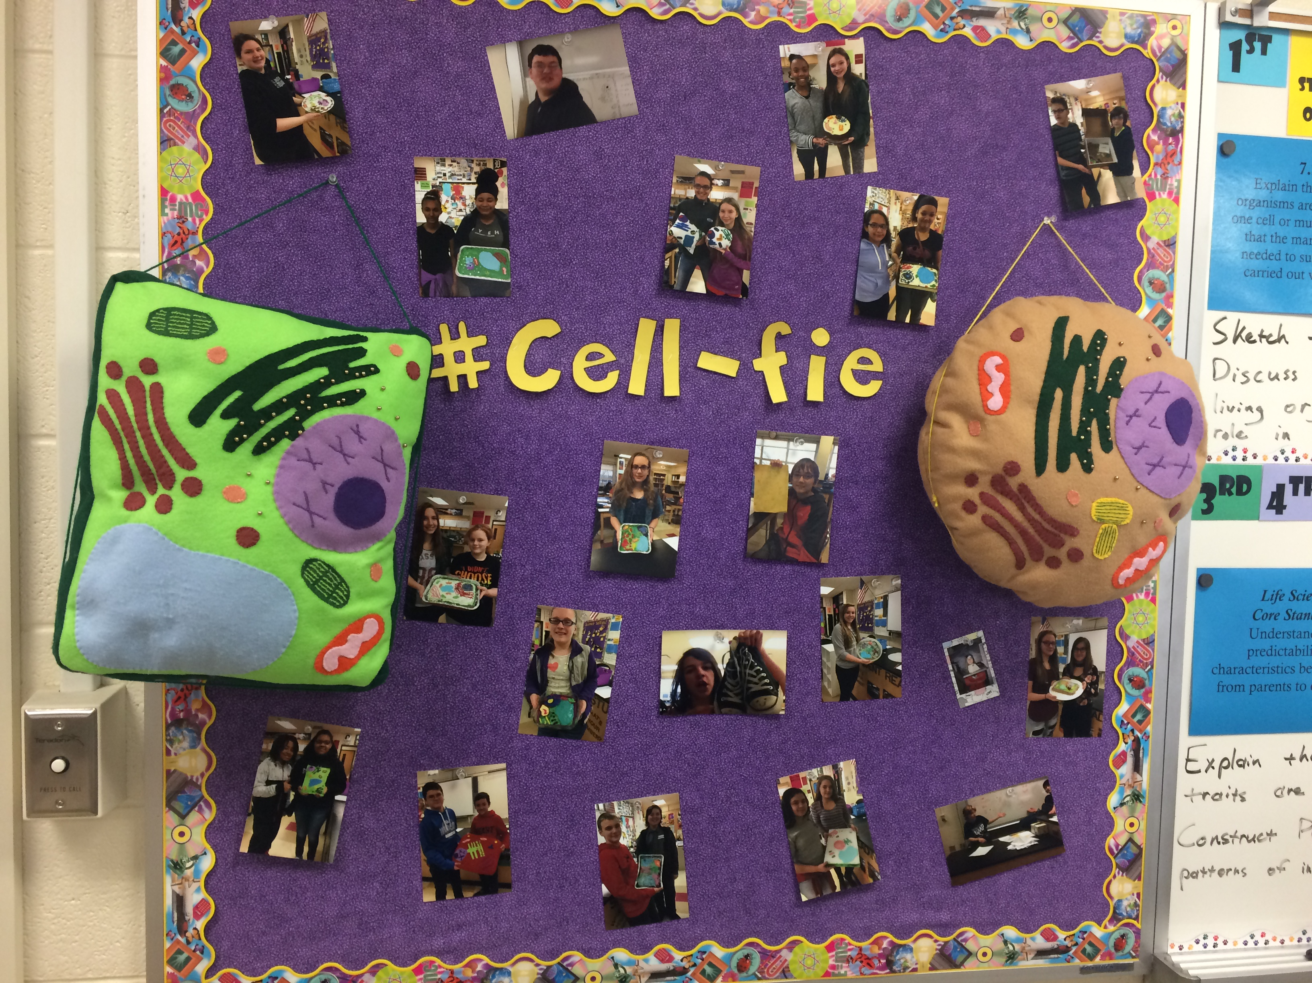

Student Project Grading System:
Note* Due to the fact that students had a choice in this project regarding whether they wanted to make a model of a plant cell or an animal cell and these cell types have differing numbers of organelles, I couldn’t assign points for each organelle included (this would mean that plant cells would be worth more points). Instead I decided a better form of assessment would be a checklist. In order to assign a grade to the projects, I checked off the cell components that were present and deducted 5 points each from the 70 point total for each organelle that should have been there but was missing. Though this is not a traditional method of grading, it worked well in this instance, my students had no trouble understanding what was expected.

Cell Modelling Project
For this project, you have two main choices. You can make a physical model of a cell (something like Miss Richard’s pillows) which displays a visual representation of each of the organelles we covered in class, or you can write a story or comic which gives each of the organelles a personality and tells a fictional story of “life within the cell”. For the story project, each organelle should still have a visual, such as a sheet on which all of the “characters” from your written story are illustrated. If you have any other formatting ideas that you would like to try for this project (such as a song or a video), let us know! Your imagination is the limit! Regardless of the formatting of your project, you will be graded according to the checklist below:

__ Neatness of final project (10 points)
__ Inclusion of ALL of the appropriate organelles from the list below (60 points):
(Each one missing that should be present will deduct 5 points)
__ Cell membrane
__ Cell wall (if applicable)
__ Centrosome (if applicable)
__ Chloroplast (if applicable)
__ Chromosome and/or Chromatin
__ Cytoplasm
__ Endoplasmic reticulum (w/ both smooth and rough regions)
__ Golgi apparatus
__ Lysosome
__ Mitochondria
__ Nucleolus
__ Nucleus
__ Ribosomes
__ Vacuole (if applicable)
__ Vessicle

Total points: _______ / 70 points

Technology:
In the direct instruction portion of this unit, technology was used to present some of the information through a video found on YouTube. The video is called “Mr. W’s Cell Song”. As many of our students have iPads and/or smartphones, I included a QR code on their note sheet so they could easily access the video as they studied, but in class, I projected the video on our smartboard. I liked this video because it not only said the names of the various organelles, but for many of them, a brief description of the organelle’s function in the cell was also given. Many students found this song to be helpful in their learning of the material.

The student project at the end of the unit left lots of room for students to use technology. While most of the projects didn’t directly involve technology, many students used their iPads to look up recipes for cakes, or look up general inspiration for their models. Two student groups made videos for their project and uploaded them to YouTube.

I found some great interactive cell models online which I would have liked to use, and may use in the future, but as our classrooms are quite far from truly being 1:1 with technology, this just didn’t fit in anywhere.

Lesson Plans:
Day 1: Monday 3/27/17
Overview
Pre-Test on Cell Structure
[7.3.1, 7.3.2, 7.3.4]
Objectives
Students will be able to…
• Identify various organelles in plant and animal cells and discuss the cellular functions that each one serves.
• Compare and contrast the structure of plant cells and animal cells.
• Construct a physical model of a plant or animal cell with appropriate cellular structures such as organelles.
Co-Teaching Strategy
One teach, one assist
Procedures
• Complete ISTEP review bell work and discuss solutions as a class (5 min)
• Hand out and briefly explain pre-test (5 min)
• Students complete pretest (20 min)
• Discuss how the test went, class discussion about what they already know about cells (10 min)
Resources/Materials
• ISTEP Review PowerPoint
• Pretest assessment
Assessment/Evaluation
• Graded (not recorded in gradebook) pre-test
• Formative assessment through class discussion

Days 2-4: Tuesday 3/28/17-Thursday 3/30/17
Overview
Begin cell notes
[7.3.1, 7.3.2, 7.3.4]
Objectives
Students will be able to…
• Explain that living things are made up of one cell or multiple cells.
• Identify various organelles in plant and animal cells and discuss the cellular functions that each one serves.
• Compare and contrast the structure of plant cells and animal cells.
• Construct a physical model of a plant or animal cell with appropriate cellular structures such as organelles.
Co-Teaching Strategy
One teach, one assist
Procedures
• Complete ISTEP review bell work and discuss solutions as a class (5 min)
• Hand out note sheet and cell diagrams, and explain how we will go through the info, then show the full YouTube video, instructing students to just watch (no notes yet) (5 min)
• Slowly go through video together, pausing often to fill in notes, find organelle on cell pillow, and pass pillow around class to have at least 3-5 students find the organelle and point it out to the class (30 min)
Resources/Materials
• ISTEP Review PowerPoint
• Mr. W’s Cell Song
• Cell notes and diagram sheet (see below)
Assessment/Evaluation
• Formative assessment through class discussion/pillow passing

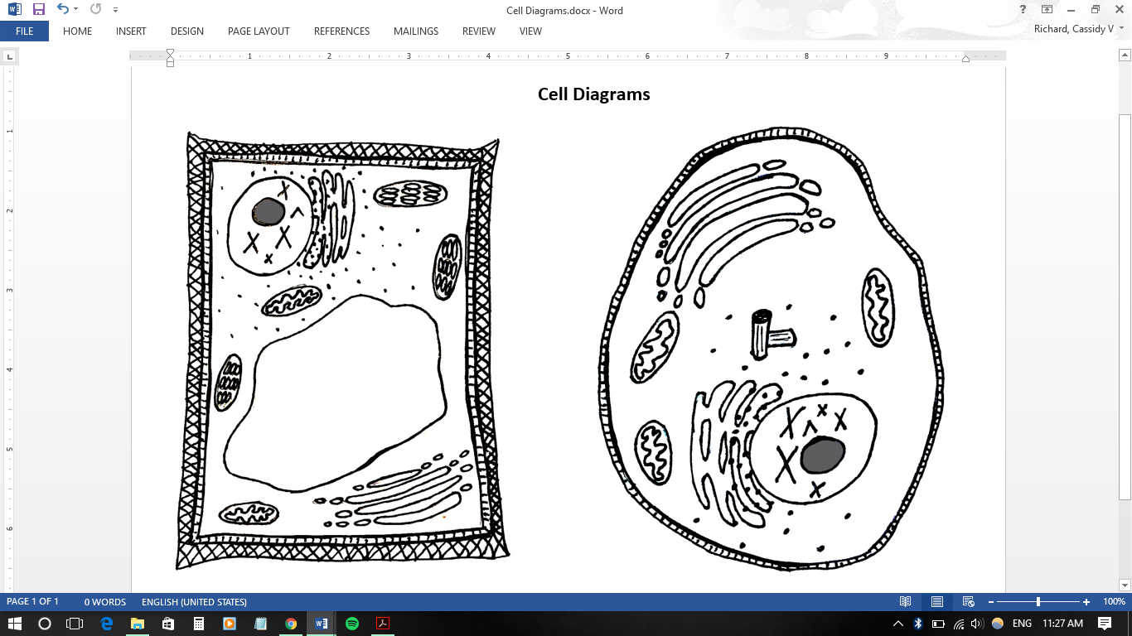
Name: _________________________________________________ Date: _______________ Per: ________

The Cell: With help from Mr. W’s Cell Song (https://www.youtube.com/watch?v=rABKB5aS2Zg)
Scan this QR code with your smartphone or iPad (you need a QR code scanner app) to take you right to Mr. W’s Cell Song video!

- The _____________ is the basic unit of structure and function in living things. You might think of them as the “_____________” that make up a building.

- Just like our bodies have organs like a brain, a stomach, and lungs, cells have “tiny organs” too, called _____________________.

- The _________________________ is the outer layer of the cell. Why does Mr. W say it’s a “gatekeeper”?

- The _____________________ is responsible for producing energy in the cell. You might think of this organelle as the cell’s “____________________________”

- The ____________________ is what controls or directs the cell. You might think of this organelle as the cell’s “____________________________”
  - Inside this organelle we find ___________ which can be tightly wound up and compact, in structures we call __________________ or loose and stringy in a form we call _________________. In the space below, sketch these 2 forms and label them.

  - Deeper inside this organelle we find ANOTHER organelle called the ___________________ which is responsible for creating ribosomes (you’ll learn about those later).

- The ______________________ is the clear, jelly-like stuff that fills the cell. It’s mostly __________________.

- The __________________________ (abbreviated ER) is a large structure that surrounds the nucleus. There are two regions of this organelle, one is called the ___________ (sER) and the other is called the _____________ (rER). The rER is called this because it has ribosomes attached to its surface.
  - If I told you that the rough ER (with ribosomes) produced a lot of proteins and the smooth ER (without ribosomes) didn’t produce very many proteins, what can you infer about what ribosomes do?

*SIDE NOTE: Some ribosomes are attached to the ER, while others float around in the cytoplasm. Either way, they do the same thing, only in a different place.
- The ____________ (body / complex / apparatus) takes cell products and transports them to where they need to go (sometimes to a different part of the cell, sometimes out of the cell). You can think of this as the “______________________” of the cell.
  - To transport these products, the Golgi produces organelles called ________________ which you might think of as “____________________” which deliver the products.

- The ____________________ is an organelle which takes in substances and old cell parts and digests them, turning them into new usable resources for the cell. You can think of this as the “________________________”

- The __________________ is an organelle which produces structures that act as a sort of skeleton for the cell. When illustrated in a cell diagram, these usually look like 2 pieces of ________________.
Special structures of plant cells
- Around the outside of a plant cell, you’ll find a _____________________ which is a rigid support structure.
  - Note that this takes the place of the light support structure of the animal cell, so plant cells do not need the ________________ that animal cells have.
  - Also note that plant cells do still have the “gatekeeper” structure, or the ______________________.

- The ________________________ is the plant cell organelle that produces energy from sunlight. You might think of these as the “_______________________” of the cell. These also make the plant green!
  - Note that the plant cell still contains __________________ to produce energy at night!

- In a plant cell, you’ll find a large organelle called a __________________ which primarily stores water.

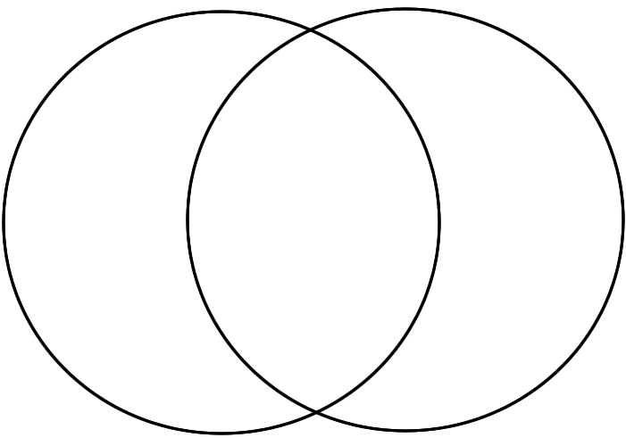
Plant Cell
Both
Animal Cell
Day 5: Friday 3/31/17
Overview
Organelle review game
[7.3.1, 7.3.2, 7.3.4]
Objectives
Students will be able to…
• Explain that living things are made up of one cell or multiple cells.
• Identify various organelles in plant and animal cells and discuss the cellular functions that each one serves.
• Compare and contrast the structure of plant cells and animal cells.
• Construct a physical model of a plant or animal cell with appropriate cellular structures such as organelles.
Co-Teaching Strategy
One teach, one assist
Procedures
• Complete ISTEP review bell work and discuss solutions as a class (5 min)
• Briefly introduce game, students are familiar with format (5 min)
• Students are on teams based on table group (6 teams) and are assigned to a bowl with strips of paper with review questions printed on them. The bowl is situated about 10 feet from their table. Students select a strip of paper, bring it back to the table, and discuss with the group to decide on an answer, then must call a teacher over to confirm their answer before selecting a new strip of paper. Students are allowed to reference their notes for this game, but are challenged to progress to not using their notes if they can. (20 min)
• Wrap up game, determine winner (most questions answered correctly), class discussion about how students felt about their performance and knowledge of cells (5 min)
• Hand out Cell Modelling project grading sheet, briefly introduce project, instructing students to think about formatting and prepare to begin project on Monday (5 min)
Resources/Materials
• ISTEP Review PowerPoint
• Review question sheet (strips cut up, placed in bowls) (see below)
• Completed cell structure notes and diagrams
• Cell Modelling project grade sheet (see below)
Assessment/Evaluation
• Formative assessment through students’ answers to review questions

- What do mitochondria do in the cell?
Cell organelle relay race questions
- What does the nucleus do in the cell?
- What does the golgi body do in the cell?
- What do the ribosomes do in the cell?
- What do the lysosomes do in the cell?
- What do the vessicles do in the cell?
- What part of the cell do we call the gatekeeper?
- What does the chloroplast do in the cell?
- Point to the cytoplasm of the cell.
- Point to the vacuole of the cell.
- Point to the nucleolus of the cell.
- Point to where DNA is held in the cell.
- Point to a chloroplast.
- What do we compare the nucleus of the cell to?
- Which organelle provides energy to the animal cell?
- What do we compare the chloroplast to?
- What do we compare the golgi body to?
- What do we compare a vessicle to?
- What do we compare a lysosome to?
- Which organelle provides the animal cell with structure?
- Which organelle does the plant cell use for storage?
- Which organelle do we call the “brain” or “boss” of the cell?
- Which 2 organelles provide energy to the plant cell?
- Which organelle has a region that produces proteins?
- Which organelle is like the “recycling center” or “digestive system”?
Days 6-8: Monday 4/3/17 – Wednesday 4/5/17
Overview
Work day for Cell Modelling Project
[7.3.1, 7.3.2, 7.3.4]
Objectives
Students will be able to…
• Explain that living things are made up of one cell or multiple cells.
• Identify various organelles in plant and animal cells and discuss the cellular functions that each one serves.
• Compare and contrast the structure of plant cells and animal cells.
• Construct a physical model of a plant or animal cell with appropriate cellular structures such as organelles.
Co-Teaching Strategy
One teach, one assist
Procedures
• Complete ISTEP review bell work and discuss solutions as a class (5 min)
• Review project requirements with students, pointing them towards to the grade sheet for expectations (5 min)
• Allow students time to work, teacher circulates to provide guidance and to be sure students stay on-task (30 min)
• Clean-up and progress check-in (5 min)
Resources/Materials
• ISTEP Review PowerPoint
• Students may have iPads for research/idea generation
• Completed cell structure notes and diagrams
Assessment/Evaluation
• Informal assessment of progress on projects

Day 9: Thursday 4/6/17
Overview
Present Cell Models
[7.3.1, 7.3.2, 7.3.4]
Objectives
Students will be able to…
• Explain that living things are made up of one cell or multiple cells.
• Identify various organelles in plant and animal cells and discuss the cellular functions that each one serves.
• Compare and contrast the structure of plant cells and animal cells.
• Construct a physical model of a plant or animal cell with appropriate cellular structures such as organelles.
Co-Teaching Strategy
One teach, one assist
Procedures
• Complete ISTEP review bell work and discuss solutions as a class (5 min)
• Begin project presentations. Student groups come to front of class to briefly tell class about how they constructed their model. Some review is worked into this by asking students to identify indicated cell components (time varies by class, 15-25 min)
• Use remaining class time to play game from last Friday to review. This time don’t allow use of notes and diagram (time varies by class, 5-15 min)
• Wrap-up, final questions about cells, reminder to study (5 min)
Resources/Materials
• ISTEP Review PowerPoint
• Smart board for video presentations
• Cell modelling grade sheet
Assessment/Evaluation
• Graded Cell Models

Day 10: Friday 4/7/17
Overview
Cell post-test
[7.3.1, 7.3.2, 7.3.4]
Objectives
Students will be able to…
• Explain that living things are made up of one cell or multiple cells.
• Identify various organelles in plant and animal cells and discuss the cellular functions that each one serves.
• Compare and contrast the structure of plant cells and animal cells.
• Construct a physical model of a plant or animal cell with appropriate cellular structures such as organelles.
Co-Teaching Strategy
One teach, one assist
Procedures
• Complete ISTEP review bell work and discuss solutions as a class (5 min)
• Time for any final questions, hand out and briefly explain post-tests (5 min)
• Allow time to complete tests (15 min)
• Wrap-up discussion about what most helped students learn the material, how they feel they did on the test, and discussion about mitosis which will be studied next week (15 min)
Resources/Materials
• ISTEP Review PowerPoint
• Post-tests
Assessment/Evaluation
• Graded post-tests

Differentiation and/or accommodations:
This project was done with our two honors classes, so there were not many accommodations needed for these students. The cell project, however, was very broad and open-ended, allowing students to showcase their varying skill sets in their cell models. Many baked cakes and decorated them with frosting to look like cells, a few sewed pillows like the ones we used in class, some put together skits which they edited and made into videos, and one even made a short comic strip! I feel that this project really allowed students to get creative in how they represented the cell.

Authentic Real-Life Applications:
Since this is a life-science topic, I think it’s easy for real-life connections to be made. When through with going over all of the organelles on the note sheet, I made sure to remind students that over those few days, we didn’t just learn about cells, they were in fact learning about themselves! They are all made of cells and now they have a more in-depth understanding of what they are physically made of and all of the complex things going on inside of them. This introductory knowledge about cells will lead to more in-depth topics that will have more direct relevancies to their lives and lives of their loved ones.

Name: _________________________________________________ Date: __________________ Per: ________

Cells: Pre-test
- Which cell organelle is responsible for creating energy?
  - Nucleus
  - Ribosome
  - Mitochondria
  - Golgi Apparatus

- The Nucleus of the cell is often thought of or referred to as the __________ of the cell.
  - “Brain”
  - “Power plant”
  - “Solar Panel”
  - “Shipping Facility”

- Which is NOT a difference between plant and animal cells?
  - Only plant cells have a cell wall
  - Only plant cells have a vacuole
  - Only animal cells have a centriole
  - Only animal cells have mitochondria

- Please identify and label the NINE structures that are present in the cell diagram below.
*Note that you have TWELVE words in your word bank, so THREE of the words will not be used.
Word Bank
Cell membrane | Chloroplast | Golgi apparatus | Nucleolus
Cell wall | Chromosome | Mitochondria | Ribosome
Centriole | Endoplasmic reticulum | Nucleus | Vacuole
Golgi Apparatus
Cell Membrane

Mitochondria
Centriole

Nucleus
Ribosomes

Chromosome
Nucleolus
Endoplasmic reticulum

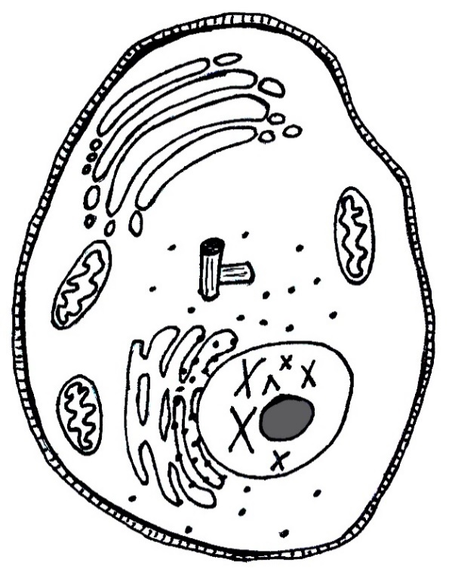
- Please briefly explain the function of each of the following organelles within the cell:

  - Golgi apparatus - _The “shipping facility” of the cell. Exports cellular products like proteins____ ______________________________________________________________________________

  - Mitochondria - __The “power plant” of the cell. Produces energy from sugars in food_________ ______________________________________________________________________________

  - Chloroplast - ____The “solar panel” of the plant cell. Produces energy from sunlight _ ______________________________________________________________________________

  - Nucleus - ___The “brain” of the cell. Holds the DNA or genetic info of the cell._______________ ______________________________________________________________________________

Great job! Thank you for your hard work!

** Post-test is identical to the pre-test **

Test Data:
The results of the pre- and post-assessments indicate that my students made great gains in their knowledge of cells. The average score on the pre-test was 18% while the average post-test score was 94%. Figure 1 below indicates the individual scores of the students. Four of the thirty-one students here are marked with an asterisk, these indicate students who had been formally introduced to at least some cell structure before the pre-test. Three of these students were absent on the day of the pre-test and I felt it was more valuable for them to join the rest of the class on the first day of study rather than take the test and miss out on so much important information. The other student had recently transferred from another school where he had already studied cells.

Figure 1: Pre- and post-test scores broken down by student. Asterisks indicate students who had been formally introduced to cell structure (with varying levels of depth) before taking the test.

Of the thirty-one students, thirty failed the pre-test (one student scored 60%, a D-), and one failed the post-test. This one student who failed the post-test was absent for two of the three days of heavy instruction, though he did show great gains between the two exams.

Other pieces of data I analyzed with the post-exam included which questions were most often answered right and wrong, and which question type seemed to present the most trouble to the students. Table 1 shows the percentage of how often each test question was answered correctly (the table can be matched up with the test questions included previously in this document). In order to grade the labelling section, I tallied how many organelles were properly labelled and awarded points for these, so I only include in this table the organelles present in the diagram, not all of what was present in the word bank.

Table 1: Percent of correct responses broken down by question.

When looking at this data as a class, I pointed out to students that everyone seemed to be pretty sure about what the nucleus does in the cell, and what mitochondria look like, though at least one person got each of the other questions wrong. I also noted how many people missed the short answer question about the chloroplast. Many of the incorrect answers I got referred to cytoplasm or chromosomes which indicated to me a confusion among students with the many long “C” words.

Finally looking at this table, I pointed out to students the average score of each of the question types. They did quite well with the labelling, not badly with the multiple choice, but they seemed to have struggled most with the short answer questions. I told them to keep this in mind with future tests, so they might know to study a little harder or answer more carefully with this type of question as they seem to give a bit more trouble.

Narrative Statements:

IN Standards covered in this unit:
7.3.1 Explain that all living organisms are composed of one cell or multiple cells and that the many functions needed to sustain life are carried out within cells.
7.3.2 Understand that water is a major component within all cells and is required to carry out many cellular functions.
7.3.4 Compare and contrast similarities and differences among specialized sub cellular components within plant and animal cells (including organelles and cell walls that perform essential functions and give cells shape and structure).

All of us have some basic understanding of life, but often we don’t really think about what makes up all of this very different living things. One might find it surprising that the building blocks of your cat are actually very similar to the building blocks of you, and even the building blocks of that tree outside are similar to your building blocks. I started this unit by asking students what they knew about cells, and many of them knew that they make up living things. I expected some possible confusion when I pointed to the tree in the courtyard and asked if that was made of cells, but my students are no fools! There was a bit of confusion when I pointed to the door which is made of (obviously dead) wood. We decided that the door was in fact made of cells, though they were dead. We experienced similar confusion when I asked about a loaf of bread. At first they said no, but then I asked what are the ingredients in bread and where do things like wheat come from? We decided again that there are probably lots of dead cells in bread.

At this point, I asked if students had heard of yeast, and they said yes, that it was a type of bacteria. I explained that it wasn’t exactly bacteria but it was similar because it was only one cell, just like bacteria. I also explained that these types of organisms are actually made of a different type of cell, which we would not be talking about in class, but they were very interesting and worth looking up sometime. Instead, we were going to focus on the types of cells that make up plants and animals, so us, and our cats and dogs and fish, and also that tree outside and all the grass and even the weeds. Those were the types of things made up of the cells that we would be studying.

There were two main sections of this unit, one made up of interactive direct instruction, and the other made up of hands-on group or individual work. After getting the information to students in an engaging way, they were set free to solidify the information on their own through a project that allowed them to build a cell model however they wanted to. This hands-on project seemed to really help a lot of students realize some of what’s going on in a cell and become more familiar with it all.

Assessment Narratives
After assembling more of this LAMP report, I realize that I didn’t do as good of a job with aligning my pre- and post-tests to the standards as I should have. I felt that the main standard in this unit was 7.3.4 (differences between plant and animal cells), and that 7.3.1 and 7.3.2 (cells make up living things and cells are mostly water) would just come naturally with the rest of the material. Based on informal assessment through discussion with my students, I feel that they’ve achieved all of these standards, but I regret not having questions in the test that directly measured these things.

I do feel that the test items I wrote did a good job of assessing standard 7.3.4, and I’m very pleased with the growth my students made in this area. I expected the labelling of the organelles on the diagram to be the most difficult section of the exam, but overall they did very well with this item.

Project/Rubric Narratives
Though I’ve used rubrics for nearly all of the projects I’ve done with my students this year, I could not find a rubric format that I felt clearly addressed what was expected to be in the students’ models (since the components of plant and animal cells differ slightly). This is why instead of the traditional rubric, I assembled a checklist that I believe still clearly laid out what was expected and I explained to my students why I did it this way. The checklist itself clearly indicates where points for the project are awarded, and where they may be lost if certain things are not completed. I was also sure to explain to students that if they chose to make a plant cell model, they would have more components to include, but would not be earning any more points than they would if they chose to make an animal cell. No students had any complaints about this, and many chose to make plant cells anyway.

I was worried that the change in format from a rubric to a checklist might be confusing for the students, but I found that it may have even been more clear as they could check components off as they added them to their project. The only students who were missing components of their cells were those who did not check things off as they went. All of those who actually used the checklist as they made their cell had all components and received full points. I could tell the groups who kept their checklists with them as they made their models because these were full of frosting, cake batter, paint, and glue.

Evaluation of Student Learning Narratives
Since life science is my specialty, this section of the year is particularly exciting for me. I can remember studying cells for the first time, and in the middle of the chapter we were reading in class, I stopped, looked down at my hand, and thought, “All of this stuff is going on in there??” That was one of the first times I realized a love for life science and I still am a little taken aback when I think about the complexity of cells. I went into this unit very excited to share some of these amazing things with my students.

This project was run with our two 7th grade groups, both of which are honors groups. There are a total of 31 students between these two classes. I expected low scores for the pre-test as these students have only vaguely talked about cells before now in school. One student had recently transferred from another school where he had already studied cells, but even his scores were low on the pre-test. This test had an average score of 18% with a low score of 0% and a high score of 60%. All students showed great improvement in the post-test with an average score of 94%, a high of 100% and a low of 52%. This low score was the only F on the post-test, and this student still greatly improved from his pre-test score. It is worth noting that this student was absent for 3 days of the 10 day unit, and pulled out of class for 2 days to do make-up NWEA testing, so in all he missed half of the unit.

Though, as I mentioned earlier, I regret not having made my test items standard-specific, I did notice some interesting trends as I graded the tests that indicated some points of confusion for students. The most obvious thing I noticed is how much students struggled with the short-answer items. The multiple choice showed to be pretty simple, the labelling even went very well, but when asked to explain the functions of the organelles in the cell, the students seemed to struggle a bit more. That being said, they still performed overall well on these items, but on average it was the lowest-scoring section. In particular, students were confused when asked about what a chloroplast does in the cell. I expect they might have met similar confusion if I had asked them about cytoplasm or chromosomes. These are all long “C” words that I believe many students got confused.

When having my data talk with students after the unit, I pointed out these trends to them and tried to clarify each of the “C” words once more. I also encouraged them to be sure they study a little extra hard if they have a test coming up where they know they’ll be asked to answer short answer questions.

I feel that this unit did a great job preparing our students for the life science lessons that are to come, both this year and in future years of their schooling. I especially liked the data analysis involved in this LAMP project and would like to include more hard data in future units. Though data is important, I also love teaching just for the chance to share my passion with students, and this was a great unit for me in regards to passion-sharing. I only hope that maybe I lit a spark in one of them that will one day mature into a full flaming love for science, especially biology, just as mine has done.

