Plop…Plop…Boom!

Overview:
You notice that your younger brother reaches into the snack cabinet at exactly 3:00 PM every day and is stealing your favorite candy. You decide that you want to scare him in hopes of deterring him from continuing to do this. You gather some household items such as alka seltzer, water, and a small capsule and plan to build a miniature explosive device that will detonate as soon as he opens the door. You want to place the capsule in the closet exactly 18 seconds before the clock strikes 3:00 PM to give you time to flee. Your task is to determine the correct mass of alka seltzer to use in the reaction in order to pop the cap off in approximately 18 seconds. Day 1 will include preliminary trials outlined in the procedure below. Day 2 will be a time when you can refine the mass of alka seltzer used in order to get as close to 18 seconds as possible.

Objectives:
-Produce accurate and consistent measurements using graduated cylinders and electronic.
-Identify aspects (independent variables) within the experiment that can be altered to affect the reaction.
-Identify measureable (dependent variables) components of the reaction.
-Predict how the time it takes to pop the top off of the capsule will be affected if the amount of alka seltzer used is varied.
-Create a data table and corresponding graph for the change in time it takes to pop he top off the capsule for each amount of alka seltzer used.

Driving Questions:
-What is happening in the reaction that would lead to popping the cap off of the capsule?
-How is the time that it takes for the cap to pop off of the film capsule affected by the amount of alka seltzer in the reaction?
-What mass of alka seltzer (in grams) can you use in order for the cap to pop off -at approximately 18 seconds?

Materials:
  - -Alka seltzer tablets
  - -Two Film capsules with lid
  - -Water
  - -Paper towels
  - -Graduated Cylinder
  - -Electronic balance with plastic weighing tray
  - -Safety goggles

Procedure
- Gather necessary materials.
- Using the graduated cylinder, measure 20 ml of water and pour it into the film capsule.
- Using an electronic balance, measure approximately 1.6 g of crushed alka seltzer. Do not pour into the film capsule until the team member with the timer is prepared.
- Pour the alka seltzer into the film capsule and close the cap. As soon as the cap snaps on, begin timing.
- When the cap pops off, stop the timer immediately. Record the total time that it took for the cap to pop off in the provided data table.
- Rinse the film capsule with tap water and wipe up any liquid on the table.
- Repeat steps 2 through 6 two more times. Record the total time that it took for the cap to pop off for each trial in the data table provided.
- Repeat steps 2 through 6 three more times, this time using approximately 3.2 g of crushed alka seltzer for these trials. Once again, record the total time that it took for the cap to pop off for each trial.

Data Table
Trial | 1.6g of Alka Seltzer | 3.2g of Alka Seltzer
1
2

3

Average Time (s)

Graph
Construct a graph on the grid below using your average times and masses of alka seltzer. Mass (g) should be on the X axis, with Time (s) on the Y axis.

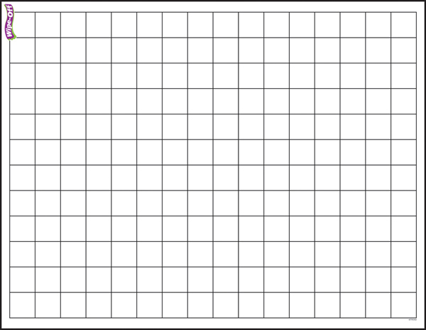

Predict
Using your graph, form a hypothesis about what amount of alka seltzer we will need to use in the reaction in order to have it explode at approximately 18 seconds. Write that below.

