Skipper and Lantz
Constructing Carbohydrates

Purpose
- Students will explore the intricacies of building and breaking down monosaccharides, disaccharides, and polysaccharides.
Objectives
- Students will derive the molecular formula of glucose.
- Students will be able to explain the reaction that takes place when joining simple sugars.
- Students will be able to explain the reaction that disassembles carbohydrates in the body.
- Students will be able to distinguish monosaccharides, disaccharides, and polysaccharides.
Standards
- B.1.1 Compare and contrast the shape and function of the essential biological macromolecules (i.e. carbohydrates, lipids, proteins, and nucleic acids), as well as, how chemical elements (i.e. carbon, hydrogen, oxygen, nitrogen, phosphorus, and sulfur) can combine to form these biomolecules.

Procedure
The Monosaccharide
- Locate your bag of puzzle pieces.
- To construct the monosaccharide, you will need 1 glucose (green), three oxygen (red), and three hydrogen (white).
- Assemble the monosaccharide using these three rules.
  - Oxygen and Hydrogen puzzle pieces (atoms) connect only via specifically shaped slots or pegs.
  - Assembled molecules are stable, or complete, only if there are no further available slots or pegs with which to connect other puzzle pieces.
  - For correct assembly, the raised letter on each of the connected puzzle pieces must be visible and upright.
- Complete the monosaccharide so that it is stable, or complete.
- When finished, contact the teacher for approval. You need approval on ALL completed molecules. [TEACHER INTIALS________________]
- Sketch the monosaccharide below using colored pencils.

- Answer the questions below.
  - Count the number of carbon, hydrogen, and oxygen atoms that were used to construct the monosaccharide. Record as a subscript below.

C___H___O___

  - Why is the monosaccharide stable, or complete?

  - Could this monosaccharide bond to another molecule without breaking any current bonds?

The Disaccharide
- You will now merge with the group across from you with your completed monosaccharide. DO NOT DISASSEMBLE YOUR MONOSACCHARIDE before joining groups.
- Using both monosaccharides, you will construct a disaccharide. Remember, a disaccharide is two monosaccharides bonded together.
- Line up the monosaccharides next to each other on the table facing the same direction (see below). Now, combine them to form a disaccharide. To do this, you may need to destabilize (expose slots and pegs).

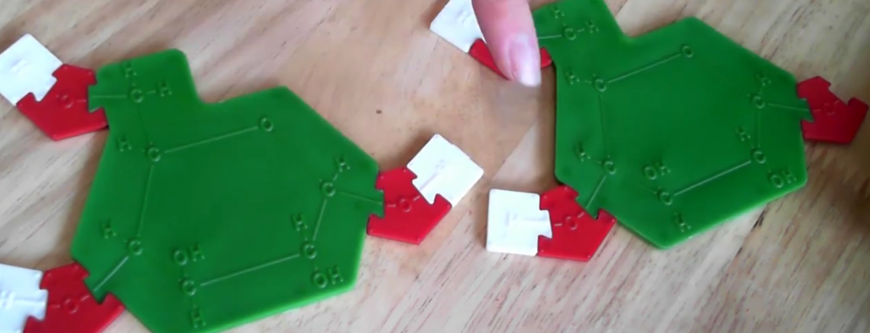

- After combining the two monosaccharides, you should have your disaccharide and a few stray pieces (atoms). Using what you know about chemistry, what molecule do these stray pieces’ form? Answer below.

- Now, contact your teacher for approval. [TEACHER INITIALS____________]
- Sketch the disaccharide and the other resulting molecule below using colored pencils.

- Answer the questions below.

  - Count the number of carbon, hydrogen, and oxygen atoms that were used to construct the disaccharide. Record as a subscript below.

C___H___O___

  - The combination of two monosaccharides forms a complete water molecule. What is this reaction called? (you may use the computer to find this answer).

  - How would you go about BREAKING up a disaccharide into monosaccharides?

Splitting the Disaccharide
- Using both the disaccharide and water molecules, break the disaccharide and reassemble the two original monosaccharides. Each member of the group should PERFORM this reaction once.
- This reaction also has a specific name. Using a computer, find the name of this reaction. Write it below.

- Contact your teacher for approval of correctly splitting a disaccharide. [TEACHER INITIALS_____________]

- Answer the questions below.

  - What are the differences between dehydration and hydrolysis reactions?

  - Using what you know about the formation of disaccharides, how would you form a polysaccharide. Which reaction would be used to do so?

The Polysaccharide
- Be sure that each group of 2 has, once again, a single monosaccharide.
- You will now join together as TWO large groups at the middle lab tables on each side of the room. Each large group should consist of 6-7 original groups of lab partners. Listen for instructions from the teacher.
- As a large group, combine ALL monosaccharides into a straight chain polysaccharide. The polysaccharide will be composed of 6-7 monosaccharides.
- Be sure to construct the water molecules that have formed due to dehydration reactions and place them underneath the newly formed bonds.
- When the polysaccharide is formed, contact the teacher for approval.
- Sketch the polysaccharide below using colored pencils. The water molecules SHOULD be included in the sketch.

- Now, each group of partners perform one hydrolysis reaction within the polysaccharide, reclaiming your monosaccharide. When the polysaccharide is fully disassembled, return to your original lab stations and break down your monosaccharide, placing the pieces in the bag.

Complex Carbohydrates
- Each group should receive a set of laminated pieces with magnetic tape on the back. Listen for the teacher to call your group up to the board.
- Quickly, form a monosaccharide with your pieces.
- Perform a dehydration synthesis reaction to join the monosaccharide with the existing chain where the teacher instructs you to do so.
- Once all groups have added their monosaccharides, the _______________ carbohydrate ____________ is formed. Sketch below.

- Each group perform a hydrolysis reaction to once again obtain a full monosaccharide. Listen for the teacher to call your group up to do so.
- Next, wait to be called to the board to form another polysaccharide. Perform the dehydration synthesis reaction and connect your monosaccharide where the teacher instructs you to do so.
- The completed polysaccharide is known as a ________________ carbohydrate. This one, in particular, is _____________. Sketch Below.

