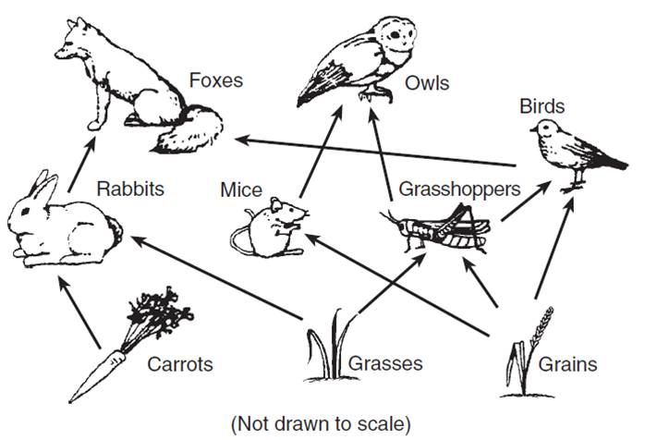
Food Web Construction
And Manipulation

Purpose: To construct an accurate food web and explore the implications of species extinctions on the food web.

Materials
- Food Web Information
- Colored Pencils
- Food Web Outline
- Chromebook
Procedure
- Complete the “Terms to know” sheet in this packet.
- Examine the food web information sheet and the food web outline. Note that there are eleven species and four trophic levels.
- Arrange the species into a logical food web using the provided information. Be sure to include arrows in the appropriate direction indicating energy flow. Use black colored pencils to draw these arrows.
- Fill in the “Trophic Level” blanks with the appropriate terms.
- Color the trophic level containing the producers, or autotrophs, green.
- Color the primary consumers yellow and secondary consumers red.
- Color the apex, or tertiary, trophic level blue. Sign off with teacher. The teacher will now kill off one of the species in your web.
- In the space provided on the “food web information” sheet, discuss the impacts of the extinction of this species. How will their extinction impact the animals who feed on them? How will it affect the species that were preyed upon by them?
- Turn in your web and paragraphs.

Food Web: Terms to Know
Directions: Using Chapter 5 Section 1 reading in CANVAS, record the definitions below. These will assist you in constructing the food web later in the activity.

Producer/Autotroph

Consumers/Heterotrophs

Trophic Level

Herbivore

Carnivore

Omnivore

Primary Consumer

Secondary Consumer

Apex Predators

Food Web Information

Owl  Eats:  Mice  Fish |  | Mouse  Eats:  Grasshoppers  Snails
Sparrow  Eats:  Snails  Grasshoppers  Salt Marsh Plants | Small Crustacean  Eats:  Salt Water Algae | Hawk  Eats:  Mice  Sparrows  Fish
Fish  Eats:  Small Crustaceans  Salt Marsh Plants  Salt Water Algae | Sandpiper  Eats:  Crustaceans  Snail  Algae | Grasshopper  Eats:  Salt Marsh Plants
Salt Water Algae  Energy Source:  Sunlight  CO₂  Water | Salt Marsh Plants  Energy Source:  Sunlight  CO₂  Water | Snail  Eats:  Salt Marsh Plants  Salt Water Algae

Directions: In no less than 5 sentences, discuss the implications on the food web due to the extinction of a species. Mention which species went extinct and refer to #8 in the directions for specific questions to be answered. Use the back of this sheet if needed.

Names _______________________________________________ P. __________
___________________
Trophic Level

___________________
Trophic Level

___________________
Trophic Level

___________________
Trophic Level

