Beaks
A Natural Selection Activity

Introduction
Natural selection is the theory that explains how slight differences among members of a population can be advantageous survival and reproduction of that population. Those differences are passed on to offspring, with the most beneficial traits increasing in frequency within the population. Over time, changes become noticeable among the population.

Concepts
- Microevolution
- Natural Selection
- Engineering Design
Background
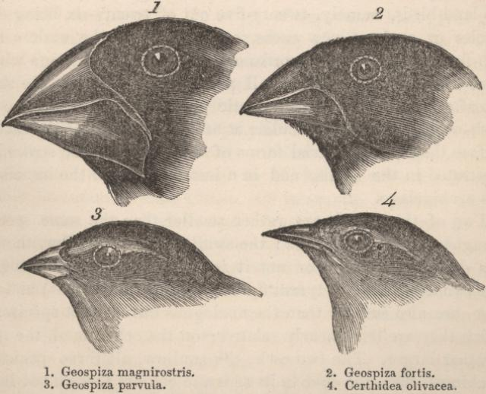
Evolution on the smallest scale is called microevolution. It is the ch ange of allele frequency from generation to generation within a population. A population is a local group of individuals of the same species with the potential to mate and produce viable offspring. The individuals that reproduce successfully pass their unique genetic material to the next generation. Those that do not reproduce die prior to passing on their genetic material.
Alleles are alternative forms of a gene. All the genes within a pool are known as the gene pool. The gene pool is where the genetic variation is stored and pulled from for future generations. The gene pool varies based on how environmental factors impact natural selection. For example, if the environment “selects” for traits, and the conditions increase the ability to survive and reproduce, then those traits become more common, indicating a change in the gene pool.
A terrific example of microevolution occurs regularly on the Galapagos Islands. This is the same set of islands where Charles Darwin studied. The data he collected helped form his ideas of evolution through natural selection. Currently, there are 13 different species of finches that call the Galapagos Islands home. They are distinguished primarily by their beaks, each suited for a different food source. The medium ground finch, Geopiza fortis, is a medium-sized bird with a blunt beak suited for crushing small seeds. All the finches will dine on small, soft seeds, but some—those with slightly bigger beaks—can eat larger, tougher seeds as well. In this activity, you will be given a finch “beak” and participate in a simulation to show how variation within the gene pool can be caused by environmental changes from generation to generation. You will then design and construct a finch beak that you deem most effective for the environment and the food sources.
Materials
Food Items Bowls
Stopwatch Beaks
Safety Precautions
Do not ingest “food items” used in the lab. Use sharp “beaks” with precaution. Avoid pointing “beaks” at group memebers faces.

Procedure
- Finish the pre-lab section individually (1-5). You may use the front page of the lab handout.
- After reviewing part A, complete Parts B and C with group members.
- Complete post lab analysis with group members.
Part A. Feeding Rules
- You may not use your hands except to hold your beak.
- You may not push other “birds,” knock the food out of other “birds’ beaks,” or steal food from other birds’ nests.”
- When time is called, you must stop where you are. If you have food in your “beak,” you may place it in your nest.
- You can use your fingers to remove food from your beak.
Part B. Trials
- Using your assigned beak, collect as many food items as possible from the tray following the rules above.
- Transfer the food items into the correct nest (bowl).
- Collect and transfer food until the 45 second trial is up.
- Count and record the number of food items collected in the data chart below for your beak AND the beaks of your group members.
- Repeat steps a-d three more times.
Part C. Data
- Using the collected data and the reference chart below, determine the total number of offspring produced over the four trials for each beak type. Next, create a bar graph on the next page comparing the total offspring of each of the beaks. Be sure to include axis labels, units, and a title.
Trial Data
Beak Type | Trial 1 | Trial 2 | Trial 3 | Trial 4 | Total Offspring
Fork
Straw
Skewer
Forceps
Food Items Collected | Outcome
Fewer than 10 | Does not survive
10-20 | Survives but does not reproduce
20-30 | Survives and produces one offspring
30-40 | Survives and produces 2 offspring
41-50+ | Survives and produces 3 offspring

Bar Graph

Pre-Lab
- What is natural selection? Does natural selection take place on an individual or population level?

- How do alleles become more frequent in a population?

- Using your chromebook, record the difference between microevolution and macroevolution.

- Observe the four different beaks and the “food” types in the feeding tray. What do you notice about them? In what ways are they different?

- Develop a hypothesis explaining which beak will be the most successful in collecting food. Be sure to share your reasoning.

Post-Lab
- Based on your data, which beak was the most successful? How do you know this?

- Why do you believe the most successful beak was the most successful?

- Using a chromebook, record the definition of adaptation below.

- Using data, relate the “success” of a beak to adaptations. Distinguish between the better adapted and lesser adapted beaks.

- Using what you have learned from the lab, describe two adaptations that have allowed polar bears to thrive in the arctic. Be sure to say why each is beneficial.

