Inquiry Lesson 1
EDSE 690, Fall 2016
Betsy Lange

Key Concept: Creating Algebraic Equations

Standards: Representing information with algebraic expressions and equations. Solving equations with multiple variables.

Objective: Students will define variables and represent relationships between these variables with equations in order to solve a problem.

Optional Hook: Once the students are in the room, have them count off numbers so they can work in different groups than their normal math groups. This hook would be reserved for the class periods that do not necessitate predetermined groups. I would use this for period 1 and period 5. Since this problem is about fish, numbered construction paper worms or bobbers could be given to each student with to assign groups.

Essential Question: How much does each fish weigh?

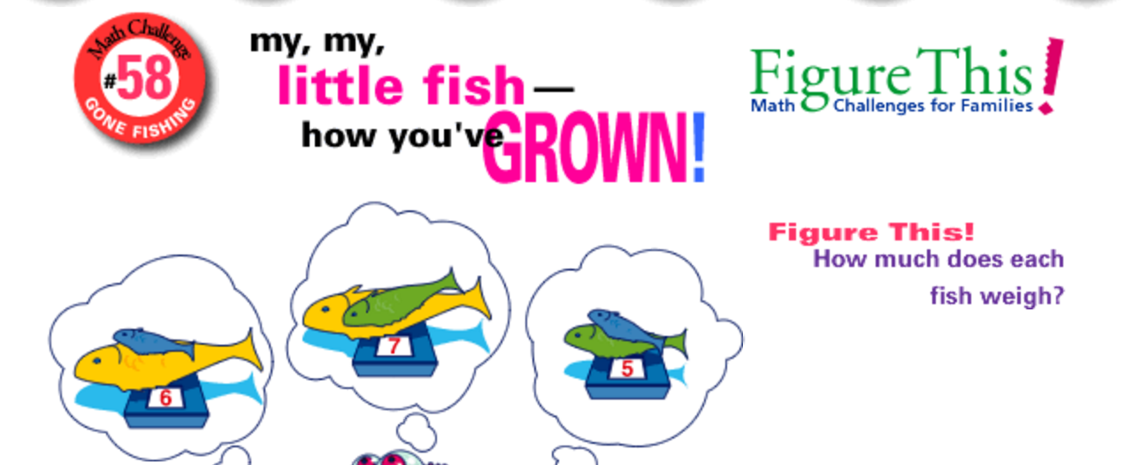

Engage: Place the above picture on the smart board. Give each group 2 construction paper fish of each color and an index card to use as their scale. They will arrange the fish and the cards however they wish to best organize the given information. They need to record the weight on the scale to start the problem.

Teacher support – Allow the students to utilize paper, markers, small white boards, or ipads. The initial goal of this lesson is for them identify what they already know from the given information. If they struggle getting started, prompt them to discuss what they know from the picture and write it down.

Explore: Working in groups, the students will define variables and write equations for the known information. The students will need to discuss what they do know in order to substitute known information from one equation into another equation to solve the problem. Since there are multiple ways to solve this, they have many possible paths to lead to a solution. If some groups solve it more quickly, they can be instructed to see if they can find an alternative way to solve the problem.

Explain: Students groups will determine a method of sharing their solution with the class. They must share how they defined their variables and the relationship between the variables by either drawing a picture or writing an equation. The groups can choose to share on the smart board, the large white boards, holding up their small white boards, or staying in their place and verbalizing the solution.

Teacher Support: The explanation stage is a place to reinforce the need to define variables and the parts of an equation. This is also a place to identify possible misunderstandings of combining like terms. (for example: a blue fish and a yellow fish cannot be added together to make a striped fish). It is also a place to identify errors in substituting for variables, order of operations, and computations.

Extend: Change the weights on the original problem so that the solutions are not integers but decimals or fractions and have them solve it again. Do not tell them the solutions will not be integers. Equations with decimals and fractions are difficult for middle school students and they often don’t think their answer could possibly be correct unless it’s an integer or whole number. This scenario is a good place to demonstrate that rarely do fish (or anything) weigh exactly 4 pounds which is why working with decimals and fractions is more realistic.

Depending on the class period, a 3rd colored fish could also be added requiring an equation with a 3rd variable. This may be an appropriate extend for one of the honors periods.

UDL Considerations:

Information is given in a picture, with manipulatives and verbally.

Students can share their solutions in a variety of ways and work with their choice of materials including their device.

