Lesson Plan: Probability

Overview
The students will discover basic probabilistic concepts via physical manipulatives, computer simulations, and their textbook.

Process Standards
- Make sense of problems and persevere in solving them.
- Reason abstractly and quantitatively.
- Model with mathematics.
- Use appropriate tools strategically.
Content Standards
PS.P.1: Understand and use the addition rule to calculate probabilities for mutually exclusive and nonmutually exclusive events.

PS.P.2: Understand and use the multiplication rule to calculate probabilities for independent and dependent events. Understand that two events A and B are independent if the probability of A and B occurring together is the product of their probabilities, and use this characterization to determine if they are independent.
PS.P.4: Calculate the probabilities of complementary events.

PS.P.10: Describe events as subsets of a sample space (the set of outcomes) using characteristics (or categories) of the outcomes, or as unions, intersections, or complements of other events.

Engagement
- Work individually or in pairs/small groups with manipulatives such as dice and cards to determine how the probabilities of various events are calculated.
- Access Microsoft Excel to see how performing simple tasks many times (i.e. rolling dice) makes probabilities of each possible outcome approach the true long-term probabilities.
- Answer challenging questions put on board that will stimulate those who may already have a solid grasp on the concepts being introduced.

Essential Questions
- What values may a probability take? What do they represent, especially the endpoints?
- What is the sum of all possible probabilities of an event?
- What does it mean for something to be the complement of the event? How does an event compare to its complement?
- How do we figure out the joint probability of multiple events?
- Why do probabilities not always work out the way we might expect?

Objectives
The students will be able to…
- Determine basic probabilities involving dice or drawing cards from a standard deck.
- Understand basic probabilistic terminology, such as sample space, complement, joint probability, mutually exclusive.
- Experience through simulation how probabilities converge as the number of trials increases.

Procedures
The classroom will be set up approximately as via the drawing shown below:
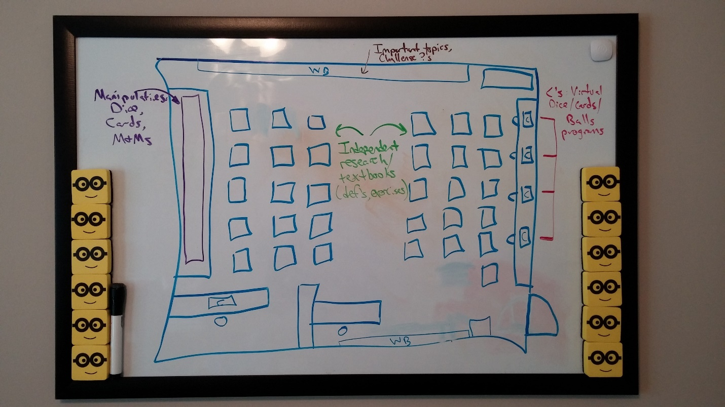
- Before class: As students enter the room, have them choose (something with 3 possible c
- hoices) at random. This will determine their starting station.
- Introduce “stations” – 3-D objects (manipulatives), Independent research, Computers. Split class into three equal sections and discuss rotation scheme. – 3 minutes
- First rotation – 12 minutes
- Second rotation – 12 minutes
- Third rotation – 12 minutes
- Wrap-up – Assign exit ticket. Discuss what was learned by asking students what they liked most and why. Review important terms.– 6 minutes

Co-Teaching Model
- One teacher is at the board at all times, helping students with key terminology and answering questions for those working with their textbooks.
- The other teacher roams around the manipulatives and computers, assisting if there are any questions and asking what they like/dislike about this station.

Resources/Materials
- Manipulatives, terminology, simulations worksheets
- Dice
- Decks of cards
- Computers open to Microsoft Excel

Assessment/Evaluation
- Exit ticket: Which activity was most valuable to you? Why?
- Have teachers ask questions of students at particular stations.

Inquiry 4Ex2 Model
Engage:
- Manipulatives
  - Dice
    - What are the possible values from a roll?
    - What do you think is the probability of rolling a pre-determined number?
  - Cards
    - What do you think is the probability of drawing a card that is a pre-determined suit?
    - What happens if you draw a card? What changes now?
- Textbook/Board/Challenge Station
  - Challenge questions – what can we learn about long-term behavior of probabilistic events?
- Computer Station
  - How likely do you think it is to roll a sum of 2? Sum of 7?

Explore:
- Manipulatives
  - Dice
    - Roll 6 times and record. Was it unusual or common? Why?
  - Cards
    - Draw, what is new probability of same suit on next draw?
    - Draw 4. Were they unusual or common? Why?
- Textbook/Board/Challenge Station
  - Going through section of book independently, at own pace. Absorbing the material students find interesting, with questions guiding what is most important.
- Computer Station
  - Filling in “random” dice rolls using Excel RANDBETWEEN function
  - Constructing histograms and observing behavior of many simulated rolls
    - Comparing/contrasting two sets of rolls

Explain:
- Manipulatives
  - Dice
    - Teacher available to answer questions at station during inquiry Day 1; formal explanation on inquiry Day 2
  - Cards
    - Teacher available to answer questions at station during inquiry Day 1; formal explanation on inquiry Day 2
- Textbook/Board/Challenge Station
  - Textbook provides explanations of key concepts, both relevant to other stations and probability more generally
  - Formal explanation on inquiry Day 2
- Computer Station
  - Formal explanation on inquiry Day 2

Extend:
- Manipulatives
  - Dice
    - If you rolled 6,000 times how many times for each number would you expect? What is unusual?
      - Is it possible for the same number to come up 6,000 times?
  - Cards
    - Which is more likely to be drawn: a set of 4 pre-determined “boring” cards, or four aces?
- Textbook/Board/Challenge Station
  - Challenge problems
    - 10 coin flips, all heads. What is probability? Probability of next being tails?
    - Probability of drawing a flush in 5 cards?
    - Probability of rolling a sum of 2? 7?
      - Wagering: how much of a payout necessary to come out even in the long run?
- Computer Station
  - What would you expect the distribution of 6,000 single-die rolls to look like?
  - Distribution of sum of two dice (no longer uniform, but t -> normal). How is this different from distribution of single die?

UDL Strategies
- 3-D manipulatives for kinesthetic learners. Also, this station doesn’t feature seats so students can stand/move around as needed.
- Interactive computer-based simulation. Students can perform simulations at their own pace, and the size of the text/pictures on the screen can be changed easily for those with vision complications.
- Provides multiple examples of the same topics.
- Highlighting important information/vocabulary on the board for those who have trouble cognitively drawing out the important features in a lesson.
- Providing challenge problems on the board for those gifted and talented students who would otherwise not be challenged by the lesson’s activities.
- Allow students to verbally answer exit ticket by telling everyone what they liked most, instead of writing it out. The teacher will make sure to record those who participated verbally and give appropriate credit.

See separate document, “Inquiry Lesson 1 Handouts”, for a more complete idea of what will be happening at each station.

