Section 4.6 – The Quadratic Function and the Discriminant
Group 1
PART A
Take a pipe cleaner, and place it on the graph below. What shape does it make? How many times does it touch the x-axis?
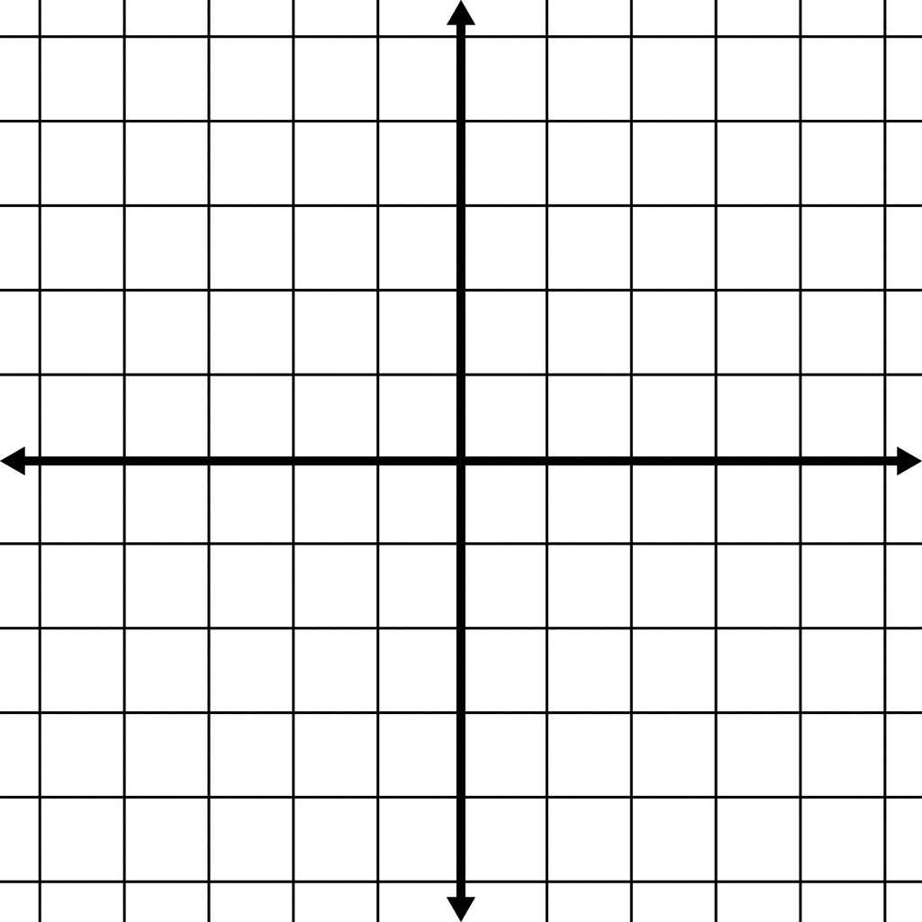
Now, what does a quadratic function look like on the graph? Create one with your pipe cleaner.

What are the possibilities for how many times a quadratic function can touch the x-axis? Think about this on your own, and write down your answer.

When you’re ready, find a partner and share your answer with them. Do you agree?

PART B
Quadratic functions have the form ax² + bx + c = 0.
The QUADRATIC FORMULA is the following: $x=\frac{-b±\sqrt{b^{2}-4ac}}{2a}$ .
When we use the quadratic formula, what do you think the result represents? (HINT: When you were working with graphing and factoring before, what did the answers represent? You may want to use your pipe cleaners to visualize the graph again.)

Starting with the function x² - 10x -11 = 0, use the quadratic formula, and find the answers. You should end up with two answers that are whole numbers. You may work with a partner on this problem.

What do your answers mean? Graph the parabola on desmos.com (type in y = x² – 10x – 11). What is the connection between the answers you got, and the graph?

PART C
Compute the following square roots. Everyone in your group can help, but you need to understand how all of them are computed.

$\sqrt{81}$= $\sqrt{-1 }$= $\sqrt{48}$= $\sqrt{-48 }$= $\sqrt{0 }$=
$\sqrt{-8}$= $\sqrt{8 }$= $\sqrt{-36 }$= $\sqrt{121}$= $\sqrt{-49 }$=

Organize the answers into groups that are meaningful to you. Name each group, and put all the answers that belong to each group under that group’s name.
Example: Group I Group II Group III
Sample answers Sample answers Sample answers

Within the quadratic formula $\left(x=\frac{-b±\sqrt{b^{2}-4ac}}{2a}\right)$ is the quantity inside the square root: b²-4ac. This quantity is called the discriminant, and it always falls into one of the groups you described just above:
Case 1:

Case 2:

Case 3:

PART D
How far is the world record for punkin’ chunkin’? Let’s use the quadratic formula!
The equation for the parabola is -x² + 4593x + 138690 = 0.
Before you solve, what group would you expect the discriminant to fall into?

Use the quadratic formula to solve. How far did the pumpkin travel, in feet?

Exit Ticket NAME:_____________________
What do the x-values you get as solutions to the quadratic function represent?

What is the formula for the discriminant?

Suppose you use the quadratic formula and you get the discriminant to equal 17. How many solutions are there? Is/Are the solution(s) real or complex?

