Overview
Reading the chapter book the BFG by: Roald Dahl illustrated by: Quentin Blake
English Language Arts grade 3
The students will be doing vocabulary stick notes in each chapter, have a vocabulary quiz at the end of 3 chapters after being given a list of words, have chapter quizzes for understanding after each chapter, they will write a letter to the BFG describing their dreams and a readers theater on the BFG if there is time. Also at the end of the book the students will take a final book quiz. Then we will watch the movie and talk about the differences between the movie and the book.

1. The students will be going through the chapter that was read the day before and choose two words that they were not familiar with and put them on a sticky note and stick the sticky note to the BFG vocabulary wall for the class to go over for that day and figure out the word and definitions, they will be given 10 minutes to do this as a warm up in the beginning of class. The teacher will make a list of all the vocabulary words and give to the students to study for the vocabulary quizzes after three chapters of reading in the book.

2. The students will be completing a 5-question quiz after each chapter to check for understanding of the chapter.

3. The students will be writing a three paragraph structured letter on lined paper to the BFG about their dreams then they will draw a picture of their dreams and staple the picture and letter to a bigger piece of construction paper that will be provided by the teacher when the letter and the picture are completed and edited by the teacher for content appropriateness.

4. The students will be acting out one scene from the book in a Reader’s Theater and we will invite another class to come watch it.

5. The students will watch the movie the BFG after we finish reading the book and they have completed all of the assignments and book quizzes, then the students and the teacher will make a ven diagram on the movie and book comparison this will complete the BFG Unit.

Learning Objectives

- Students will choose 2 words that they do not know and put them on a sticky note.
- Students will remember the main points of a chapter and complete a 5-question assessment.
- Students will write a three-paragraph letter that has all 4 major parts of a letter (Greeting, Body, closing, signature of letter writer).
- Students will fluently read lines from one scene in the BFG and act it out in front of the class.
- Students will orally compare the BFG movie to the book.
Learning objectives | Academic standards | Bloom’s Level | Item alignment
Sticky note vocabulary  Objective 1 | 3.RV.2.4 Use a known word as a clue to the meaning of an unknown word with the same root, and identify when an affix is added to a known root word | Understanding, Creating | Pre-assessment  1,2  Unit test 1,2,3
Chapter Quizzes Objective 2 | 3.RL.2.1 Ask and answer questions to demonstrate understanding of a text, referring explicitly to the text as the  Basis for the answers. | Understanding, Remembering | Pre-assessment  4,5  Unit test  4,5,6,7,8,9,10,11,  12,13,14
Letter to the BFG Objective 3 | 3.RL.3.2 Distinguish personal point of view from that of the narrator or those of the characters. 3.W.3.3 Write narrative compositions in a variety of forms that –•Establish an introduction (e.g., situation, narrator, characters). •  Include specific descriptive details and clear event sequences.  •Include dialogue. •  Connect ideas and events using introduction and transition words. • Provide an ending. | Creating, Applying Understanding | Rubric  performance  assessment  Pre-assessment 3  Unit test 16
Reader’s Theater Objective 4 | 3.SL.3.1 Retell, paraphrase, and explain the main ideas and supporting details of a text read aloud or information presented in diverse media and formats, including visually, quantitatively (e.g., charts and graphs), and orally. | Creating, Understanding | Confidence  builder  As a class.  Graded on  Perticitation  Everyone has a  role
Comparison of book and movie Objective 5 | 3.SL.2.3  Demonstrate knowledge and use of agreed-upon rules for discussions and identify and serve in roles for  Small group discussions or projects.  3.SL.2.2  Explore ideas under discussion by drawing on readings and other information. | Understanding, Evaluating, Creating | Unit Test 6

Sources
IDOE.gov standards
www.scholastic.com
The book the BFG by: Roald Dahl illustrated by: Quentin Blake
Used rubric form this class and changed
Our textbook: Popham, j. W (2017) “Classroom Assessment what teachers need to know. ” Pearson.
http://www.scholastic.com/home/
https://create.kahoot.it/#login?next= Kahoot

State standards to use
Sticky note words
3.RF.4.2 Understand the six major syllable patterns (CVC, CVr, V, VV, VCe, Cle) to aid in decoding unknown words.

Chapter Quizzes
3.RL.2.1 Ask and answer questions to demonstrate understanding of a text, referring explicitly to the text as the
basis for the answers.

Letter to the BFG
3.RL.3.2 Distinguish personal point of view from that of the narrator or those of the characters.

Reader’s Theater
3.SL.2.3 Demonstrate knowledge and use of agreed-upon rules for discussions and identify and serve in roles for
small group discussions or projects.

Performance assessment description
The students will be writing a letter to the BFG about their dreams of the future. They will be learning the letter writing format the structure with four parts, Opening, body, closing, signature of the letter writer. They will write the letter on lined paper and make it as neatly as they can. This is Learning Objective 3. The students will also write 3 paragraphs with three sentences each for a total of 9 sentences for this assignment. This will be a writing standard from the IDOE also the standard is: 3.RL.3.2 Distinguish personal point of view from that of the narrator or those of the characters.

Performance Assessment Writing a three paragraph letter to the Big Friendly Giant
Assignment worth 15 points
Scale is from 1 to 3 points on the requirements listed in the rubric
Criteria | Unsatisfactory | Satisfactory | Excellent | Total score
 | 1 point | 2 points | 3 points
Letter format  Has all the parts of a letter (Greeting, Body, closing, signature of writer)  1 | Has 2 or less parts of the four part letter | Has 3 parts of the letter | Has all 4 parts of the letter
Body of letter is 3 paragraphs long with 3 sentences in each paragraph (9 sentence total)  2 | Less than three paragraphs with less than three sentences in each paragraph | Has three paragraphs with 3 sentences in at least 2 paragraphs | Have all three paragraphs with 3 sentences each for a total of 9 sentences.
The presentation of the letter is neat and in Letter writing order. (1. Opening, 2. Body, 3. Closing, 4. Signature of writer). 3 | 3 or more elements Not in letter writing order1. Opening, 2. Body, 3. Closing, 4. Signature of writer). And or not neatly written. | 2 elements not in letter writing or partially neatly written | All elements in letter writing order 1. Opening, 2. Body, 3. Closing, 4. Signature of writer). And neatly written
Assignment deadline meets Due Date requirement  4 | Did not turn in assignment. Or assignment is turned in two to three days late. | Turned in a day past the due date. Or Assignment turned in one day late. | Turned in on time
Letter stays on topic of “what are you future dreams”. 5 | Does not stay on topic. | Partially stays on topic. | Stays on topic
Total Points Earned |  |  |  | / 15

Pre Assessment for the BFG

Phase 2 Assessments
I need to come up with a baseline data point for the level of vocabulary that my future students can comprehend and define. So I will have a 5-question quiz on vocabulary and sentence writing and reading a passage and answering questions related to the passage. Question 1 and 2. Vocab. Words different reading levels to determine level of reading. Question 3 write a sentence about what are your dreams?
Questions 4 and 5 read passage and answer the questions. See pre-assessment below.

Pre-Assessment
Name___________________________ Date______________________________
Please answer the questions below.

- Pick the best definition that defines the word Orphan?
- a child with no parents
- a child that lives with their mom
- a child that lives with their dad

- Pick the definition that best defines the word moonlight?
- light that comes from the sun
- light that comes from the moon
- light that comes from a light bulb

- Write one sentence that describes what you dream of being in the future? Example (Doctor, Teacher, Factory Worker…..).
____________________________________________________________________________________________________________________________________________________________________________________________________________________________________________________________________________________________________________________________________________________________________________________________________________________________________

Read the passage below and answer the two questions that follow numbers 4 and 5 that go with the passage. (You can use the passage to answer the questions.)

The cat went up on the windowsill to take a nap in the sun. When the cat looked down from the window and saw a mouse on the floor. So the cat jumped down from the window and ran after the mouse. The mouse ran into a hole in the wall and disappeared. The cat waited outside the hole in the wall for the mouse to come back. The cat fell asleep while waiting. Once the cat was asleep the mouse ran out of the hole and outside the house to his home in the country where he lived with his family. The cat woke up and realized the mouse was gone she was very sad but went back to the windowsill and went to sleep.

Answer the following questions about the passage by picking the letter that best answers the question.

- Where was the mouse when the cat first saw it?
- floor
- bookshelf
- kitchen

- What did the cat do while waiting for the mouse to come out of the hole in the wall?

- ran in circles
- fell asleep
- drank some milk

Unit Test for the book the BFG written by: Roald Dahl

Name________________________________ Date___________________________
Answer the following questions on the book the BFG. There are multiple choice questions, true and false and one constructed response. This unit test is worth 35 points.

Multiple Choice

1. Pick the best definition that defines the word Orphan?
- a child with no parents
B. a child that lives with their mom
C .a child that lives with their dad

- Pick the definition that best defines the word moonlight?
A. light that comes from the sun
B. light that comes from the moon
C. light that comes from a light bulb

- Pick the definition that best defines the word Dream?
- Something that you really want to come true
- Something that happens when you try your best
- Both A and B

4. In the book the BFG what was the BFG’s job in the human world?
A. baker
B. Dream Giver to children
C. Police Officer

5. Who did the BFG and Sophie go to for help to capture the other bad giants?
- The police
- The Queen of England
- Sophie’s teacher

- What happened to the bad giants at the end of the book?
- they were put on their own island
- They were put in a cave
- They were put in a cavern and fed snozzcumbers

- What do the letters BFG stand for?
- Big Friendly Giant
- Bob Finds Grass
- Big Frankenstein Gathering

- What was Dream Country?
- Were the BFG kept all the dreams
- A country dream cottage
- The BFG’s closet

- What was the name of the only food the BFG had eaten?
- Starburst
- Snozzcumbers
- Steak

- True or False the BFG was a Friendly Giant?
- True
- False

- True or False The bad giants LIKE the BFG?
- true
- False

- What does the BFG eat at the palace for breakfast for the first time ever?
- Bacon and eggs
- Oatmeal
- A pop tarts

- What does Frobscottle help the BFG to do?
- sing a song
- whizzpopp
- catch a dream

- What does the BFG make Sophie?
A. a scarf
B. a new dress
C. a pair of shoes

- Who is the author of the book the BFG?
- Shel Silverstein
- Roald Dahl
- J. K Rowlings

16. The following is a constructed Response and it is worth 5 points. Please write at least 5 sentences about what you DREAM of becoming in the future? (examples Doctor, Teacher, Movie Star etc.)?

Unit Test for the book the BFG written by: Roald Dahl Answer Key

Name________________________________ Date___________________________
Answer the following questions on the book the BFG. There are multiple choice questions, true and false and one constructed response. This unit test is worth 35 points.

Multiple Choice

1. Pick the best definition that defines the word Orphan?
A .a child with no parents
B. a child that lives with their mom
C .a child that lives with their dad

- Pick the definition that best defines the word moonlight?
A. light that comes from the sun
B. light that comes from the moon
C. light that comes from a light bulb

- Pick the definition that best defines the word Dream?
- Something that you really want to come true
- Something that happens when you try your best
- Both A and B

4. In the book the BFG what was the BFG’s job in the human world?
A. baker
B. Dream Giver to children
C. Police Officer

5. Who did the BFG and Sophie go to for help to capture the other bad giants?
- The police
B The Queen of England
C Sophie’s teacher

- What happened to the bad giants at the end of the book?
A. they were put on their own island
- They were put in a cave
- They were put in a cavern and fed snozzcumbers
- What do the letters BFG stand for?
A Big Friendly Giant
B Bob Finds Grass
C Big Frankenstein Gathering

- What was Dream Country?
A.Were the BFG kept all the dreams
B A country dream cottage
C The BFG’s closet

- What was the name of the only food the BFG had eaten?
A.Starburst
B.Snozzcumbers
C Steak

- True or False the BFG was a Friendly Giant?
A True
B False

- True or False The bad giants LIKE the BFG?
- true
B False

- What does the BFG eat at the palace for breakfast for the first time ever?
A Bacon and eggs
B Oatmeal
C A pop tarts

- What does Frobscottle help the BFG to do?
A sing a song
B whizzpopp
C catch a dream

- What does the BFG make for Sophie?
A. a scarf
B. a new dress
C. a pair of shoes

- Who is the author of the book the BFG?
A Shel Silverstein
B Roald Dahl
C J. K Rowlings

16. The following is a constructed Response and it is worth 5 points. Please write at least 5 sentences about what you DREAM of becoming in the future? (examples Doctor, Teacher, Movie Star etc.) Answers may vary depending on students thoughts but the structure is 5 sentences. Will be graded on complete sentences and having all 5 sentences.

Phase 3 Activities

1. The students will be going through the chapter that was read the day before and choose two words that they were NOT familiar with and put them on a sticky note and stick the sticky note to the BFG vocabulary wall for the class to go over for that day, we will figure out the word and definitions by using a dictionary or technology, they will be given 10 minutes to do get the words and put them on sticky notes. This is a warm up in the beginning of class. The teacher will make a list of all the vocabulary words and give to the students to study for the vocabulary quizzes after three chapters of reading in the book. If needed a larger vocabulary quiz can be given along side the Unit Test to gather assessment data points. Blooms levels for understanding, creating. This helps my assessment because there are vocabulary words for this list on the unit test and the pre-assessment.

2. The students will be completing a 5-question quiz after each chapter to check for understanding of the chapter. We will read the chapter the day before and discuss it to review then the students will complete a 5-question quiz on the chapter. These questions will help to build the unit test at the end of the book. That way the teacher can see the understanding progress throughout the book and at the end with the unit test. This would be progress monitoring these smaller chapter quizzes will help to create my unit test I will use the questions from these smaller quizzes to create the larger unit test.

3. The students will be writing a three paragraph structured letter on lined paper to the BFG about their dreams then they will draw a picture of their dreams and staple the picture and letter to a bigger piece of construction paper that will be provided by the teacher when the letter and the picture are completed and edited by the teacher for content appropriateness. This assignment has a rubric or performance assessment to go along with it. The students will be learning the structure of a letter in four main parts: opening, body, closing, and signature of the writer. This will be a friendly letter format. This assignment will contain all 4 parts of a letter that we go over in class; it will also contain 3 sentences in each of the 3 paragraphs for a total of 9 sentences in this assignment. (Unless other accommodations are specified). This could be performance assessment there will be a written response on the unit test so this will help the students to practice writing for the unit test.

4. The students will be acting out one scene from the book in a Reader’s Theater and we will invite another class to come watch it. This will help to build fluency and confidence in the reader. Every student will have a part in this and the grading will be based on if the participate or not. This is to be a confidence builder for students to get up and read and act out a scene with there peers, this will also help the social aspect for some children. Blooms level or Creating, and Understanding and applying.

5. The students will watch the movie the BFG after we finish reading the book and they have completed all of the assignments and book quizzes, then the students and the teacher will make a ven diagram on the movie and book comparison this will complete the BFG Unit. This is a class or group activity that we will complete. This is to promote verbal knowledge and confidence in-group discussions. Also this will be an informal assessment of how students compare what they see to what they have read. We will note the differences between the movie and the book and design a ven-Diagram to show the differences and similarities of the book and the movie.
Blooms levels of understanding, creating, remembering and applying.

One source that will be very valuable to my teaching career is http://www.scholastic.com/home/ This site has lots of different lesson plans and skills and standards that you can use. I would like to get a membership to this and have my students do scholastic news there is a paper version for the students and a digital one for the teachers with videos and extra things for teachers to extend their lesson plans and the scholastic news has an assessment of student knowledge on the back of each issue too.

Phase 4 Reflection of LAMP LITE Unit

Reflection for LAMP Lite unit

We completed a LAMP Lite project for EdPsych 345 in the Fall of 2016 this was to give us a chance to experience what the LAMP unit would kind of be like when we student teach. I am so glad we got a chance to do this so that we can see what we will have to do in depth when student teaching. I had a hard time picking a unit topic there are so many things to choose from. And I learned that learning objectives can be long or short but shorter and more concise was better. This was a great assignment to bring all of the components of this class together and let us refine what we have learned form this class. Once I choose my topic for my unit it was not to hard to come up with things to do for it. Making the assessment was a little harder than I expected. The pre-assessment was the hardest thing I struggled to think about what I wanted to assess before reading this book. After the students read the book I had way more questions that I could ask but trying to come up with the pre-assessment was tough. I see now why a pr-assessment is rougher than the assessments. To collect pre-assessment data point you have to think ahead to the end and kind of figure out what data you want to collect and what data points are most important to you as a teacher. Or what you are trying to collect data on exactly. I really enjoyed doing this LAMP Lite unit for a couple reasons, first it gave me an idea what I will be doing while student teaching, second I learned how to go from pre-assessment to learning objective to instruction to completing the unit with an assessment to see the learning process. It also made me think of how to come up with the data points I want to prove and how to make a pre-assessment I need a little more practice with that part this assignment gave me a chance to see where my strengths and weaknesses are before my student teaching I appreciate that. This will give me a chance to work on what I am weak in and ask some more questions before I student teach. We put our unit in an LMS Learning Management System we used Canvas. We also explored the Canvas app and Kahoot and other learning response systems. I learned a lot I did not realize there were so many different LMS’s.

Here is the Link to our canvas assignments
https://ice.instructure.com/courses/119/assignments
teacher canvas

This is a picture of my unit on Canvas with all of my activities.

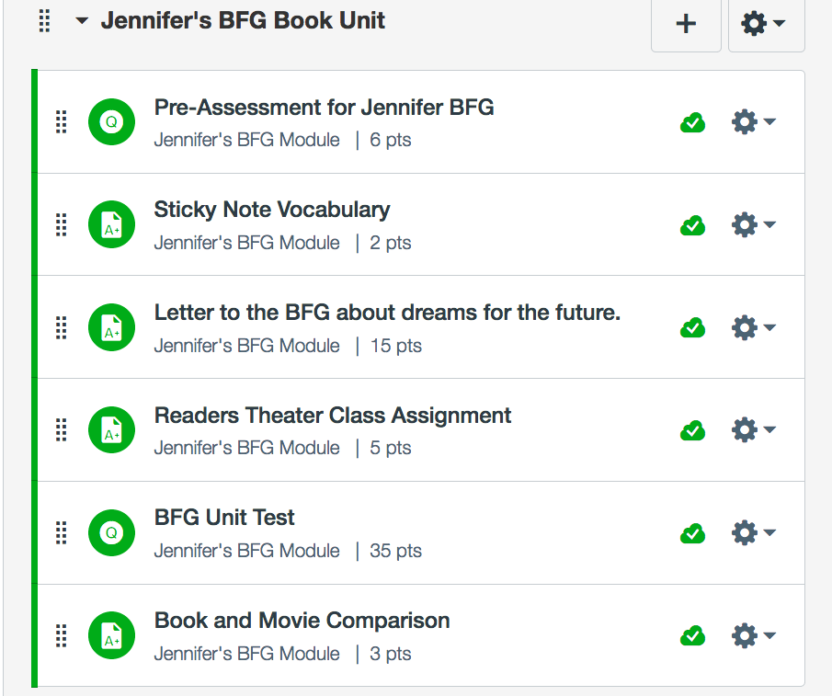

This is part of my Pre-Assessment I have a variety of questions but for the Pre-Assessment there are only 5 questions.
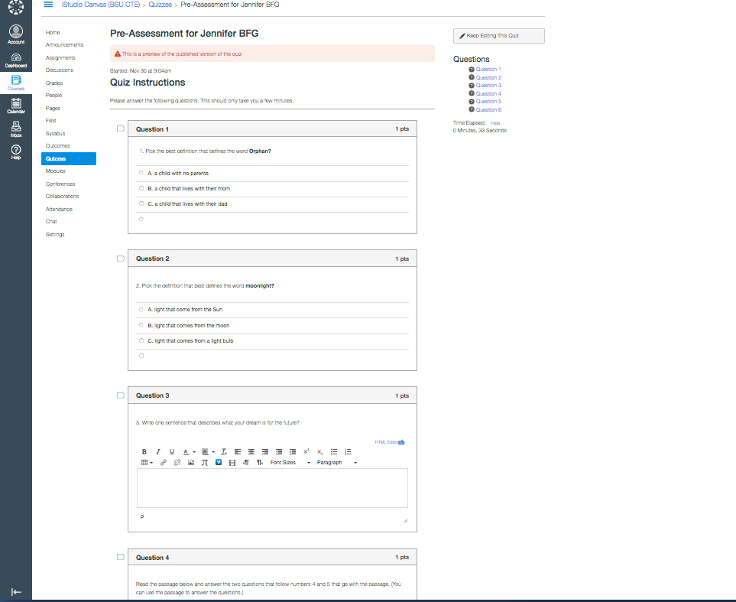

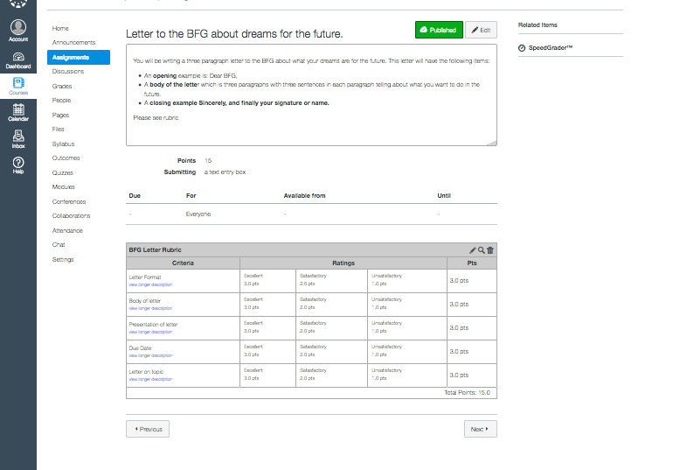
This is what the teacher view of the letter to the BFG looks like in Canvas I have attached a rubric in Canvas.

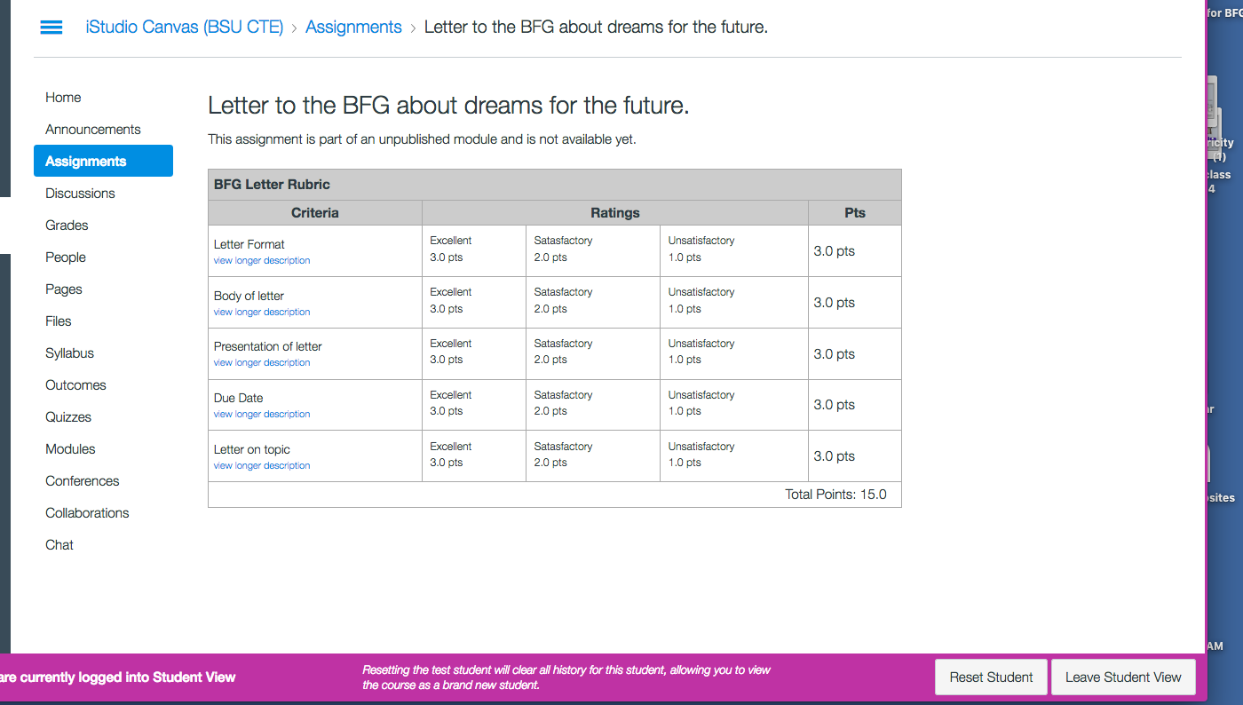
This is the student view of the letter to BFG assignment it looks a bit different and it is not yet unlocked due to the due dates not being set for the other modules. I need to go back and fix the due dates so that this can be open.

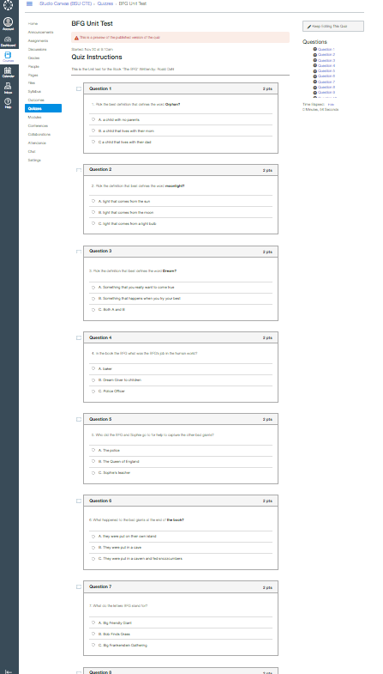
This is an example of some of the questions I will be asking on the unit test for the book “The BFG” by: Roald Dahl.

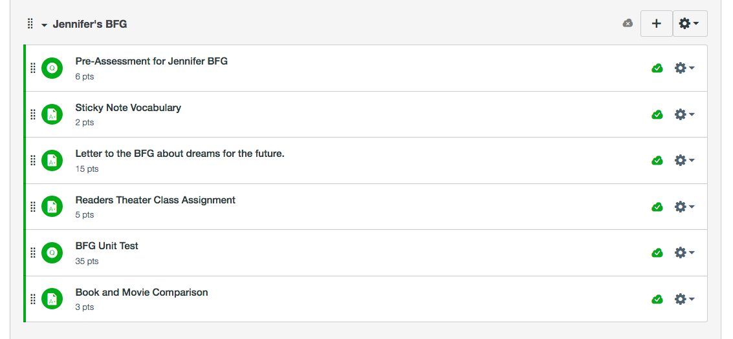
Lastly in this assignment LAMP Lite we learned how to put all the assignments into a module. This is my module.

Another Option besides Canvas would be Kahoot I am not familiar with that but I am going to explore that further in the future. I do know the website for that is: https://create.kahoot.it/#login?next= I just have to set up a free account and then create games and things for my students.

Description of Lamp lite

I wrote this Lamp Lite unit for Edpsych 345 the Fall of 2016 so that we could have an idea of what we will be doing in our student teaching experience. We picked a topic and then came up with instructional activities, learning objectives, a pre-assessment a rubric for one of our activities, then an overall unit test or assessment. Then we are going to present one aspect of this in class and video ourselves teaching and then analyze this teaching recording. I am also putting this on a Canvas site so that we can learn how to do a system like Canvas. This is similar to Blackboard for BSU students or Rgrade.

Rationale

I included this in my portfolio so that I had a completed unit that I can use later in either my student teaching experience or in my teaching career. This Lamp Lite unit can be aligned to several INTASC standards. The pre-assessment can be aligned to INTASC 6 Assessment and how teachers develop assessments for their classrooms. It can also be aligned to INTASC 1 Learner Development because it can track a students leering through the entire unit, essential knowledge 1(d) where the teacher understand how learning takes place the pre-assessment or the chapter tests can show this. Also INTASC 4 Content knowledge the rubric and chapter tests can help with knowing how the student is understanding the book so far. It can also be aligned to INTASC 7 Planning for instruction if students can retain the instruction that has been done if not then the teacher may have to due something different or slow down based on the chapter tests. This unit helped us to get a feel for what our student teaching experience will be like since our experience will be rubric based in nature as well as instruction based in nature.

