This survey was assembled using Qualtrics.com. By using this website, I was able to create an anonymous survey for fellow college students about the on-campus organization College Mentors for Kids. Because of my involvement in the group, this survey was very beneficial in giving me feedback for the future. I am better aware as to who has head about the program and how word about the program is spreading. The results are honest, however, somewhat biased towards children because every one who took my survey are future educators, which could skew the results to hearing about the organization in class and being comfortable when talking to children.

Rationale: This survey can relate to InTASC #6. The data I have collected will give me a path to follow if I want this program to continue to grow. Using this InTASC standard and the data collected will allow me to focus in on the places that are going well for the program and spend more time filling in the gaps where they are not going well.

On new page.

This survey was assembled using Qualtrics.com. By using this website, I was able to create an anonymous survey for fellow college students about the on-campus organization College Mentors for Kids. Because of my involvement in the group, this survey was very beneficial in giving me feedback for the future. I am better aware as to who has head about the program and how word about the program is spreading. The results are honest, however, somewhat biased towards children because every one who took my survey are future educators, which could skew the results to hearing about the organization in class and being comfortable when talking to children.

Below, you will see my first question: I understand that my results will be kept anonymous. For this survey, I am not interested in who the people are who answer my survey; I only care about the results. I also want people to feel comfortable answering the questions honestly, which is why I kept the survey anonymous. In the second picture below, you can see that 13 people understand their results will not be shared, while three people do not understand. Nonetheless, each person answered this question honestly. For the persons who did not understand that the survey would be kept anonymous, this was the only question; the survey ended here.
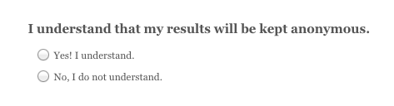

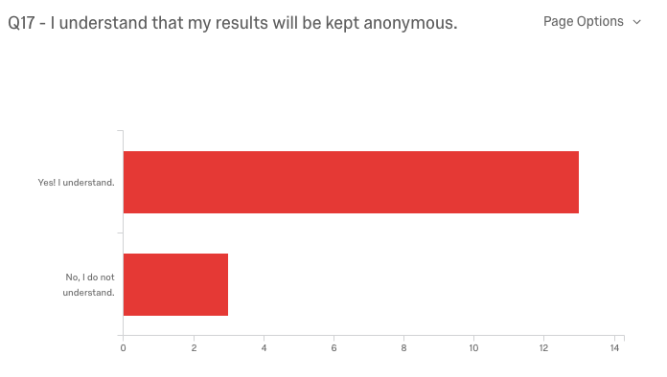

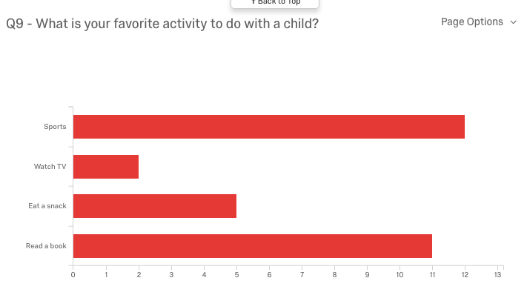
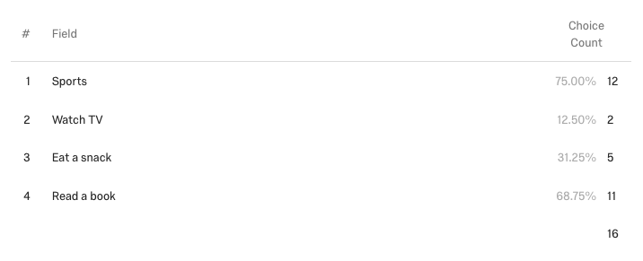
One of the other questions asked allowed more than result. Below, you can see that one question asked a favorite activity to do with a child. The two most popular results were sports and reading a book. I find this data very beneficial for two reasons. One, adults realize that sitting and eating a snack or watching TV are not the best ways to interact with a student. And the other reason why I find this so beneficial is because at every College Mentors for Kids day when the little buddies come to campus, there are physical activities involved as well as reading a book. I am reminded that the program is doing what others enjoy as well.

From the results accumulated, I found most interest in the fact that most adults who answered this survey prefer to work with 2nd graders. This could be for a variety of reasons: lots of energy, cute, never a dull moment, mature but still needy, etc. While I am not sure what the reason is at this moment, if I had to redo the survey, I would include a section in for the adults to explain why they chose that particular grade. Because I do not have the chance to revise my survey now, I will keep that in mind for the future.

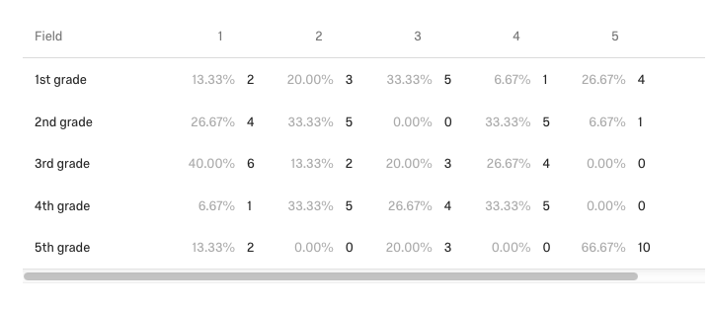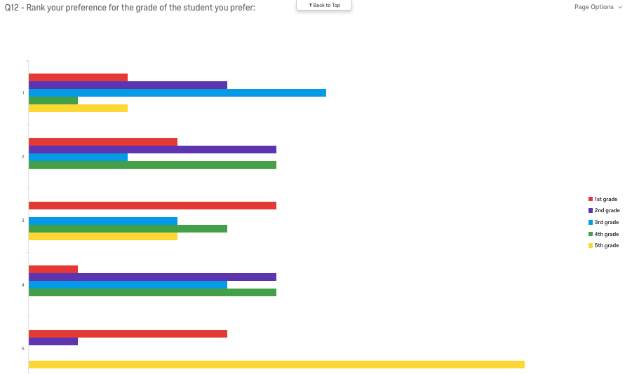

With this being my first survey, I am proud of how the results came back. I did not receive feedback about anyone being confused or unsure about the questions I was asking, which is always a positive. However, I would make changes if I would ask this survey again. For example, I would give a chance for those taking my survey to add any additional information at the end of the survey. I believe this is important for people to ‘own’ their results.

Categories:
InTASC 6

Tags:
Assessment
Survey

