Phase 1: Identify Desired Results
  - Overview: This is a lesson plan that focuses on teaching numbers to students and helps them to improve their number skills so that they are ready to enter the public-school setting. We will administer a pretest at the beginning of the year to assess their skills and at the half way point at the year to see their progress. We will also have conferences with the other teachers and parents of each student to discuss their progress and where to go from there. Students will perform tasks and practice counting and improving number skills through activities and communication. This lesson will coincide with other lessons to work on their life skills and readiness to enter the public-school system.
    - Unit Title: Numbers
    - Grade and Content: Preschool numeracy
    - Description: This unit focuses on analyzing and improving number skills. Students will work on projects and activities that focus on their number recognition and skills such as games that involve numbers or projects that requires them to count out to a certain number.
    - Sources:
      - Indiana’s Early Learning Development Framework Aligned to the 2014 Indiana Academic Standards http://www.doe.in.gov/sites/default/files/earlylearning/foundations-2015-august-12.pdf
      - Bloom’s Taxonomy wheel given to us in class

  - Learning Objectives:
    - Students will be able to count 15 beads out of a bowl full of beads for keychain making activity.
      - Bloom: Application
      - Standard: M1.1 going backwards from Kindergarten Standard K.NS.1: count to at least 100 by ones and tens and count one by one from any number
    - Students will be able to recognize numbers up to 10 and match each number in a version of the game “Go Fish!”
      - Bloom: Comprehension
      - Standard: M1.2 going backwards from Kindergarten Standard K.NS.2: Write whole numbers from 0 to 20 and recognize number words from 0 to 10. Represent a number of objects with a written numeral 0-20
    - Students will be able to recognize patterns ranging from 1 to 5 items without counting out the items.
      - Bloom: Analysis/Application
      - Standard: M1.1 going backwards from Kindergarten Standard K.NS.6: Recognize sets of 1 to 10 objects in a pattern arrangement and tell how many without counting.
    - Students will be able to recognize the difference in values of numbers when playing a game that works on number values. (the person with the larger number gets the card and they keep drawing until all cards are gone and whomever has the most cards wins)
      - Bloom: Evaluation/Analysis
      - Standard: M1.3 going backwards from Kindergarten Standard K.NS.8: Compare the values of two numbers from 1 to 20 represented as written numerals.
    - Students will be able to match numbers with their correct amount when given a flash card game.
      - Bloom: Comprehension
      - Standard: M1.2 going backwards from Kindergarten Standard K.NS.2: Write whole numbers from 0 to 20 and recognize number words from 0 to 10. Represent a number of objects with a written numeral 0-20
Phase 2: Design Assessments
  - Overview: At the beginning of the year I will be giving my students a pre-assessment to see their level of knowledge and what to cover. I will continue to use this same test to measure their knowledge as the year goes on. I will split it up into three sessions where I will determine student progress and what areas I need to work on more than others. During the Winter session, I will have the students make crafts involving counting and the Keychain project to see how they use their knowledge of counting and patterns. I will then give my students a test in the form of a scavenger hunt during the Spring session to assess their knowledge of numbers and their knowledge of the meaning of numbers.
  - Pre-Assessment: I will be giving parents a survey in which they will tell me to the best of their abilities, their child’s counting and math abilities. I will use this in conjunction to my observation assessment that I will use as a formative and pre-assessment. It will serve as a way to gauge where to begin and how far to challenge my students. I used Google forms to create this survey as an easy way for parents to have access to it and for me to be able to make changes more easily when necessary.
    - https://docs.google.com/forms/d/e/1FAIpQLSfM6IJGCN3IJId6hfSF2WopaOWIeIT0FWuuB2_HU9fF-93XpA/viewform?usp=sf_link

  - Pre-assessment instrument/Formative assessment: I will be giving my students a pretest at the beginning of the year and will be in the form of a checklist. For this test, I will have them complete certain tasks and I will record their abilities. This test will also be used as a formative assessment as a way to track their progress and readiness for Kindergarten throughout the school year.

Task | Fall | Winter | Spring
Highest number they can count to in order. (goal is to count to 100 by end of preschool education)

Highest number they can count backwards from. (goal is to count backwards from 10)
Highest number they can write to in order. (goal is to write number symbols up to 20)
Highest number they can match values of (goal is to match number values up to 10)
Highest numbers they understand the concept of more and less than values in written numbers. (goal is to compare values from 1 to 20)

Highest number of objects they can recognize without counting. (goal is to recognize numbers of objects up to 10 without counting)

  - Performance Assessment:
    - Overview: Students will be able to count 15 beads out of a bowl full of beads for keychain making activity. Students will participate in a project activity. In this project, they will be making a key chain craft. There are to be 7 beads on two strings and one bead at the end on both strings to tie it off. This activity is meant to help students work on counting, patterns, and fine motor skills.
    - Rubric:
 | Novice  0-50% | Functional  51-75% | Expert  76-100% | Total
Comprehension  Demonstrate a Strong sense of counting.  M1.1 | Does not count the correct number of beads OR does not attempt to count | Struggles to count the correct number of beads on the first try (needs to check if amount is correct) AND obtains the correct amount | Counts out the correct number with ease OR does not needs to count based on pattern using to count beads | Row Score: ____/5  points
Recognition  Recognition of number relations.  M1.3 | Does not understand the concept of matching amounts OR does not know which string has more and which string has less | Recognizes one of their strings has more and which string has less beads AND does not fix it. | Recognizes that each string should be equal AND matches the correct number of beads on each string. | Row Score: ____/5 points
Pattern Accuracy  Demonstrates awareness of patterning  M2.2 | Beads are all on one string AND/OR there are an incorrect number of beads. | Beads are unevenly placed on each string AND/OR there are the incorrect number of beads. | Beads are evenly placed in the correct pattern AND there are the correct number of beads. | Row Score: ____/15 points
Total Score |  |  |  | ____/25 points

  - Unit Test: This test will take the form of an activity that they will complete in class almost like a scavenger hunt where they find the correct place and answer to the question being asked. They will have a teacher help them to write their answer to the essay question.
    - This test will cover counting and recognizing patterns in numbers, along with the ability to write numbers and assessing their opinion of the importance of numbers.

Counting Scavenger Hunt/Test Items over Numbers

Multiple Choice (2 pt. each)

Circle the correct number to answer each question.

- How many computers are in the computer room?

1 2 3 4

- How many toys are in the pool?

4 5 6 7

- How many rooms are in the school?

7 8 9 10

Write the correct number to the answers (4 pt. each)

- How many Crayons are in the Crayon boxes in the picture room?

- How many teachers are at the school?

Have a teacher help you to write the answer to the question (6 pt.)
- Why is it important to know numbers?

Answer Key: 1) 2, 2) 6, 3) 9, 4) 12, 5) 7, 6) their opinion, but should recognize what number help them to do or accomplish.
Unanswered  0 | Novice  1-2 | Basic  3-5 | Expert  6

Phase 3: Design Instructional Experiences
  - Fall: Pre-Assessment will be given on first day, then we will focus on counting and other standards set out by the state for kindergarten readiness. This assessment will be in the form of a checklist. For this test, I will have them complete certain tasks and I will record their abilities. This test will also be used as a formative assessment to track their progress and readiness for Kindergarten throughout the school year. We will also play a game of “Go Fish!” in this session where they will be expected to know and understand number values and match them correctly.
    - Task Analysis of “Go Fish!”: Student’s will try to recognize numbers and find their match. This will be facilitated through a game of “Go Fish!”

  - Winter: Formative Assessment will be given at the beginning of the session. This assessment is going to be the same as the pre-assessment. It will be meant to see much progress they have made between sessions and where they are having trouble. The assessment will let me know where I need to focus more and where I can advance material. They will then participate in an activity where they create a keychain to take home to their parents. The Keychain will serve as a performance assessment to measure their abilities in counting, patterns, and task completion. The students will then play a flash card game with me where I hold up a card and they are to tell me what the number is.
    - Task Analysis of Flash Card Game: Students will try to recognize numbers written on a card. This will be facilitated through flash cards given to them by the teacher.

  - Spring: Formative Assessment will be given at the beginning of the session. This assessment will be given at the beginning of the final session. It will be used to determine the student’s progression in numbers and their kindergarten readiness level. This assessment will be in the same format of the pre-assessment and the Winter formative assessment. After their assessment, During Easter time, we will give the students a Test that will be in the form of a scavenger hunt. They will go around the school and find all the answers to the questions to receive an egg.

Phase 4: Gathering Data

In this Phase 4 project I created a master gradebook on Microsoft Excel. Within this gradebook, I created students and their scores. I was able to create charts based on their score compared to the class average. Each student has their own sheet where their specific scores are compared to that of the entire class average. I also created a rubric which was transferred to the students’ scores and reflected on the master grade-sheet. The rubric has its own sheet where it is created more in-depth and then was transferred onto the student’s sheets.
In the process of making this I learned many new skills and the rules of Excel. Within Excel I learned to use the Lookup Function and the Reference function so to help me find the information I needed easier. Another thing that we used was using the “=” symbol to write functions. The biggest thing that I used was called conditional formatting. In conditional formatting, you create ranges that are color coded so that you can create a visual way to see how students are doing and if there are any students that stand out and you need to be aware of.

Conditional Formatting
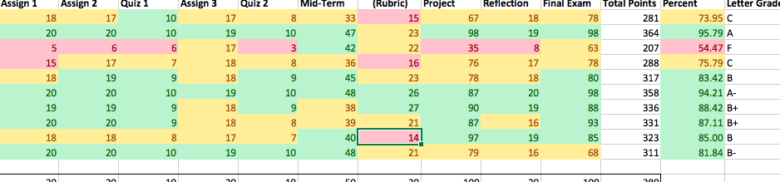

Student Page
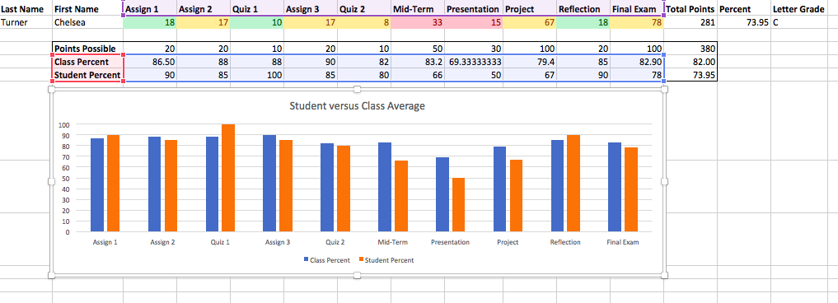

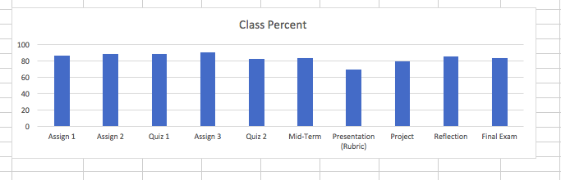
Class Average Scores

Rubric
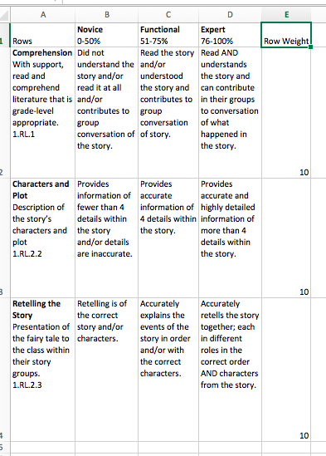

Phase 5: Implementation of an LMS
- Canvas
  - For this phase, I used Canvas to upload a few quizzes and assessments for easier access for parents and students who need to work off a computer. I used this site for my parent survey so that they can access it anywhere and I can get the results immediately. This LMS allowed for easy input of quizzes and assessments. It helped me to create a more adaptable way to collect data from students who need a computer to communicate and with parents who are busy throughout the day.

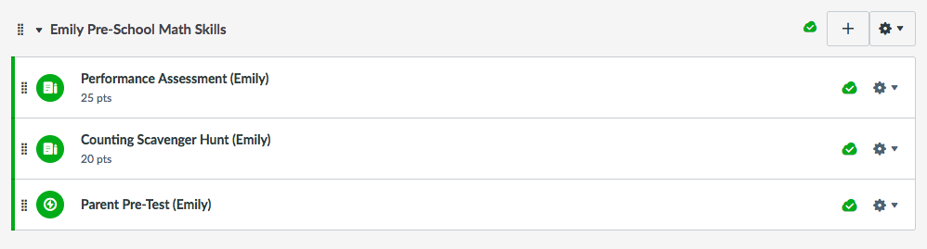

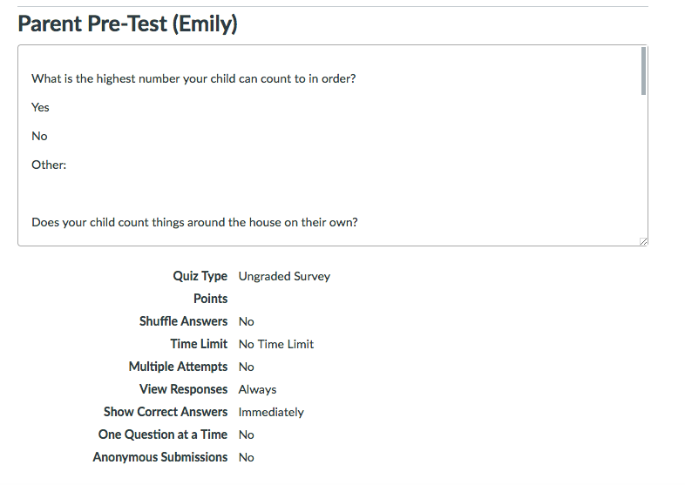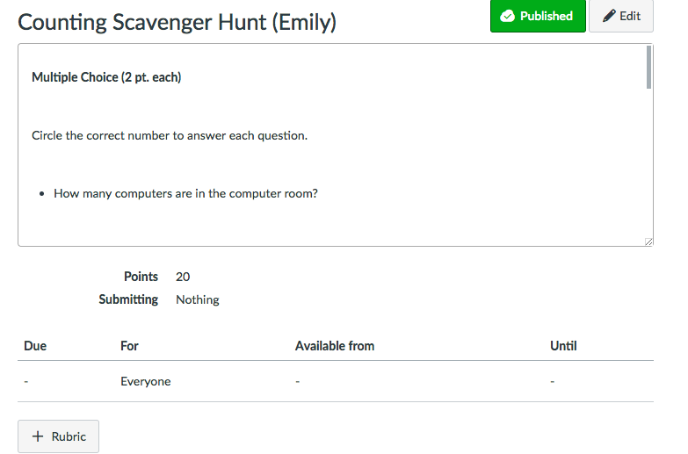

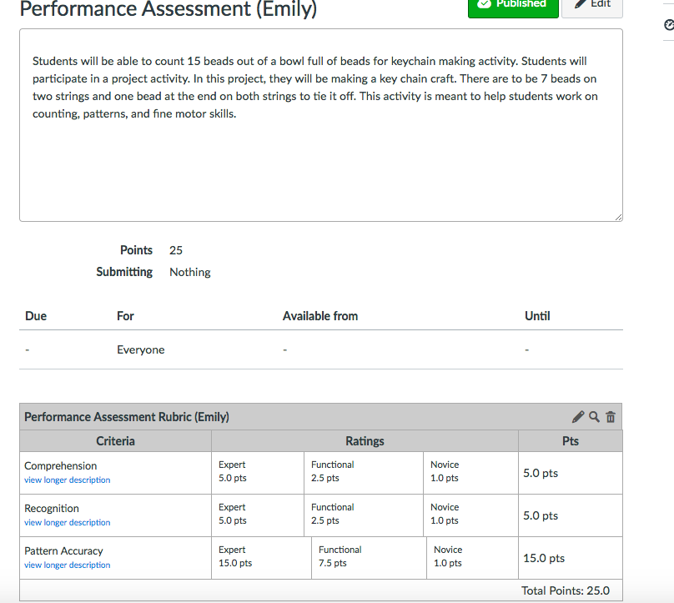

Alignment Matrix:

Objectives | Standard(s) | Item alignments (including rubric rows)
Students will be able to count 15 beads out of a bowl full of beads for keychain making activity.  Bloom Level: Application | Demonstrate sense of counting  M1.1 | Task 1, 2 & 6  Row: Comprehension  Items 1, 2 &3
Students will be able to recognize numbers up to 10.  Bloom Level:  Comprehension | Demonstrate understanding of written numerals  M1.2 | Task 3, 4 & 5  Items 4 &5
Students will be able to match numbers with their correct amount.  Bloom Level:  Comprehension | Demonstrate understanding of written numerals  M1.2 | “Go Fish”
Students will be able to recognize the difference in values of numbers.  Bloom Level: Analysis/ Evaluation | Recognition of number relations.  M1.3 | Task 4  Row: Recognition
Students will be able to identify the importance of numbers.  Bloom Level: Evaluation | Demonstrate understanding of classifying  M3.1 | Item 6
Students will be able to align beads in a pattern given to them by the teacher  Bloom Level: Application | Demonstrates awareness of patterning  M2.2 | Row: Pattern Accuracy

