
Agent Name: ___________________________________
Agent Log Book

Cancer Type: _____________________________________
Agent Job (Role):__________________________________________

PROJECT TEAM CONTRACT
Project Name:___________________________________________________
Team Members:___________________________________________________________________________________________________________________________
Our Agreement
- We all promise to listen to each other’s ideas with respect.
- We all promise to do our work as best as we can.
- We all promise to do our work on time.
- We all promise to ask for help if we need it.
- We all promise to: ____________________________________________________________________________________________________________________________________________________________________________________________________________________________________________________________________________________________________________________________________________________________________________________
If someone on our team breaks one or more of our rules, the team may have a meeting and ask the person to follow our agreement. If the person still breaks the rules, we will ask our teacher to help find a solution.

Date:__________________________________________________
Team Member Signatures:
_______________________________________________________
_______________________________________________________
_______________________________________________________ _______________________________________________________
1 Date | KNOW (Learned) | NEED TO KNOW

TIME SPENT IN MITOSIS: Connections between Cell Reproduction and Cancer

Driving Questions:
- How much time does the cell cycle take?
- How long does each phase take?
- What is different about cancer cells?
Background Info

Onion root tips are fast-growing parts of the onion plant. As you know, growth of a multicellular organism requires an increase in the number of cells. These new cells are produced by mitosis. In fast growing organisms, or parts of organisms, lots of cells will be going through mitosis. Each cell is on it’s own time frame, so if look at a tissue sample (like the root tips), we should see cells in each phase. This view only gives a momentary snapshot, though, which means the phases that take the longest time are most likely to be seen! We can use this process to estimate the time it takes for each phase of mitosis in normal cells.

Assumption

For this lab, let’s assume that the entire cell cycle for onion roots lasts 24 hours (1440 minutes).

Data Collection
View some samples of onion root tips provided by your teacher. These can include slides with stained onion root tips that you view through the microscope, printed copies of images of onion root tips, or computer images shown on a screen or monitor. Your job is to count the number of cells in each phase of mitosis, and record the numbers in the data table below. To make this more accurate, share your data with two other groups who are using different pictures! Then calculate the time for each phase based on the percentage of cells counted.

Number and time onion root tip cells spend in phases of the cell cycle.

Phases | Number of Cells |  |  | Totals | % of time | Minutes
Phases | Sample 1 | Sample 2 | Sample 3
Interphase
Prophase
Metaphase
Anaphase
Telophase
 |  |  |  |  | 100% | 1440

Displaying Data

Use the diagram below to make a chart to display the data you collected. The circle below represents 1440 minutes, and each thin wedge represents 22.5 minutes. Using a different color for each phase of the cell cycle, fill in enough wedges to represent each phase. For instance, a phase that takes 270 minutes would equal 12 wedges. Arrange the phases in order to visualize the time a cell spends in each phase!

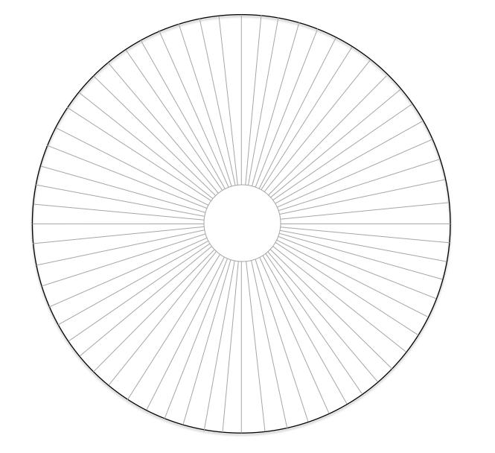
Time Spent in Mitosis Lab Continued

Conclusions

1) Which phase of the cell cycle took the most time? The least time?

2) What events take place during the longest phase of the cell cycle? Why are these events so important?

Time Spent in Mitosis Lab Continued Extension

Now look at some data collected from chicken stomach cells. Two samples were counted. The first includes normal cells, while the second sample is from a cancerous tumor in the stomach. Cancer cells grow faster than normal cells, so the total time is only 16 hours. Calculate the time spent in each phase for both normal and cancerous cells, then answer the questions that follow.

Phases | Normal Cells |  |  | Cancer Cells
Phases | Number | % of Time | Minutes | Number | % of Time | Minutes
Interphase | 900 |  |  | 768
Prophase | 168 |  |  | 240
Metaphase | 60 |  |  | 84
Anaphase | 24 |  |  | 36
Telophase | 48 |  |  | 72
 | 1200 | 100% | 1440 | 1200 | 100% | 960

Reflection Questions

- What are the biggest differences between the normal and cancerous cells?

- What phase is most affected in the cancer cells?

- Why would this change cause problems in the way the cancer cell functions?

- How could you use this process to diagnose cancer cells in humans?

Group Research
Directions: Answer the following questions, but do not give only a few words for an answer. Elaborate on the questions. For each question, answer the question and then generate another question based on the information you find in your research. Then get together with a partner and discuss your questions.
- What are the cancer cells in our cancer type?

Question:
- How fast can they grow?

Question:
- Where are they in the body?

Question:
- Can they spread to other areas?

Question:
- How can cancer spread to different tissues?

Question:
What caused the cancer cells to be different in the lab? B.5.1
DNA & Chromosome Lab
Directions: build three models and label with all bolded words.
Goals:
- Create and label DNA with all parts: sugar phosphate backbone and all 4 nucleotides types (adenine, thymine, guanine, and cytosine) paired correctly.
- Create and label a chromosome with all parts: centromere, telomeres, sister chromatids, and genes.
- Show how DNA makes up chromosomes. Include histones.
Diagram your model below including all parts:

DNA & Chromosome Modeling Rubric:

Categories |  | Unsatisfactory | Adequate | Proficient | Exemplary | Points Possible
DNA  - Sugar phosphate backbone  - Adenine  - Thymine  - Guanine  - Cytosine |  | More than 1 component is missing or misplaced. More than 1 label is missing or misplaced.  No explanation or explanation of components are not correct. (5) | One component is missing or misplaced. One label is missing or misplaced. Explanation is missing one component or explanation of components are correct except one. (10) | All components are present. All labels are present. Explanation is correct and leaves out no components. (15) | Proficient is met. Models are exceptionally detailed. Labels include definition and function. Explanation is detailed. (25) | 25
Chromosome  - Sister chromatids  - Telomeres  - Centromere  - Genes |  | More than 1 component is missing. More than 1 label is missing.  No explanation or the explanation is missing more than 1 components. (4) | One component is missing or misplaced. One label is missing or misplaced. Explanation is missing one component or explanation of components are correct except one. (8) | All components are present. All labels are present. Explanation is correct and leaves out no components. (12) | Proficient is met. Models are exceptionally detailed. Labels include definition and function. Explanation is detailed. (20) | 20
DNA to Chromosome  - DNA wound around histones  - Chromatin  - Chromatin organized into chromosome |  | More than 1 component is missing. More than 1 label is missing.  No explanation or the explanation is missing more than 1 components. (4) | One component is missing or misplaced. One label is missing or misplaced. Explanation is missing one component or explanation of components are correct except one. (8) | All components are present. All labels are present. Explanation is correct and leaves out no components. (12) | Proficient is met. Models are exceptionally detailed. Labels include definition and function. Explanation is detailed. (20) | 20
 |  |  |  |  |  | Total: 65

What caused the cancer cells to be different in the lab? B.5.1
DNA Replication Lab
Directions: build and label model for DNA replication expanding on your models in the previous lab
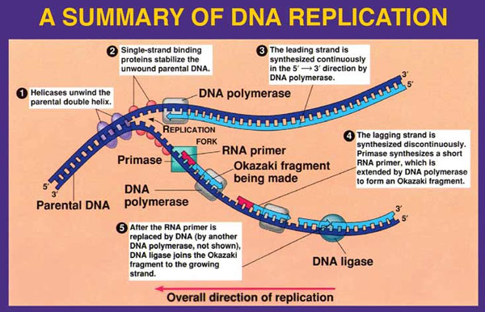
Diagram the process below explaining all parts and steps
Plan in the space below what you will use to model the parts and process of DNA replication

DNA Replication Modeling Rubric
Categories |  | Unsatisfactory | Adequate | Proficient | Exemplary | Points Possible
Step 1  - Helicase  - Replication Fork |  | More than 1 component is missing or misplaced. More than 1 label is missing or misplaced.  No explanation or explanation of components are not correct. (2) | One component is missing or misplaced. One label is missing or misplaced. Explanation is missing one component or explanation of components are correct except one. (4) | All components are present. All labels are present. Explanation is correct and leaves out no components. (6) | Proficient is met. Models are exceptionally detailed. Labels include definition and function. Explanation is detailed. (10) | 10
Step 2  - Single-strand binding proteins |  | More than 1 component is missing. More than 1 label is missing.  No explanation or the explanation is missing more than 1 components. (1) | One component is missing or misplaced. One label is missing or misplaced. Explanation is missing one component or explanation of components are correct except one. (2) | All components are present. All labels are present. Explanation is correct and leaves out no components. (3) | Proficient is met. Models are exceptionally detailed. Labels include definition and function. Explanation is detailed. (5) | 5
Step 3  - DNA Polymerase  - 5’ – 3’  - Leading strand  - Type of synthesis |  | More than 1 component is missing. More than 1 label is missing.  No explanation or the explanation is missing more than 1 components. (4) | One component is missing or misplaced. One label is missing or misplaced. Explanation is missing one component or explanation of components are correct except one. (8) | All components are present. All labels are present. Explanation is correct and leaves out no components. (12) | Proficient is met. Models are exceptionally detailed. Labels include definition and function. Explanation is detailed. (20) | 20
Step 4  - Lagging strand  - Type of synthesis  - Primase  - RNA Primer  - Okazaki fragments  - DNA Polymerase |  | More than 1 component is missing. More than 1 label is missing.  No explanation or the explanation is missing more than 1 components. (6) | One component is missing or misplaced. One label is missing or misplaced. Explanation is missing one component or explanation of components are correct except one. (12) | All components are present. All labels are present. Explanation is correct and leaves out no components. (18) | Proficient is met. Models are exceptionally detailed. Labels include definition and function. Explanation is detailed. (30) | 30
Step 5  - DNA ligase |  | More than 1 component is missing. More than 1 label is missing.  No explanation or the explanation is missing more than 1 components. (1) | One component is missing or misplaced. One label is missing or misplaced. Explanation is missing one component or explanation of components are correct except one. (2) | All components are present. All labels are present. Explanation is correct and leaves out no components. (3) | Proficient is met. Models are exceptionally detailed. Labels include definition and function. Explanation is detailed. (5) | 5
 |  |  |  |  |  | Total: 70
Group Research
Directions: Answer the following questions, but do not give only a few words for an answer. Elaborate on the questions. For each question, answer the question and then generate another question based on the information you find in your research. Then get together with a partner and discuss your questions.
- What type of mutation is involved with your group cancer?

Question:
- What gene(s)? Location on chromosome?

Question:
- How many people have this gene or are at risk of developing this mutation?

Question:
- What environmental factors (positive and negative) affect the probability of having that mutation?

Question:
Second Friday Reflection: Group Reflection
Directions: With your group answer these questions and be as specific as possible.
- How are we meeting the marks to present to the Muncie community?

- What have we accomplished & can cross off of our list?

- What do we still need to do?

2 Date | KNOW (Learned) | NEED TO KNOW
Notes

3 Date | KNOW (learned) | NEED TO KNOW
Notes:

