Name: Jessica (Ulrich) Flessner
Date: 9/20/2015
Chem. 675

Demonstration Script: Brass Pennies

1. Title of Demonstration: Making Brass Pennies

2. Alternate Title: Ahoy, Alloy! 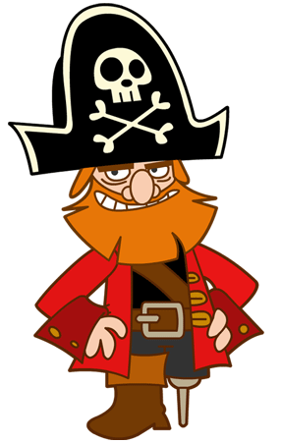Captain Redox Sparrow The Brass Pearl

3. Topic Focus: Redox reactions, formation of alloys, & significance of alloys

4. Other Potential Topics:

5. Written on Board/Projected: chemical equation for oxidation reaction of solid zinc to zincate ion in NaOH:
(Equation 1)
Chemical equation for the oxidation of Zn:
Zn_{(s)} → Zn ²⁺ _{(aq)} + 2e−
(Equation 2)

Guiding question: What happens to the 2e- ? Have students write their thoughts in the beginning. Perhaps as a bell ringer.

6. Text of Script:

I have here a 100 mL beaker, a container with zinc powder, and a bottle labeled “6 M NaOH”. You may notice I have this in the fume hood, so that might give you a clue as to what might happen. The bottle of 6 M NaOH is concentrated and corrosive. What is another word for corrosive? And what does that mean? (ANS: caustic. It is able to burn or corrode organic tissue by chemical action.) It should be handled with gloves and in the fume hood. I am also glad to see that everyone is wearing their goggles. We do not want any accidents in the lab to cause permanent damage to anyone.
The zinc powder is in the fume hood because we do not want to breathe it into our lungs. I have measured out 0.2 grams of the zinc powder in the weighing boat. Does anyone know of any products in which zinc is present, hint: summer time activities? (ANS: sunscreen.) I will pour 20 mL of the 6 M NaOH into the 100 mL beaker and add the zinc powder. Measure 20 mL 6 M NaOH in beaker and add zinc powder. Now, using tweezers, I am adding pennies dated before 1982. Does anyone know why we are using pennies of those dates? (ANS: yes, it is because pennies after 1982 have a zinc core with copper plating.) Add pennies.
Now everyone take a look at what is happening to the pennies. What do you see? (ANS: bubbles forming from the penny and rising to the surface of the solution.) Good! What do you think might be in those bubbles? Hint: take a look at the first equation on the board. (ANS: Hydrogen gas). Very good. Hydrogen gas is released when the zincate ion forms. Does anyone see a color change in the pennies yet? (ANS: not quite.) Good. We do not see an immediate change in the pennies’ color, but let’s check back in a few minutes to observe if there are any changes. We can swirl the solution to allow for more zinc to be in contact with the pennies. Swirl beaker.
As we wait for the pennies to change, let us take a look at the molecular reactions occurring in the solution right now. What are your thoughts on the guiding question? (Guiding question: What happens to the 2e- ?). (ANS: They are transferred to the copper penny) Very good. So what charge would the copper penny have? (ANS: negative charge). Correct. So we have a negatively charges penny in a solution with positively charges zinc ions. How do you think the zinc attaches to the penny? (ANS: The positively charged zinc is attracted to the negatively charged penny). Wonderful. What do we call reactions which involve the transfer of electrons from one chemical species to another? (ANS: Redox reactions). What are the two kinds of reactions, and how can we remember the differences between them? (ANS: Oxidation and reduction. OIL RIG (Oxidation is loss of e-, reduction is gain of e-) LEO GER (lose e- oxidation, gain e- reduction). First, how could we label the solid zinc to the zincate ion? (ANS: solid zinc is oxidized to zincate ion.) Second, how could we label the penny when it takes on the 2e-? Is it oxidized or reduced? (ANS: the penny is reduced.) Is the penny oxidized or reduced when the zinc binds? (ANS: the penny is oxidized because it transfers the electrons to the zinc in binding, thus coating the penny in solid zinc.)
Wonderful. Let’s look at a diagram of what is occurring: Diagram the following on the board. And explain.(Pictures taken from video source at bottom. Another option could be showing this part of the video to the students, or even flipping the classroom and assigning the video clip and a short reading for homework.

- Zinc and Copper toughing each other in an electrolyte solution

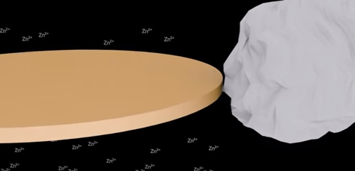

- Zn_{(s)} → Zn ²⁺ _{(aq)} + 2e− and drops 2 electrons off onto the Cu
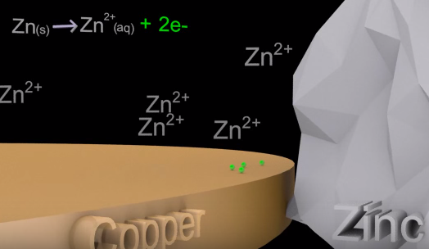

- So Cu now has a net negative charge, so…
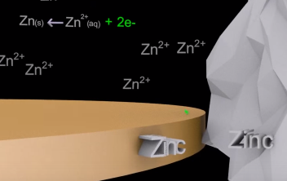

- Zn ²⁺ ions are attracted to the net negative penny, plating the penny in Zn
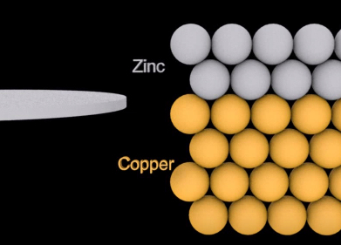
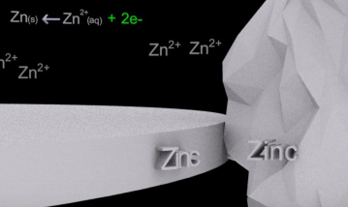

- Heating gives enough energy for metallic bonds to break and swop places which created brass, the “gold” color. Brass is an alloy.

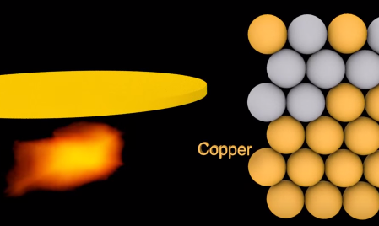

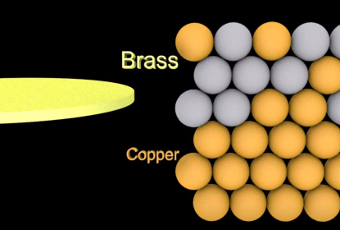

So let’s go back and check on the pennies. Walk over to fume hood and pull our pennies with tweezers to check for zinc coating. Pull penny out and show students. What do you see? (ANS: a zinc or “silver” coating.) Wonderful, now we can rinse the penny in our DI water and complete the flaming on the penny. Who would like to turn on the Bunsen burner? Make sure the flame is not too high. We only need enough to pass the penny through. We do not want to hold the penny in the flame because we want an even coating of brass. Pass penny through flame, back and forth. Everyone look for the color change. Look, it is changing to a brass color! Ahoy, there be an alloy in this lab! Say with pirate accent, because the teacher takes on the persona of “Captain Redox Sparrow” the captain of the Brass Pearl.
As review, what is an alloy? (ANS: a metal made by combining two or more metallic elements to give a greater strength or resistance to corrosion.) Wonderful. When something is made of metals, we do not want it breaking down or becoming corrosive if we want it to last for a long time. What are some things that are made of brass? (ANS: music instruments, door knobs, bullet shells, locks, zippers, clock cogs, art…) Great. All these items resist corrosion and can last in weathered conditions for a while.
Now you are going to make your own brass pennies. Be sure to follow the directions and ask any questions. KEEP EVERYTHING IN THE HOOD until you need to flame your pennies in the Bunsen burner.
Tell joke: What is a pirate’s favorite element?...ARRRRGGon!

Sources:
https://www.youtube.com/watch?v=UqVP3WdOqUk
http://www.cwu.edu/~petersj/chem101sp09/zinc%20redox.pdf
http://depts.washington.edu/chem/facilserv/lecturedemo/BrassPenny-UWDept.ofChemistry.html

