Ahoy, Alloy!
Redox Reactions & Alloy Synthesis: Brass Pennies
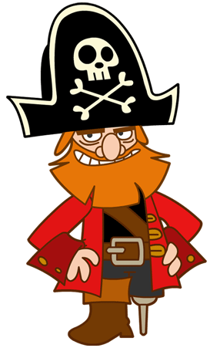
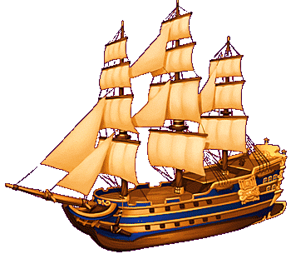
Arrrrg! It be Captain Redox Sparrow here! I am captain of the lovely Brass Pearl. Today I need your help to make fake gold colored coins to replace the real coins I am “borrowing.”

Instructions: Circle words you do not know, or need a review of in the Introduction. Then we will review them with small groups.

Introduction

In this lab you will carry out oxidation/reduction reactions involving the element zinc. You will treat a penny with a mixture of zinc metal and aqueous sodium hydroxide. Some of the zinc metal will be oxidized and enter solution as Zn⁺² ions according to the equation shown below. Electrons can then be transferred from unreacted zinc metal to Zn⁺² ions at the penny's copper surface. These newly reduced Zn metal atoms are deposited on the penny. Heating the zinc coated penny in the flame of a Bunsen burner allows the zinc atoms to migrate into the copper surface. The result is an alloy, or solid solution, of zinc and copper known as brass. Other alloys include bronze, sterling silver, 14 carat gold, and mercury amalgam for filling cavities in your teeth.

Write the equations discussed in class in the following lines:

Chemical equation for oxidation reaction of solid zinc to zincate ion in NaOH:

______________________________________________________________________________
(Equation 1)
Chemical equation for the oxidation of Zn:

_____________________________________________________________________________
(Equation 2)
Guiding Question

What do you think happens to the two electrons in Equation 2?

__________________________________________________________________________________________________________________________________________________________________________________________________________________________________________

Experimental Design
In the following space, draw and label the materials used in this demonstration. You should include: beaker, pennies, zinc, NaOH solution, DI water wash bath, Bunsen burner, and crucible tongs. Be sure to include the amounts of materials used (Example: 0.2 g Zn powder)

Experimental Outcome
In the following space, draw and color the three pennies start to finish. Be sure to label the metals on each penny for the specific color.

Discussion
- What happened to the two electrons in Equation 2?
________________________________________________________________________________________________________________________________________________________________________________________________________________________________________________________________________________________________________________________

- What is an alloy? What are some examples of alloys in everyday objects?
__________________________________________________________________________________________________________________________________________________________________________________________________________________________________________
______________________________________________________________________________
- Why are alloys important?
__________________________________________________________________________________________________________________________________________________________________________________________________________________________________________

- What is a redox reaction? (Hint: two part reaction) What is one way to distinguish between the two reactions?
__________________________________________________________________________________________________________________________________________________________________________________________________________________________________________
__________________________________________________________________________________________________________________________________________________________________________________________________________________________________________

- From the demonstration, give one example of reduction and one example of oxidation and explain where the electrons move.
__________________________________________________________________________________________________________________________________________________________________________________________________________________________________________
__________________________________________________________________________________________________________________________________________________________________________________________________________________________________________

