Overview
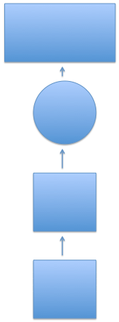

Describe Indiana’s landforms (lithosphere), water features (hydrosphere), and plants and animals (biosphere).
Explain how glaciers shaped Indiana’s landscape and environment.

How to write an informational essay
How to identify and classify things

When did glaciers move through Indiana? What was the effect?
What is Indiana’s lithosphere like? It’s hydrosphere? What plants and animals are in Indiana?

What is the lithosphere? The hydrosphere? The biosphere?

What is a glacier?

The learning progressions shown above will guide the teaching and assessment of this unit. Students will first take a short online pre-assessment on Kahoot.it. This pre-assessment will have ten questions relating to content and student interest. Following the pre-assessment, the teacher will provide three weeks of instruction on the lithosphere, the biosphere, and the hydrosphere—in general and also specifically related to Indiana. At the end of those three weeks of instruction, the students will take a formative assessment, which will allow the teacher to see if he/she can continue on, or if additional instruction is needed. This formative assessment will be a performance-based assessment that requires students to think deeply about what is in each ‘sphere’, and draw and label their own imaginary environment. Following this, the teacher will provide a week of instruction about glaciers and how they have affected Indiana’s landscape. At the end of this, students will take a formative assessment, which will once again inform the teacher as to whether or not he/she can move on. This formative assessment will be in the form of a short quiz. Once the class is ready to move on, the teacher will provide a lesson that overviews and ties together everything that has been learned over the past four weeks. The class will then take the summative assessment, which is in the form of a paper-and-pencil test.

Pre-Assessment Instrument
This pre-assessment is intended to gauge how much students already know about the topic, and how interested they are in learning about it. Students will be able to log in to Kahoot to take this short 10 question pre-assessment.
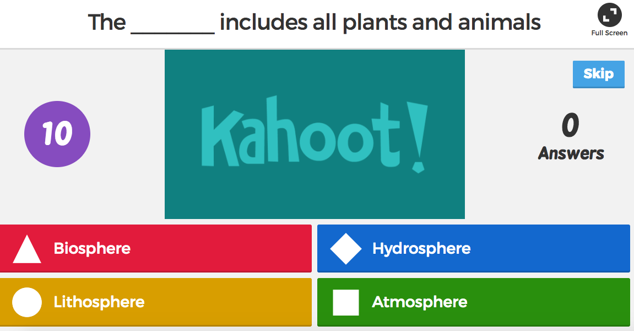
A small number of questions are intended to measure student interest, while the other questions are closely aligned with the lesson objectives in order to see how much students may already know about the topic. These questions are designed to resemble the questions that will be found on the summative assessment. By using similar questions on the pre-assessment and summative assessment, I will very clearly be able to see and measure students’ growth and learning. Here is the link to the assessment: https://play.kahoot.it/#/k/bbb0667a-6bb9-40f0-9174-ac9ceb6ded1f

Formative Assessments
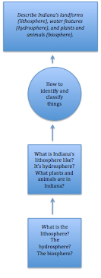
Formative Assessment #1 will address the first learning progression for this unit. This assessment will be performance based. Students will have the opportunity to be creative while also demonstrating their knowledge and understanding of the lithosphere, biosphere, and hydrosphere. Students will be directed to create an imaginary environment that they think would be ideal. Students will be allowed to create this imaginary environment through any medium they choose—paper and crayons/colored pencils/markers, digital, clay, etc. Students must also label each feature and identify whether it is a feature of the lithosphere, biosphere, or hydrosphere. Students will also be asked to mark any features from their environment that are also found in Indiana’s environment. The assessment will be scored by the rubric below.
 | 0 | 1 | 2 | Raw Score
Features of Lithosphere  Number of features included | No features of the lithosphere are present. | Only 1 feature of the lithosphere is present. | At least 2 features of the lithosphere are present. | _____/2
Features of Hydrosphere  Number of features included | No features of the hydrosphere are present. | Only 1 feature of the hydrosphere is present. | At least 2 feature of the hydrosphere is present. | _____/2
Features of Biosphere  Number of features included | No features of the biosphere are present. | Fewer than 8 features of the biosphere are present. | At least 8 features of the biosphere are present. | _____/2
Labels  Accuracy of labeling | No labels are shown. | Some features are labeled, or some are labeled incorrectly. | All features are labeled correctly. | _____/2
Design  Quality of design | No creativity or effort is shown in the design. | Some creativity and effort is evident in the design. | Both creativity and effort are evident in the design. | _____/2
 |  |  | Total Score | _____/10

Formative Assessment #2 will address the second learning progression for this unit.
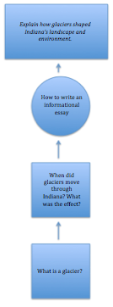
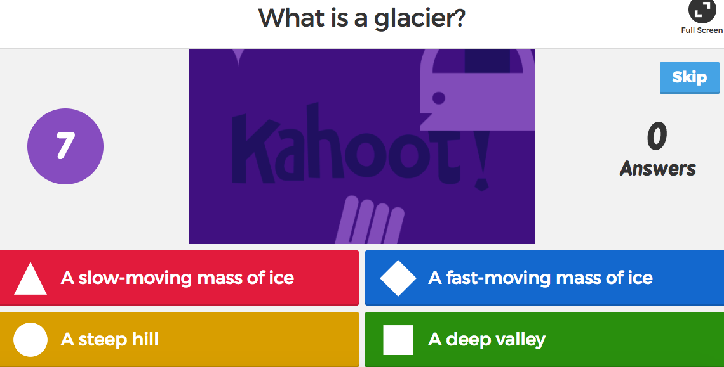
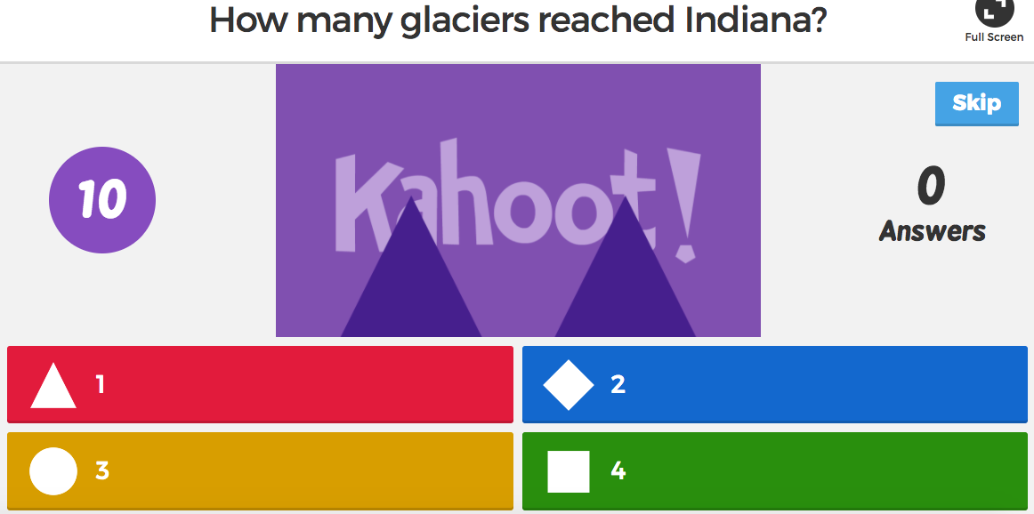

This formative assessment is a brief four-question quiz that assesses how much students have learned about glaciers and their affect on Indiana’s landscape. It is in the form of a Kahoot online, which can be found via this link: https://play.kahoot.it/#/k/bf030630-adeb-4bd8-ad24-2d6134d73c65

Summative Assessment
The Social Studies test below is designed to assess student learning over Indiana’s physical systems. This test has been developed for use in a fourth grade classroom, and aligns with two Indiana Academic Standards as provided by the Indiana Department of Education:

SS. 4.3.5 Explain how glaciers shaped Indiana’s landscape and environment.
SS. 4.3.6 Describe Indiana’s landforms (lithosphere), water features (hydrosphere), and plants and animals (biosphere).

This test should be administered following a one-month unit in which students spend one week on each of the following topics: 1) Indiana’s lithosphere, 2) Indiana’s hydrosphere, 3) Indiana’s biosphere, and 4) Glaciers’ impact on Indiana’s landscape and environment. Students will learn definitions of related terminology, examples of such terminology, view pictures and maps, and think critically about how different physical features and systems impact the environment. A mini-assessment will be given at the end of each week. The test presented here will serve as the summative assessment for the unit.

INDIANA’S LANDSCAPE AND ENVIRONMENT FINAL EXAM
Matching:

- Draw a line to match the definition on the left with the correct term on the right. Each definition/term may only be used once; not all terms will be used. (3pt):
Lithosphere

Hydrosphere

Atmosphere

Biosphere

“All plants and animals”

“The soil and rock that form Earth’s surface”

“All the water on Earth’s surface”

Multiple Choice & Binary Choice:

- Which of the following can be found in Indiana’s hydrosphere? Circle the correct answer. (1pt)

- Wabash River*
- Raccoon
- Pine tree
- Pacific Ocean

- Which of the following can be found in Indiana’s biosphere? Circle the correct answer. (1pt)

- Saguaro cactus
- Lake Michigan
- White-tail deer*
- Flamingo

Imagine that you work at a welcome center in Indiana. A tourist asks you several questions about the land. Please answer “Yes” or “No” to each of their questions below:

- Are there any caves in Indiana? (1pt)

- Yes*
- No

- Are there any dunes in Indiana? (1pt)

- Yes*
- No

- Are there any mountains in Indiana? (1pt)

- Yes
- No*

Short Answer:

- Define the term “glacier” in one sentence. (2pt)

________________________________________________________________________________

- What is a mass of soil and rock left behind by a glacier called? (1pt) ________________________.

- What are the three main physical regions of Indiana? (6pt) ________________________________, ________________________________, and ________________________________.

Essay:

- Write a two-paragraph essay explaining two ways in which glaciers impacted Indiana’s landscape and environment. (8pt)

Total Score: _______/25 points
FINAL EXAM SCORING KEY:
- Each matching item is worth 1 point for a total of 3 possible points.
- An asterisk indicates correct answers for selected response questions.
- Short answer questions will be graded on accuracy alone, not spelling.
  - Number 7: “A slow-moving mass of ice”
  - Number 8: “Moraine”
  - Number 9: “Northern Lakes and Moraines, Central Till Plains, and Southern Lowlands”
    - 2 points will be awarded for each correct answer for a total of 6 possible points.
- The essay will be graded based on the factors listed below. Each paragraph is worth 4 points for a total of 8 possible points.
  - Did the student write two full paragraphs?
  - Did the student accurately and thoroughly explain two impacts of glacier movement?
  - Does the student’s spelling and/or grammar make it difficult to read/understand?

Alignment Matrix

Objectives | Standards | Items Aligned | Bloom Domain and Level
Referencing their notes, students will be able to write a short essay that explains two ways in which glaciers impacted Indiana’s landscape and environment. | SS. 4.3.5 Explain how glaciers shaped Indiana’s landscape and environment. | Summative, Item 7 | Cognitive, Knowledge
 |  | Summative, Item 8 | Cognitive, Knowledge
 |  | Summative, Item 9 | Cognitive, Knowledge
 |  | Summative, Item 10 | Cognitive, Comprehension
 |  | Pre-Assessment, Item 7 | Cognitive, Knowledge
 |  | Formative Assessment 2, Item 1 | Cognitive, Knowledge
 |  | Formative Assessment 2, Item 2 | Cognitive, Knowledge
 |  | Formative Assessment 2, Item 3 | Cognitive, Comprehension
 |  | Formative Assessment 2, Item 4 | Cognitive, Comprehension
Students will be able to match the key terms ‘lithosphere’, ‘hydrosphere’, and ‘biosphere’ to their correct definition with 100% accuracy. | SS. 4.3.6 Describe Indiana’s landforms (lithosphere), water features (hydrosphere), and plants and animals (biosphere). | Pre-Assessment, Item 1 | Cognitive, Knowledge
 |  | Pre-Assessment, Item 2 | Cognitive, Knowledge
 |  | Pre-Assessment, Item 3 | Cognitive, Knowledge
 |  | Summative, Item 1 | Cognitive, Comprehension
Given a list of various features of hydrospheres, lithospheres, and biospheres, students will be able to identify those that are found in Indiana. | SS. 4.3.6 Describe Indiana’s landforms (lithosphere), water features (hydrosphere), and plants and animals (biosphere). | Pre-Assessment, Item 5 | Cognitive, Knowledge
 |  | Pre-Assessment, Item 6 | Cognitive, Knowledge
 |  | Summative, Item 2 | Cognitive, Comprehension
 |  | Summative, Item 3 | Cognitive, Comprehension
 |  | Summative, Item 4 | Cognitive, Knowledge
 |  | Summative, Item 5 | Cognitive, Knowledge
 |  | Summative, Item 6 | Cognitive, Knowledge
 |  | Pre-Assessment, Item 4 | Cognitive, Knowledge
 |  | Formative Assessment 1 | Cognitive, Application

References:

- http://www.doe.in.gov/sites/default/files/standards/socialstudies/ss-2014-gr4-20150317.pdf

This source was used to identify standards that align with the test content, and to derive definitions for the terms ‘lithosphere’, ‘hydrosphere’, and ‘biosphere’.

- https://prezi.com/noago4dquvvf/indiana-history-unit-1-lesson-2/

This source was used to inspire questions related to the topic.

