Shana Miller
Phase 1

Overview:
- 1st grade
- English language arts – Key ideas and textual support in literature
- Unit: This unit will be all about key ideas and textual support in literature. We will be reading different kinds of stories and they will be asked to retell them in sequential order, be able to identify the main details, and make predictions. This unit will be done around the middle to the end of the year because the objectives are a little more difficult. This unit will be a week long, possibly going into the next week depending on the assessment data.
  - Books: Fly Away Home,

Standards/Objectives:

- Standard 1:
  - 1.RL.2.4 Make and confirm predictions about what will happen next in a story
- Learning Objective:
  - Students will formulate their own predictions after reading the beginning of a book as a class with correct writing functions.
- Blooms Taxonomy:
  - Synthesis

- Standard 2:
  - 1.RL.2.2 Retell stories, fables, and fairy tales in sequence, including key details, and demonstrate understanding of their central message or lesson.
- Learning Objective:
  - Students will organize parts of a story in sequential order when given pieces of the story out of order with 90% accuracy
- Blooms Taxonomy:
  - Synthesis

- Standard 3:
  - 1.RL.2.3 Using key details, identify and describe the elements of plot, character, and setting.
- Learning Objective:
  - Students will accurately identify what the plot is, who the character is, and the setting after reading a story.
- Blooms Taxonomy:
  - Remember/understand

Alignment Matrix:

Learning Objectives: | Academic Standards: | Blooms Taxonomy Level: | Item alignment:
Students will organize parts of a story in sequential order when given pieces of the story out of order with 90% accuracy | 1.RL.2.2 | Synthesis
Students will formulate their own predictions after reading the beginning of a book as a class with correct writing functions. | 1.RL.2.4 | Synthesis
Students will accurately identify what the plot is, who the character is, and the setting after reading a story. | 1.RL.2.3 | Remember/understand

PHASE II: Design Assessments

Overview
The sequence for my assessments will follow my learning objectives and their difficulty. I will begin assessing making predictions, then move onto sequencing parts of the story, and end up talking about character, plot, and setting. I will not be doing any quizzes or tests because I don’t believe testing second graders is the best option. I think using different types of assessments such as hands on activities would be better suited for them. The activities within the lessons are what I am going to use as my assessment tools and have them turn in the final product for a grade.

Pre-Assessment:
I will be creating a Kahoot for my pre-assessment where I will be asking questions about prior knowledge with making predications, details about characters, plot, and setting. I chose to do this assessment because it is an east way to see where students are in a fun way. This also lets them answer the questions anonymously so they feel better about not knowing the answer or getting it wrong. I also didn’t want to give them a pencil paper assessment especially because they aren’t the best readers at this age yet and I don’t want them to be confused or not know how to answer the questions.
- https://play.kahoot.it/#/k/3eeece9c-b235-49ff-b501-9ad264f6cb98

Formative assessment.
- The formative assessment I will be doing is for the sequencing parts of the story activity. They will be cutting out pictures from the story and putting them in order and gluing them down onto construction paper. Before they get to glue it down they must get it approved by the teacher so they can make any changes necessary before permanently gluing the pictures down. This will be more of a feedback type assessment. To score this assignment I will have a completed example to look at and a scoring key as well to check off and make sure they completed the activity and they had it in the right order, which they should since it needed to be approved.

 | Check if it is correct or completed | Total
Sequenced Correctly  Row score: 5 |  | ____/5
Completed  Row score: 5 |  | ____/5
Total Score |  | ____/10

Performance Assessment
- For the second objective, making predictions, I will be having them do a performance assessment that may also be used as a formative assessment. We will be reading the story, “Goldilocks and the Three Bears.” First, they will make a prediction based on the title. After they do that I will read them the back blurb and have them make another. Then, I will read the story to them but I will stop after a few pages and have them make predictions for what will happen next. They will write their prediction down, write why they think that, and draw a picture. They will turn this in and we will continue reading the story to see if anyone’s predictions will be wrong. They will be graded on the detail, support, etc. rather than correct predictions.

 | Apprentice  Below 51% | Basic  51%-64% | Learned  65%-84% | Exemplary  85%-100% | Total
Prediction  Their prediction relates to characters and events and has supportive details.  1.RL.2.4  Row scoring:15 | No attempt made to respond or response in inappropriate | Fails to make prediction or makes a prediction which is illogical, irrelevant, or unsupported. | Makes prediction about character(s) and/or event(s). Uses few/no details to make connection between the story and the inference. Very generalized. | Makes reasonable prediction about character(s) and/or event(s). Uses some details to make connection between story and the inference | ____/15
Handwriting  Their handwriting is legible so that all readers are able to read the product  1.W.2.1  Row score: 5 | Student did NOT do their personal best. It was very sloppy and illegible. | SOME words/spacing were legible but most were not. | MOST words/ spaces were correctly formed | ALL words were formed correctly as well as the spacing between words and were legible | ____/5
Spelling  All grade-level appropriate words are spelled correctly.  1.W.6.2c  Row Scoring: 5 | More than 4 errors | 2-4 errors | 1-2 errors | No errors | ____/5
Total Score |  |  |  |  | ____/20

Summative Assessment
- This will be the summative assessment but can also be used as a performance assessment. This will be done the next day, after predictions, but we will read the same book, “Goldilocks and the Three Bears.” I would like every student to have their own copy of the book for this assessment so they can look through the book as the complete the activity. We will first read the book together and then I will send them to complete their flip book. They will be making a flipbook for character, plot, and setting. They will flip it over and write the characters, the plot, and the setting. This will be for the final objective listed on the first page. They will be graded on correct answers for this activity as well as including descriptions when needed and correct writing functions.

 | Apprentice  Below 51% | Basic  51%-64% | Learned  65%-84% | Exemplary  85%-100% | Total
Character  Describe main characters including information about them such as personality or physical traits.  1.RL.2.3  Row scoring: 7 | There is an attempt but they didn’t quite understand who the characters were or any details | Characters are correct but there is no description or details | Characters are correct and there is some sort of description but lacks details | Description of the character has been expertly detailed and discuses traits of the character | ____/7
Plot  Describe the events that take place in the story using supporting details.  1.RL.2.3  Row scoring: 7 | There was an attempt but the events are incorrect and/or has no supporting details. | The events are correct but there are no supporting details. | The events are correct but only has a few supporting details. | Description of the events has been stated and has plenty of supporting details. | ____/7
Setting  Describe where and when the story takes place and support ideas by including specific details form the story.  1.RL.2.3  Row scoring: 7 | The effort was there but the setting was incorrect and/or had no detail. | The setting was accurately stated but there are no supporting details. | The setting was accurately stated but only had a few details. | The setting was accurately stated and there were many supporting ideas and details. | ____/7
Handwriting  Their handwriting is legible so that all readers are able to read the product  1.W.2.1  Row score: 5 | Student did NOT do their personal best. It was very sloppy and illegible. | SOME words/spacing were legible but most were not. | MOST words/ spaces were correctly formed | ALL words were formed correctly as well as the spacing between words and were legible | ____/3
Spelling  All grade-level appropriate words are spelled correctly.  1.W.6.2c  Row Scoring: 5 | More than 4 errors | 2-4 errors | 1-2 errors | No errors | ____/3
Total Score |  |  |  |  | ____/27

Revised Alignment Matrix

Learning Objectives: | Academic Standards: | Blooms Taxonomy Level: | Item alignment:
Students will organize parts of a story in sequential order when given pieces of the story out of order with 90% accuracy | 1.RL.2.2 | Synthesis | FA activity of gluing
Students will formulate their own predictions after reading the beginning of a book as a class with correct writing functions. | 1.RL.2.4 | Synthesis | 3 prediction activity
Students will accurately identify what the plot is, who the character is, and the setting after reading a story. | 1.RL.2.3 | Remember/understand | Flip chart

Sources:
http://www.doe.in.gov/sites/default/files/standards/enla/grade_1_ias_2014.pdf
-Where I got the standards
http://crystals-classroom.blogspot.com/2015_04_01_archive.html
-Where I got the predication flipbook
https://www.slideshare.net/jaimedominguez/variety-of-language-rubrics
-Ideas for PA rubric
https://www.pinterest.com/pin/475129829414947059/
-Rubric ideas for SA

PHASE III- activity description

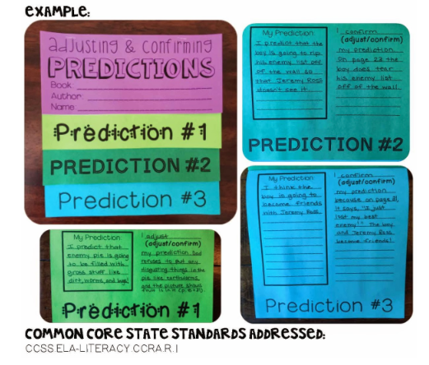
For this activity students will be making three predictions in a flipbook format. The first will be based on the title of the book. The second will be based on the blurb on the back cover. The final one will be based off of the first few pages of the story. Each prediction should have an explanation/reasoning and follow correct writing functions. They will be graded on their writing functions, depth of thinking, reasoning, support, etc.
This activity connects to phase II because this is one of the assessments. This is the performance assessment. It is worth 20 points total.

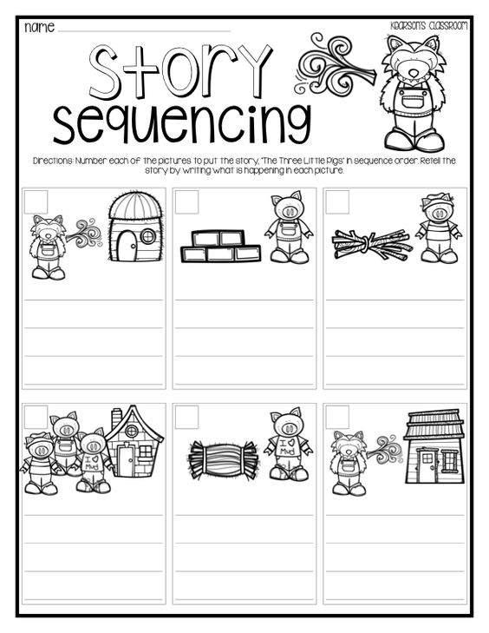

For this activity students will be labeling the pictures in order by putting the number, cutting them out, putting tem in order, getting it approved, and then gluing it down on construction paper. They will be doing this after reading the story, Three Little Pigs. This will be the second activity of the unit.
This activity is also connected to phase II because it is an assessment. This activity in particular is a formative assessment and is worth 10 points total.

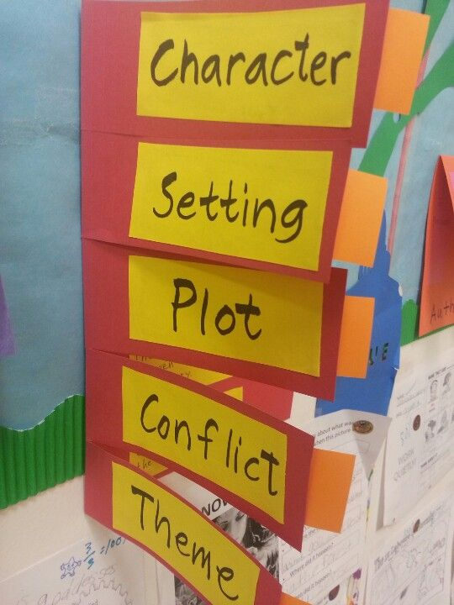

This is the final activity of the unit and worth the most points. They will be creating a flipbook for character, plot, and setting. They will read the book, Goldilocks and the Three Bears to complete this activity. They will be working independently for this activity.
This activity is the final connection to phase II and is the last assessment. It is a summative assessment and is worth the most amount of points. This activity is worth 27 points.

Phase IV Reflection

This assignment taught me a lot about excel, how to create a master grade book, and how to create a grade sheet for individual students. The assignment was quite the experience but I think it was very beneficial. Before this assignment I had no idea how to format, lookup, fill, etc. on excel. I always did small graphs or documents that didn’t require that much data or excel work. This assignment is something I can definitely carry with me during my teaching career.
The major key components for the assignment (I think) are: Do not copy raw data, Filling, Rubrics, Averages, Graphs, and conditional formatting.
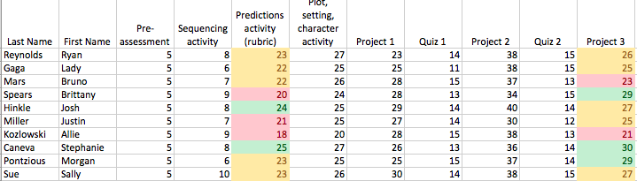
The screen shot below illustrates the conditional formatting functionality. This was an important part because it shows us teachers, the different ranges of scores and the funny things that happen sometimes. It may show where more instruction is needed or if one student is struggling more. It could also show if a student who usually does well had a mishap or the opposite.
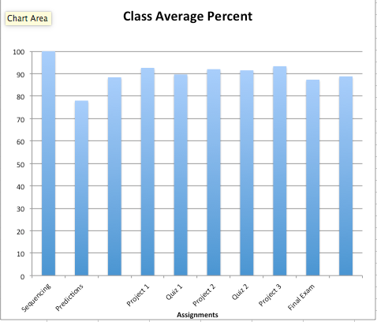
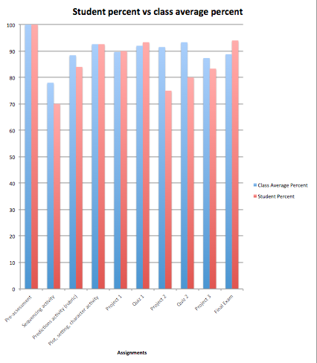
The next screenshots to the left are taken from the master grade book and an individual student sheet. Having the graphs gives a visual representation of scores. This also shows deviation or places where changes need to be made. The individual sheet does the same thing as well. It shows their percent compared to the class percent. This gives you the opportunity to see where the student stands individually in comparison to the class as a whole. You can then modify where needed to help the student reach their full potential.

