Marilyn Kinsey
Lamp Lite

Phase 1:
Overview
Title: Area and Measurement Unit
Grade Level: 5
Content Area: Math, Measurement
Description: In this unit, students will explore the concept of area and build off of their previous knowledge from estimating area and the formula for area of a rectangle, which students learned in fourth grade. Students will use manipulatives to deepen their understanding of area as a concept of covering the surface of a shape. Students will follow instructions to manipulate cut outs of shapes and draw conclusions about area formulas. Students will create a “Reference sheet” of the area formulas, explaining how they are connected and/or how they are developed, including illustrations. By the end of the unit students will be able to calculate the area of simple and complex shapes. There will be two major assessments in this unit and a pre-assessment to judge interest levels and overall attitudes. The first assessment will be the performance assessment where students will work in groups to create a presentation and teach the class. The second assessment will be a unit test done individually by the students after the performance assessment presentations and sufficient instruction. After the unit test there will be a participation-based activity to find the area of a large, odd shape made up of common geometrical shapes, i.e. rectangles, squares, triangles, trapezoids, parallelograms, and the students will work in pairs to find the area of the entire shape.

Standards:
- 5.M.2: Find the area of a rectangle with fractional side lengths by modeling with unit squares of the appropriate unit fraction side lengths, and show that the area is the same as would be found by multiplying the side lengths. Multiply fractional side lengths to find areas of rectangles, and represent fraction products as rectangular areas.
- 5.M.3: Develop and use formulas for the area of triangles, parallelograms and trapezoids. Solve real-world and other mathematical problems that involve perimeter and area of triangles, parallelograms and trapezoids, using appropriate units for measures.
Objectives:
- Given two values for base, height, or area of a shape, students will calculate the missing value, showing their work and use of an area formula.
- Using cut outs and unit cube manipulatives, students will discover the formula for triangles, trapezoids, and parallelograms.
- Students will use their knowledge of area to discover the area of a complex shape (shape made of smaller rectangles and triangles).
- Students will explain how to find the area of a rectangle and a triangle.
- Students will compare the area formulas for area of a rectangle and area of a triangle.
Alignment Matrix:
Standard | Objective | Bloom’s Level
5.M.2 | Given two values for base, height, or area of a shape, students will calculate the missing value, showing their work and use of an area formula. | Apply
5.M.3 | Using cut outs and unit cube manipulatives, students will discover the formula for triangles, trapezoids, and parallelograms. | Apply
5.M.3 | Students will use their knowledge of area to discover the area of a complex shape (shape made of smaller rectangles and triangles). | Apply
5.M.2, 5.M.3 | Students will explain how to find the area of a rectangle and a triangle. | Comprehension
5.M.2, 5.M.3 | Students will compare the area formulas for area of a rectangle and area of a triangle. | Evaluation

Day 9: Culminating activity, working in pairs to find the area o a complex shape
Day 8: Unit Test
Days 6 & 7: Student presentations, kahoot formative assessment, review and additional teaching of formulas
Days 3-5: Student workdays in groups with teacher scaffolding as necessary, discovering formulas, preparing for presentations
Day 2: Review of area of a rectangle and class discussion about area
Day 1: Pre-Assessment
Phase 2:
Pre-Assessment
Students will have a short, 6-question pre-assessment worth 5 points. This is a pre-assessment the students will take at the beginning of the unit, before any instruction, and individually. In a yearlong classroom I would routinely ask questions 3 and 4 (pertaining to the current topic) just to gauge where the students are mentally. This pre-assessment allows me to see what the students remember from fourth grade about area of a rectangle and how much I need to reteach and if it needs to be a class lesson or small groups. From this assessment I can also gather information about interests and the students’ feelings and confidence concerning math. I would grade this on completion, as long as the students took it seriously and tried to answer honestly.
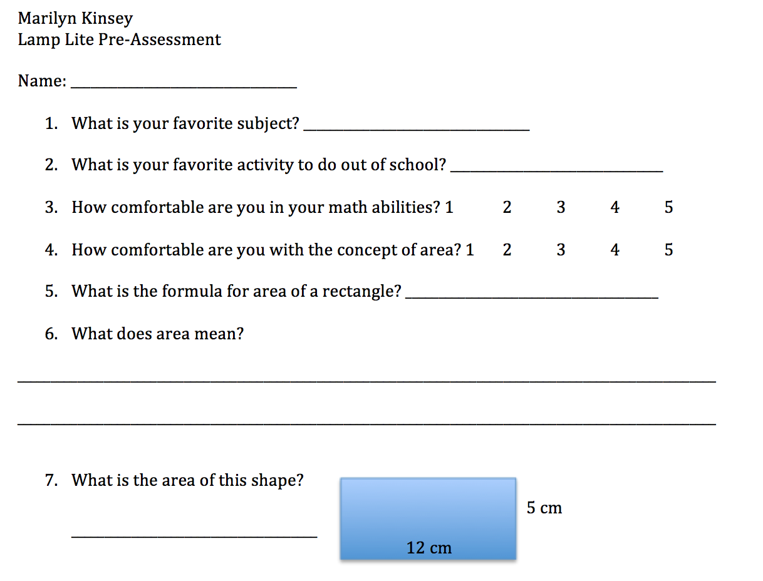
Formative Assessment
Students will do a Kahoot game with 6 questions on calculating area.
Link: https://play.kahoot.it/#/k/16cab3ac-570c-4f65-9a03-451ebcc4ca63
This will allow the teacher to see what the class as a whole needs more work on and explain problems while the students play the game. The teacher can also evaluate the students individually using the results downloaded from Kahoot. The fun game will encourage students as well as give an idea of how much they are learning. The questions for the kahoot are extremely similar to the questions #1-10 on the unit test, but with different values.

Performance Assessment
Students will give group presentations comparing the formula for area of a rectangle to area of either a right triangle, non-right triangle, trapezoid, or parallelogram. The students will be responsible for demonstrating how they found their formula from the formula of a rectangle, including a visual aid, and explaining/answering questions for the class. Students will also take notes during the classmates’ presentations.

 | Unsatisfactory  0-60% | Basic  61-80% | Proficient  81-100% | Total
Presentation: Groups of students will give an oral presentation in front of the class explaining their area formula and how they figured it out. | Student does not help present to the class | Student has a minimal role in presenting to the class | Student presents at least his or her fraction of the presentation | _____/5
Visual Aid: Along with the area formula and an explanation of how they arrived at the formula, the group must also include a picture or series of pictures or models that demonstrate finding the area and will help their classmates remember the formula. | No visual aid, or visual aid is confusing and not connected to the formula | Visual shows basic application to the formula | Visual aid clearly demonstrates how the formula for the new shape was derived from the area formula for a rectangle | _____/10
Connection to area of a rectangle: Groups of students must explain or demonstrate how the new area formula is connected to or derived from the area of a rectangle. | Does not mention formula for area of a rectangle | Compares to area of a rectangle formula | Explains how formula of new shape was derived from area of a rectangle formula | _____/10
Written explanation: Each student, INDIVIDUALLY, must turn in a one paragraph, written explanation of the group presentation and area formula. | Student does not submit a written explanation of the formula for area of the shape | Student does not connect back to area of a rectangle or does not explain how the student found the area formula | Student fully explains how connecting back to area of a rectangle developed the area formula | _____/10
Notes from presentations: Students must take notes on the other groups’ presentations, and must include more than just the area formula to be sufficient. | Student does not take notes or notes are not complete | Student takes notes on all presentations including the area formula for the new shape | Student takes notes on all presentations including the area formula and the connection to area of a rectangle | _____/5
Total Points |  |  |  | _____/40

Unit Test
Area Test
Name: _____________________________________________
For problems 1-6 find the area. Four points each.
1. Area=_________________
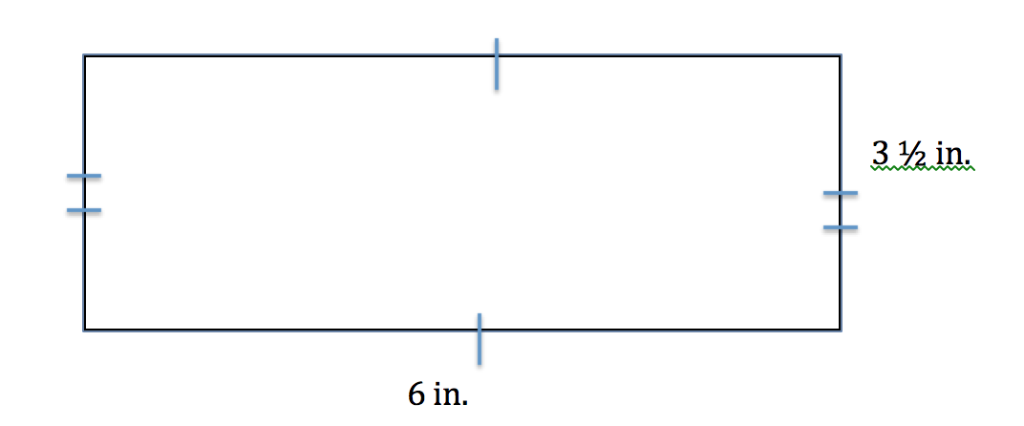
2. Area=_________________
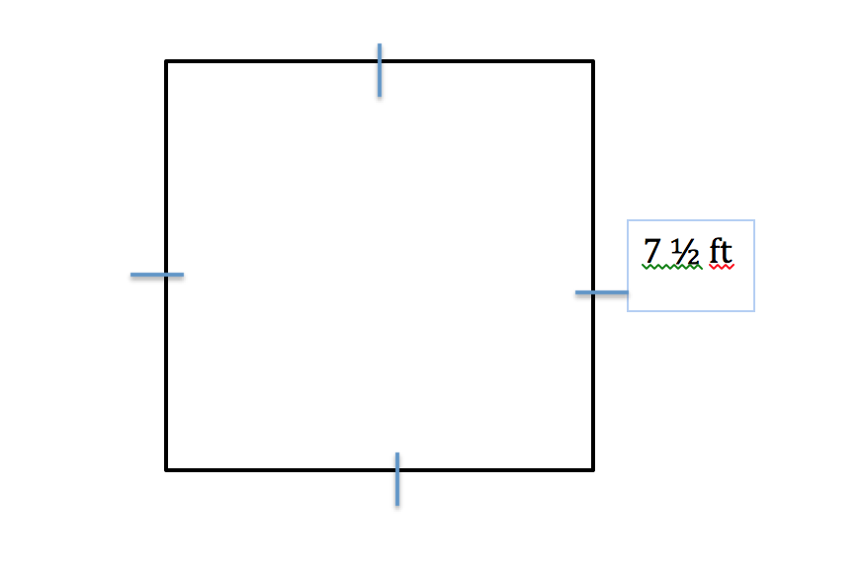
3. Area=_________________
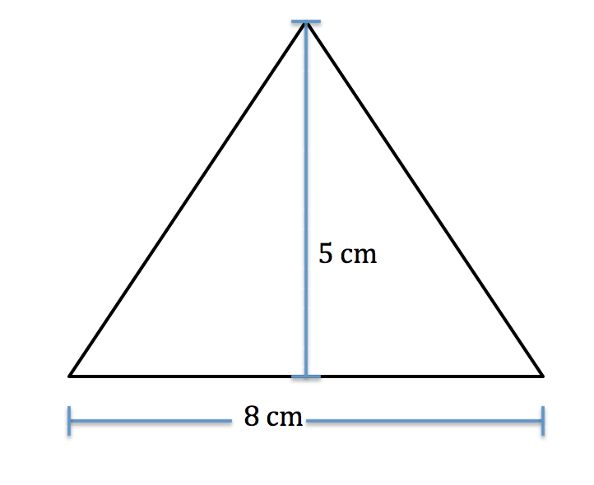
4. Area=_________________
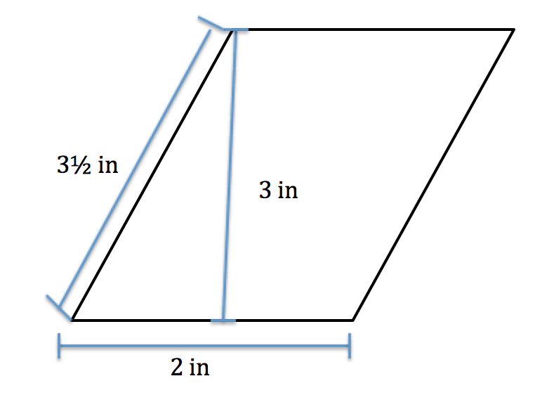
5. Area=_________________
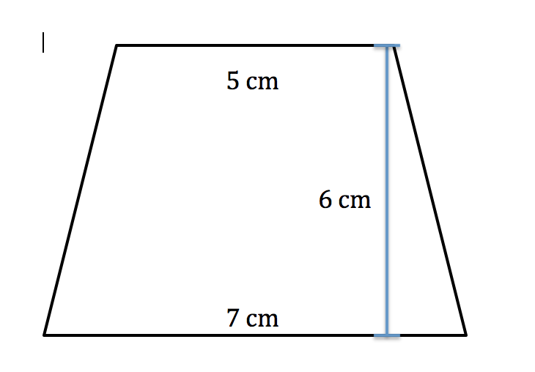
6. Area=_________________
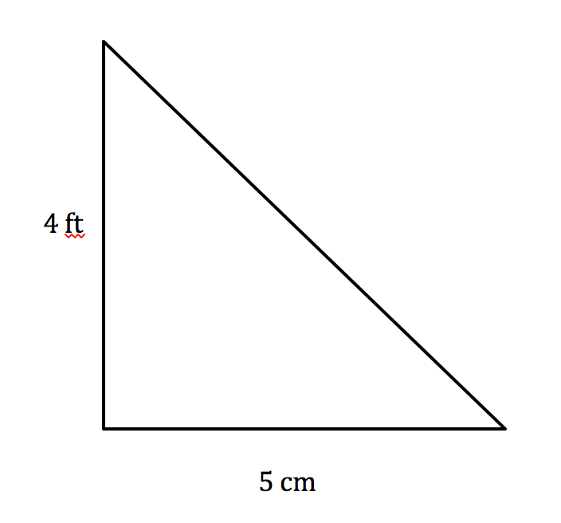

For problems 7-10 find the missing value. Four points each

7. Missing value=______________
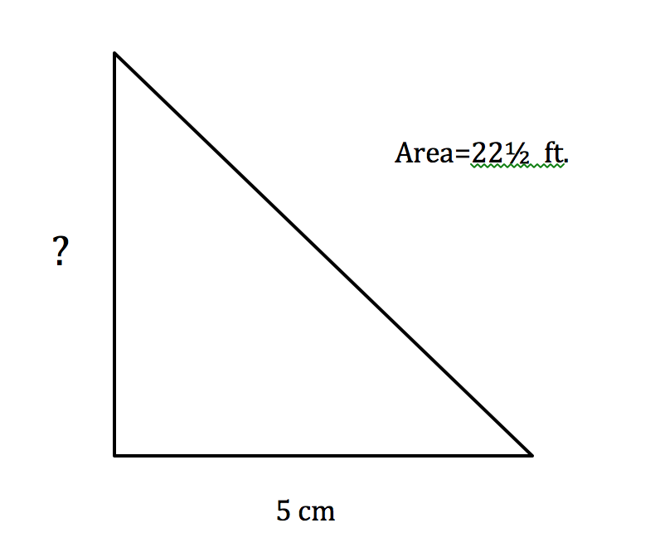
8. Missing value=______________
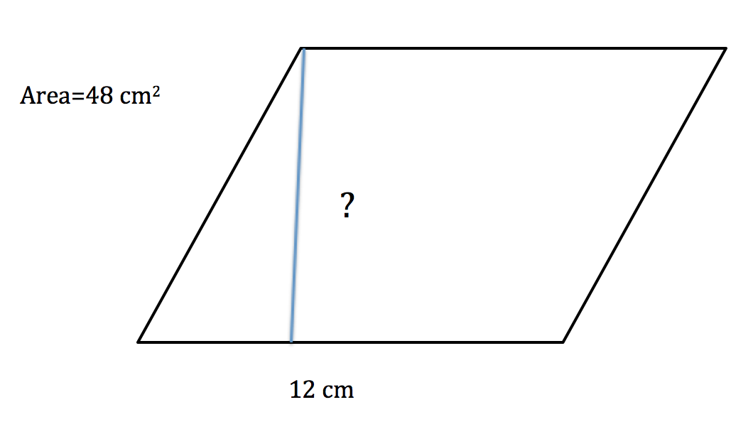
9. Missing value=______________
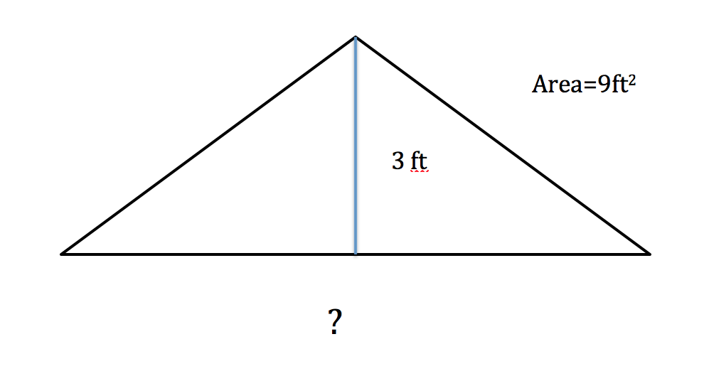
10. Missing value=______________
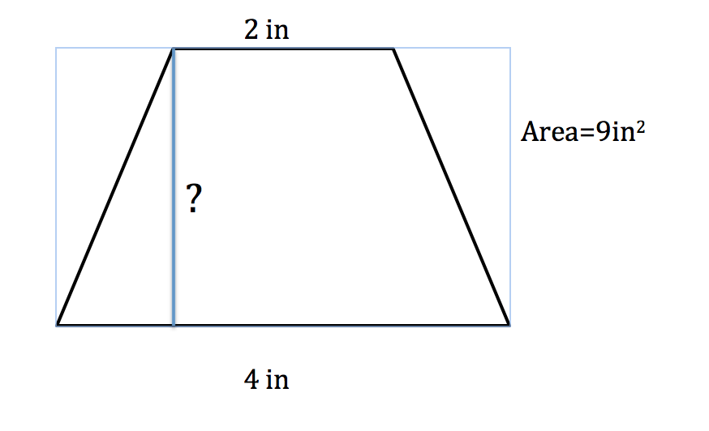
True/False
Choose “True” or “False” for each of the following. One point each.
- ________________The formula for a right triangle is different than the formula for a non-right triangle.
- _______________The formula for area of a rectangle can be written in this way: Area=base x height.
- _______________To determine area of any shape, all you need is two values.

Writing
1. How is the area of a triangle is like the area of a rectangle? How is it different? (5 points)
__________________________________________________________________________________________________________________________________________________________________________________________________________________
_________________________________________________________________________________________________________
_________________________________________________________________________________________________________
_________________________________________________________________________________________________________
_________________________________________________________________________________________________________
2. What does the area of a shape refer to? (3 points)
_________________________________________________________________________________________________________
_________________________________________________________________________________________________________
_________________________________________________________________________________________________________

Unit Test Answer Key

1-6: four points each, 1 point for each of the following: units, correct answer, correct formula, no mathematical errors
- 21 in²
- 15 ft²
- 20 cm²
- 6 in²
- 36 cm²
- 10 cm²

7-10: four points each, 1 point for each of the following: units, correct answer, correct formula, no mathematical errors

- 7 ft.
- 4 cm
- 6 ft.
- 3 in

11-13: 1 point each, based on correct answer

- False
- True
- False

- Sample answer: They are the same because you multiply the base and the height. They are different because for area of a triangle you multiply the base and height times ½. (5 points, necessary elements: base, height, ½, same/similar, different)
- Sample answer: The area is the amount it would take to cover the shape. (3 points, necessary elements: cover/take up, whole shape/entirely)

Revised Alignment Matrix
Standard | Objective | Assessment Elements |  | Bloom’s Level
Standard | Objective | Unit Test | Performance | Bloom’s Level
5.M.2 | Given two values for base, height, or area of a shape, students will calculate the missing value, showing their work and use of an area formula. | Q1 |  | Apply
5.M.2 |  | Q2 |  | Apply
5.M.2 |  | Q3 |  | Apply
5.M.2 |  | Q4 |  | Apply
5.M.2 |  | Q5 |  | Apply
5.M.2 |  | Q6 |  | Apply
5.M.2 |  | Q7 |  | Apply
5.M.2 |  | Q8 |  | Apply
5.M.2 |  | Q9 |  | Apply
5.M.2 |  | Q10 |  | Apply
5.M.2 |  | Q12 |  | Apply
5.M.2 |  | Q13 |  | Apply
5.M.3 | Using cut outs and unit cube manipulatives, students will discover the formula for triangles, trapezoids, and parallelograms. |  | Performance | Apply
5.M.3 |  |  | Visual Aid | Apply
5.M.3 | Students will use their knowledge of area to discover the area of a complex shape (shape made of smaller rectangles and triangles). |  |  | Apply
5.M.2, 5.M.3 | Students will explain how to find the area of a rectangle and a triangle. | Q14 | Performance | Comprehension
5.M.2, 5.M.3 |  | Q15 | Visual Aid | Comprehension
5.M.2, 5.M.3 |  | Q11 | Written Explanation | Comprehension
5.M.2, 5.M.3 | Students will compare the area formulas for area of a rectangle and area of a triangle. | Q11 |  | Evaluation
5.M.2, 5.M.3 |  | Q14 |  | Evaluation
5.M.2, 5.M.3 |  | Q15 |  | Evaluation
Example of end-of-unit activity
2 cm
4 cm
3.5 cm
1 cm
2 cm
1 cm
1 cm
2 cm
2 cm
3 cm
2 cm

Phase 3:

Lesson 1
After the students have completed the lesson pre assessment, I will have the students do an activity with area of a rectangle using cm square paper. They will draw rectangles, using a ruler to ensure straight lines, and then each student will figure out the area of his or her rectangle. Once I have checked that everyone has the correct area, as a class we will figure out the formula for a rectangle. It is very likely that some of the students will know and remember the formula from fourth grade, but I will also be asking the students why the formula works and how they could have figured that out.
I will assess the students in this activity based on participation with a checklist-style rubric. The students must draw a rectangle on the cm square paper using a ruler, they must figure out what the area is, they must write down the formula for a rectangle, and they must write out a brief explanation of how the formula works.
Draw rectangle on cm square paper (-½ if no ruler used) | ____/1
Value for area of the rectangle (-½ if no proper units) | ____/1
Formula for rectangle that we came up with in class | ____/1
Explanation for why the formula works | ____/2
Total | ____/5

Activity 1
This activity will take place after lesson 1, either later that day or the next day. Students will have a shape made up of 2-3 rectangles connected together and the students will have to find the area of the shape. Students will work independently and the teacher will walk around and help if students get stuck. This activity is meant to get students thinking more critically and to lead into manipulating shaped in order to find the area. This also connects to the end of the unit activity of finding the area of a large, complex shape.
Students will be assessed by their answers and showing their work in finding the area of the shape. If a student shows work with the proper formula and line of thinking, but does the computation incorrectly, the student can still receive some points. This would be a 7 point assignment.

1 cm
1 cm
2 cm
½ cm
1½ cm
1 cm

Final Activity
At the end of the unit, students will do the end of unit activity and find the area of a large, complex shape. Students may work in pairs or by themselves, but if students work in pairs they must both submit a sentence describing what part they shared in the activity and if they feel the work was equally shared. An example of the complex shape is on page 14. The activity will be a “quiz” grade and be worth 20 points. I will grade the students on the correct answers, including the correct units and using the correct formula.
This is meant to be a culminating activity where students use all the area formulas they have learned in this unit. The examples will be of fun looking shapes, for example a rocketship.

Phase 4:
Key Components
The Dashboard component includes a mastergradebook for side by side score reporting of all ten assignments in the unit and for all ten students in the class. It also includes averages in the form of points and percents for each assignment which can help the teacher see how the assignment stacks up against the other assignments in th eunit as far as student achievement. This also has an accompanying graph to more easily and visually compare:

Additionally, the Master Gradebook has easy access to seeing every student’s individual grades by assignment and overall grade in total points, percentage, and letter grade according to the approved school letter grade system.
Along with the master gradebook, the dashboard also has tabs for each of the students that lists the scores for each assignment as well as a more detailed breakdown of th eproject rubric and scores, including feedback: 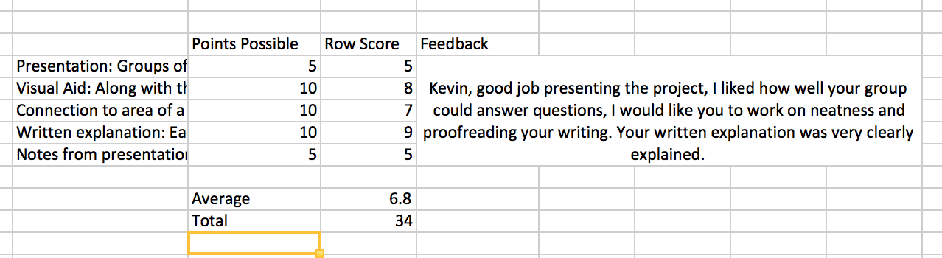
This allows the teacher to see more about why the students received that grade on the project and what the teacher was thinking about the project overall. Feedback also allows the studetns to see their strengths and weaknesses and the teacher can easily point out the feedback during a conference.
Within each individual student’s tab, there is a graph that compares the studetns scores to the class averages. This is obviously not something students would have access to, but it gives the teacher and idea of where the students fall compared to classmates. This can also be a useful to see how students are doing overtime compared to their usual standards. For example if a student was consistently aove average, then started scoring below the class average, that would be more clear and the teacher could look into possible causes.

Reflection (Connect to InTASC 6)
I learned that although many people were not very experienced with excel, it is a very useful tool. Tis would be especially helpful to know if a school did not already have a system for comparing grades and examining them in this way because it is easily accesible. I originally thought it seemed redundant and a waste of time to spend so much time on, but I realized that a lot of people do not have sufficient experience to do all th eamazing things excell can do. I learned how to use the reference feature to fill in the letter grade and make red or green highlights to point out where students did well or poorly on an assignment. This can be especially helpful to see if a student is consistently dooing poorly and needs some intervention, especially on a large spreadsheet with many stdents where a few lower numbers may go unnoticed.
The teacher can look at the scores to see if a certain assignment was overall difficult for the class and revise the assignment or the teaching of that content. Just from examining the limited “data” I had I could see that a student started off scoring well, but the scores began to go down over the course of the unit. By examining these types of trends, a teacher can step in and help the student with motivation, explaining topics, or any other factors that may be contributing to the decrease in performance. Using spreadsheets to see performance by the numbers is a great way to include InTASC Standard 6 and to help the teacher make decisions based on class and individual student performance.

