Qualtrics Survey Design
I used the survey design site, Qualtrics, to make my survey. My survey was a pretest to see what prior knowledge the students had about a few US presidents, what type of assignments they would prefer and their interest in specific US Presidents for a report. I used several types of questions with in my survey, including a Likert scale, multiple choice, and write in option. I distributed my survey through email and social media. The first question of the survey was making sure the students knew that it was not graded, and anonymous, 30 out of the 33 students answered Yes they understood. The other 3 students that chose no did not continue the survey. From the survey, I learned that I would need to review how many Presidents there has been. There were a few responses that were on the extreme on both ends, like 27 presidents to 62 presidents. All students were asked how they would enjoy 3 different types of assignments. I wanted to get this information anonymous because I wanted honest opinions on what they would like to do in class. The results are shown below in the pie graphs.
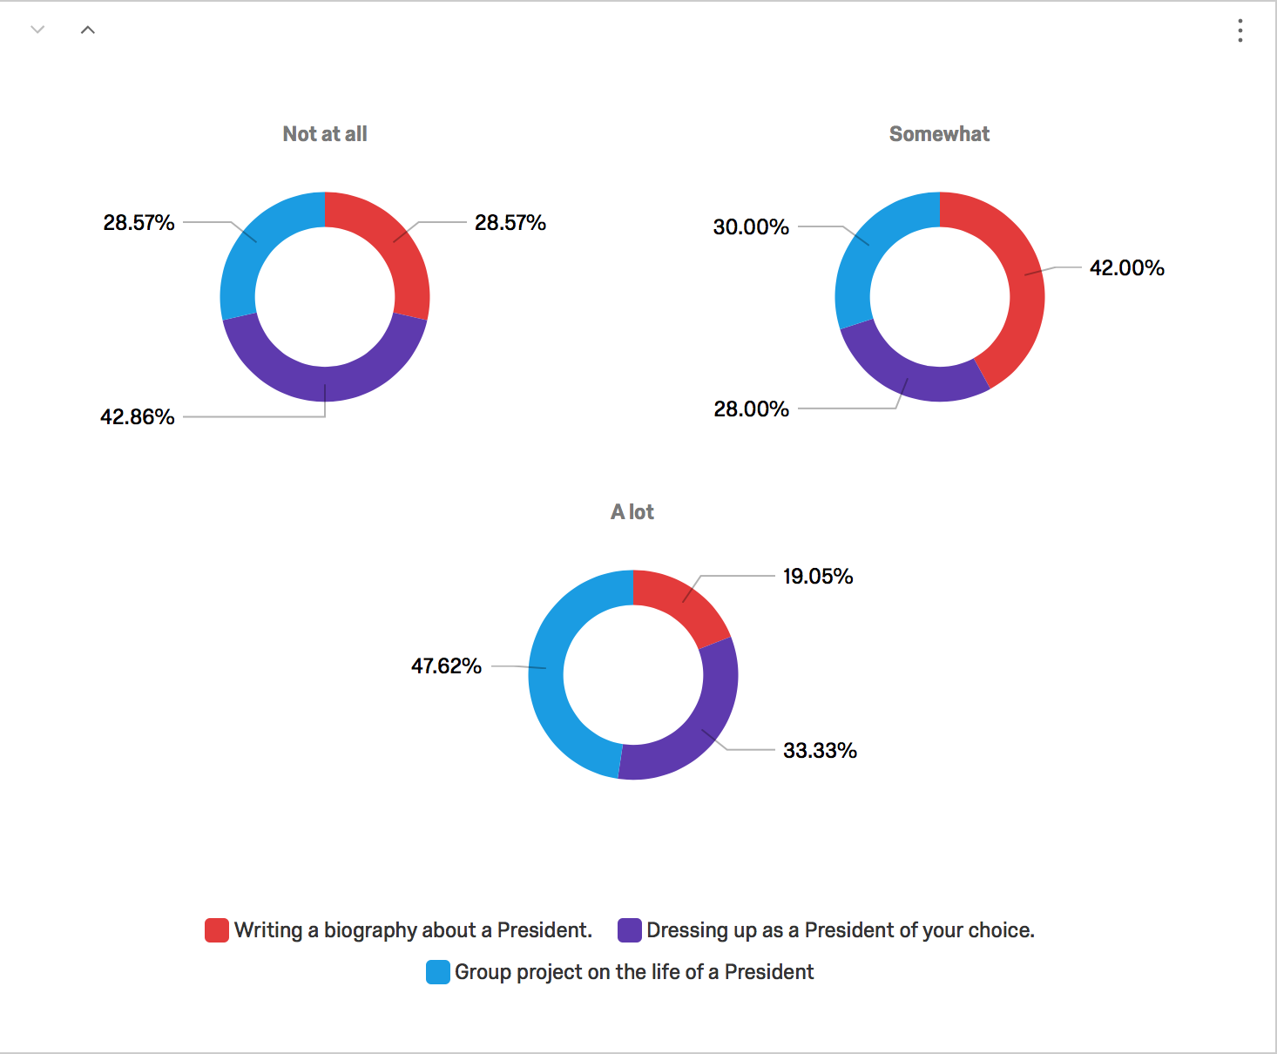
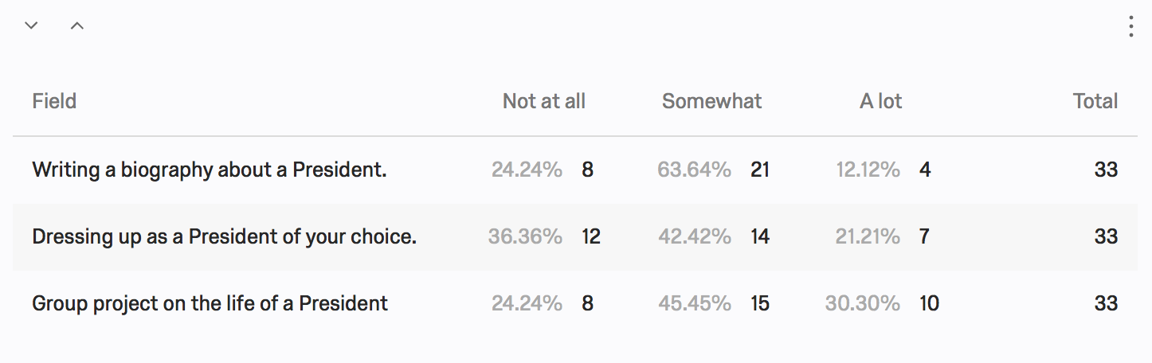
I also asked them to put in order the last 5 Presidents we have had. I got pretty consistent results but I should have dictated if 1 was most recent or if 5 being most recent President. Another question that I wanted to ask was which presidents were the class most interested in. This survey question allows me to know what Presidents the students are most interested in. This will allow me to plan fun activities to teach them about these specific Presidents. The results are displayed below.

Based on the survey results, I would want to review how many presidents we have had, and why we have had only 43 presidents but President Obama is the 44th President. I would also plan a few group projects for the class, as that was the most popular choice. When I am deciding on which Presidents to focus on for possible projects or reports; Lincoln, Reagan, JFK and Obama were the 4 most chosen Presidents. Using the result of the survey to help plan this unit will help ensure that the students are engaged in the topics and activities.

