School Name: Huffer Memorial Children’s Center Date: 3-20-14
Contributor: Tanya Walden, Infant Teacher in the Emerald Room
Category for submission: Instructional (Early Childhood)

- Provide a short, description of the best practice:
Best practice for infant care focuses on the unique characteristics and needs of each individual child. Our best practice is exhibited by the environmental design which includes those individual needs/characteristics. The design of our infant room acknowledges and reflects the field of study’s researched elements of such a best practice environment.

- Briefly describe the issue(s) the best practice was developed to address:
We focus on individualizing our setting and assuring developmentally appropriate practices are used to ensure that all children can fully participate and be engaged even at our infant level.

- Describe major challenges to implementation:
One major challenge to implementing best practices in infant care environments is the rapid pace of development in a child’s first year of life. To keep pace with that developmental growth in an environment with many developing infants is a major challenge.

- Briefly describe the benefits derived from implementing the best practice:
Each child and family involved in the program will be able to access the environment as it relates to individual development by accessing the forms, centers, communication concerning individual children and appropriate materials. Beyond the obvious benefits of modeling best practice, there are benefits in terms of shared goals and communication.

- What evidence can you provide to illustrate the success:
Infants show body language, facial expression and active engagement that suggests physical, emotional and cognitive experiences are positive. By educator observation, cognitive growth is assessed and emotional experiences are evaluated. To this point, all infants have progressed in development in all areas.

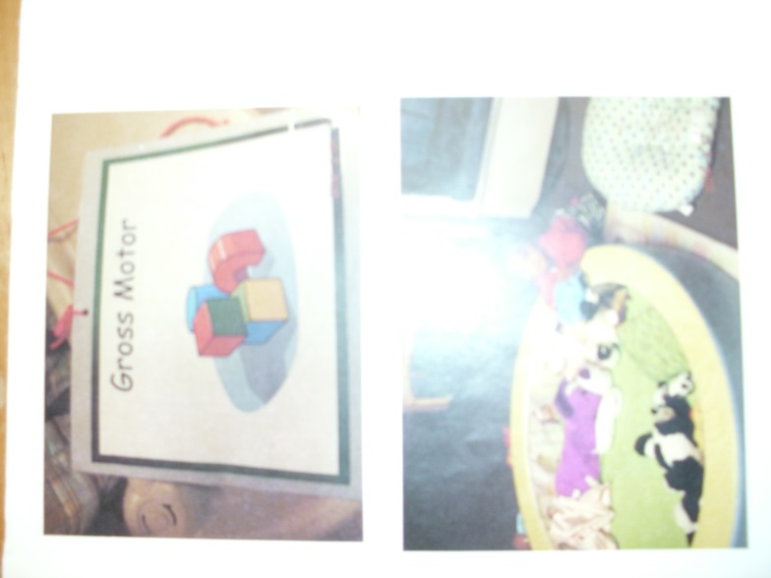

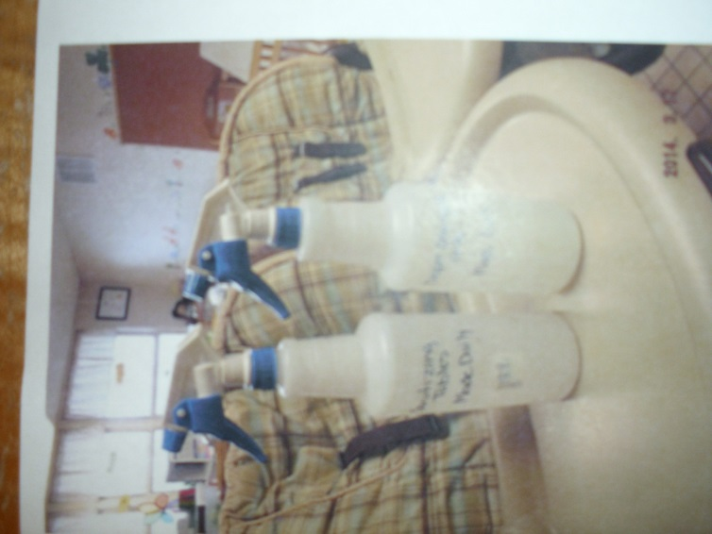

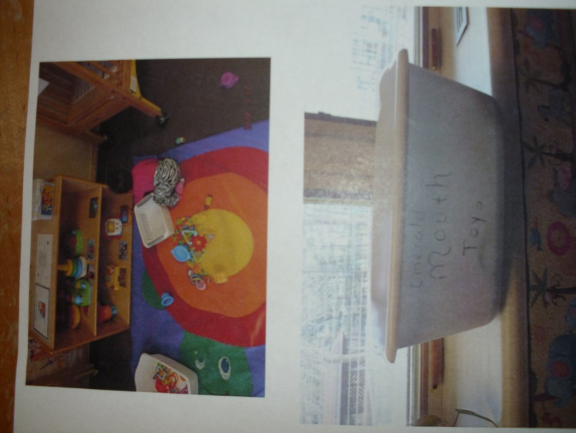

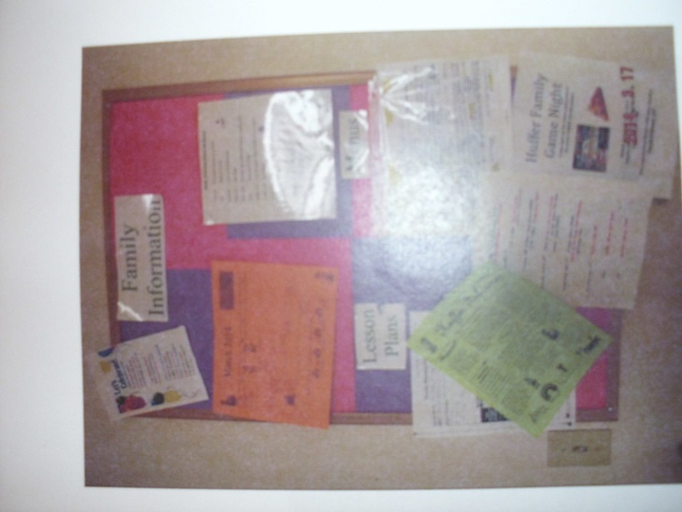

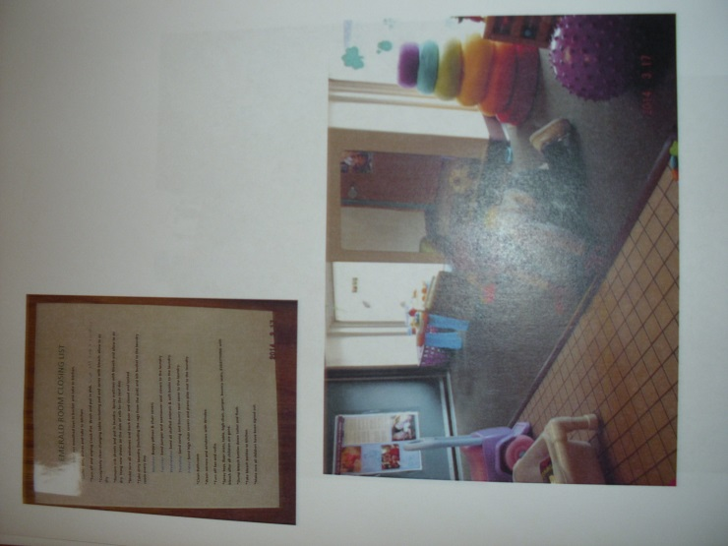

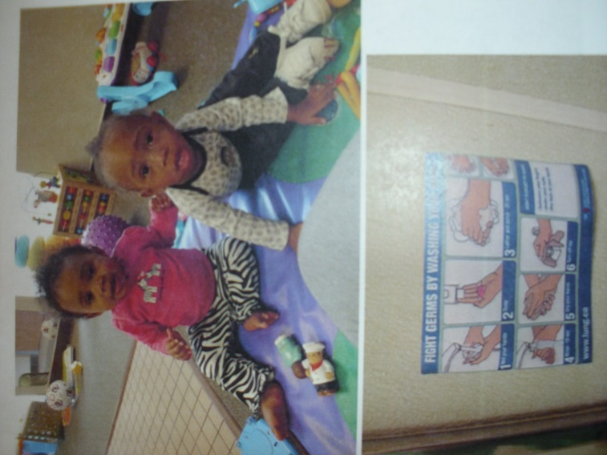

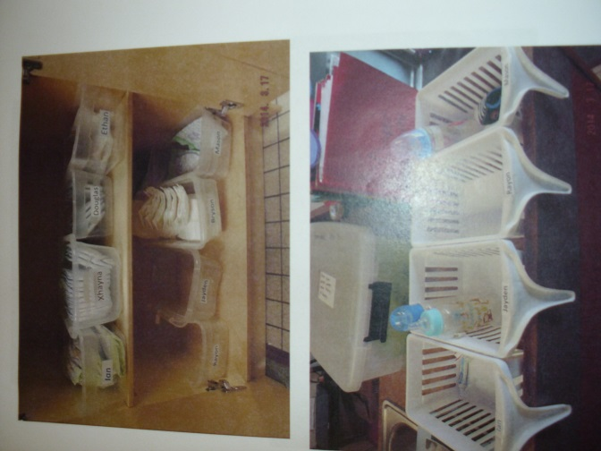

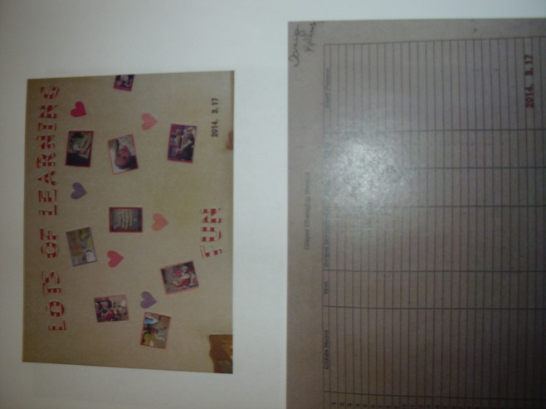

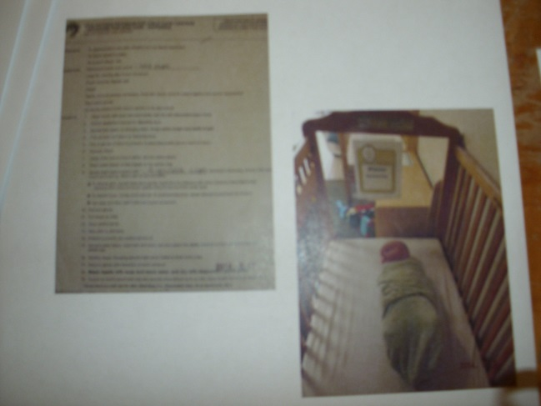

School Name: Huffer Memorial Children’s Center Date: 3-20-14
Contributor: Carrieann Churchill, Preschool Teacher in the Yellow Room
Category for submission: Instructional (Early Childhood)

- Provide a short, description of the best practice:
Best Practice includes developmentally appropriate learning activities that encourage a mixture of teacher-directed and child-directed activities. Teacher-directed learning involves the teacher as a facilitator who models learning strategies and gives guided instruction. Child-directed learning allows the child to assume some responsibility for learning goals. In our preschool classroom it has become an effective tool for learning when using the student’s ideas to direct the activities.

- Briefly describe the issue(s) the best practice was developed to address:
The issue being addressed is the students not being fully engaged or losing interest in activities/learning that the teacher has tried to create. When the students take interest in a hands on/real world activity with wonder and question it is best practice to teach the children to learn from their questions. Experimenting with the knowledge they have and growing their interest is the perfect opportunity for students to direct their learning.

- Describe major challenges to implementation:
A challenge to implementing the perfect mixture of teacher-directed and child-directed activities is having the tools at hand that the children need in the “moment” to continue effective learning. If the students go in a direction that was not planned and you do not have the materials they need “bringing it tomorrow” may be too late. The teacher must effectively continue the learning environment.

- Briefly describe the benefits derived from implementing the best practice:
The benefit of allowing children to direct their learning is that they take ownership of what they have studied. The hands on experiences to their wondering questions allow them to be fully engaged and retain the knowledge and experience longer. They are able to share the new information for better retention.

- What evidence can you provide to illustrate the success:
The evidence I can provide to best illustrate this success is sharing the learning that has been created in our classroom through child-directed activities. Students are engaged and sharing new knowledge with teachers and parents. Their achievements will be displayed through photos and art work. Success is evident when you walk in the classroom.

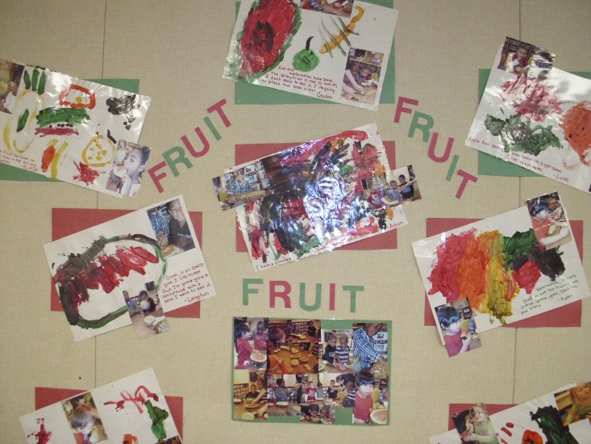

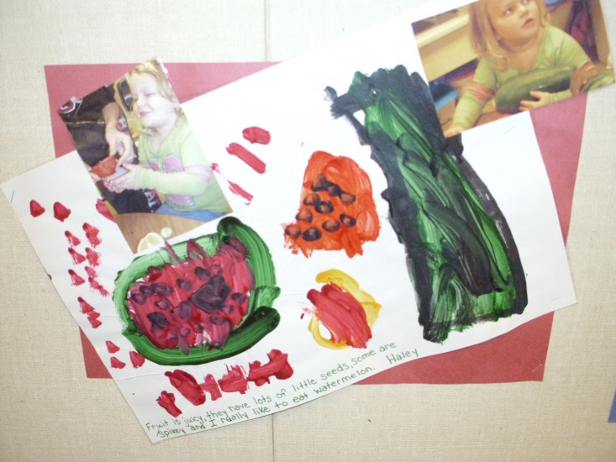

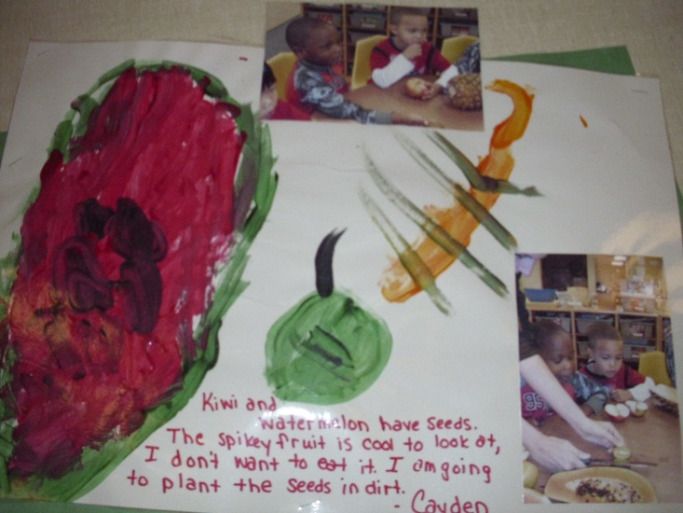

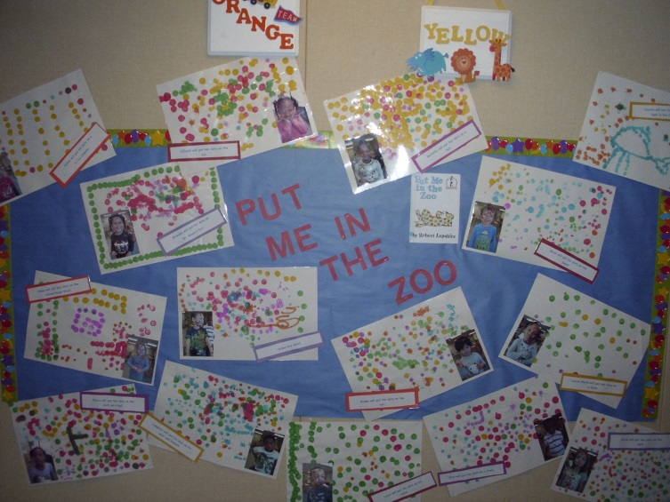

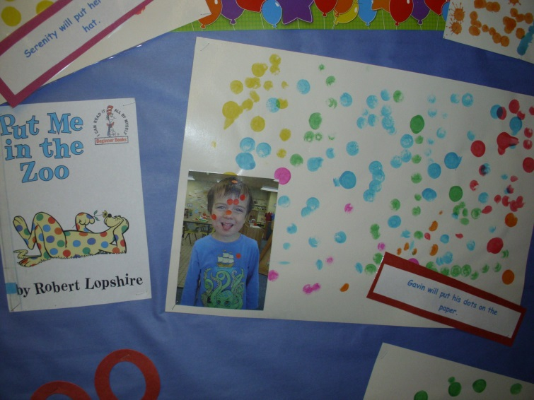

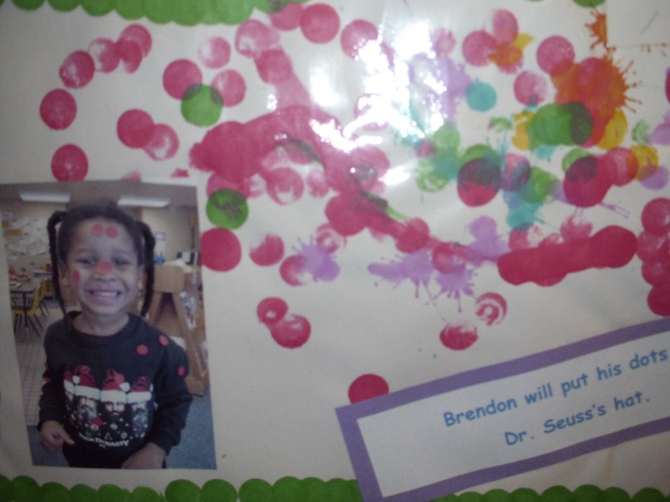

School Name: Huffer Memorial Children’s Center Date: 3-20-14
Contributor: Toni Kirtz, Preschool Teacher in the Red Room
Category for submission: Instructional (Early Childhood)

- Provide a short, description of the best practice:
MY FRIENDS AND ME is a program of group activities and versatile materials to help nurture the personal and social development of preschool children. With FRIENDS, children participate and are encouraged to make discoveries about themselves and their friends and to develop healthy, realistic attitudes about themselves, their peers, and their world. This best practice program was carefully designed and is used to help preschool children grow personally and socially.

- Briefly describe the issue(s) the best practice was developed to address:
The issue being addressed is young children properly developing personally and socially. Learning to work alone as well as working with others is a key factor in growing into a successful adult. Children need to be encouraged to practice these skills by seeing effective modeling, and then having the opportunity to participate in situations that challenge them to grow.

- Describe major challenges to implementation:
A challenge to implementing this program is the take home activity bag and the dolls Willdoo and Candoo being returned after taking them home. This program requires families to participate in activities and journaling from home. The program is not as effective without the family participation.

- Briefly describe the benefits derived from implementing the best practice:
The benefit of implementing a program that encourages the personal and social growth of children is happier preschoolers. Not only are the children happier because they are better able to express themselves, but they learn social skills that they will continue to use for the rest of their lives. The student’s experiences contribute to the wellbeing of themselves, their classroom, homes, and communities.

- What evidence can you provide to illustrate the success:
The evidence I can provide to best illustrate the success of this program is that I have been using it for over twenty years. The children are proud to share when they return to school with the kit from home. The activities are practiced weekly in the classroom and the knowledge learned and information shared is used daily. The children put what they learn to use. The children grow personally and socially and this program lends a hand in preparing these students for life long skills.

