
Nombre__________________________________ Apellido______________________________________
Fecha____________________________________ Período_______________________________________
There are 4 stations in the classroom with different maps from Disney World. For each park, you will make directions for how to get from one attraction to another. Use usted commands to write the directions.
Name #12: Pirates of the Caribbean Name #23: Peter Pan’s Flight
Directions: Siga la carretera hasta el café Pecos Hill y doble a la derecha. Pase por “Country Bear Jamboree” y el restaurante “Diamond Horseshoe.” Camine hasta el Liberty Square y doble a la derecha al restaurante “Lliberty Square Market.” Pase por The Hall of Presidents y doble a la izquierda cerca del “Sleepy Hollow.” Siga derecho hacia Prince Charming Regal Carousel. delante del carrusel doble a la izquierda. Pase por Mickey’s PhilharMagic y Peter Pan’s Flight está allí.
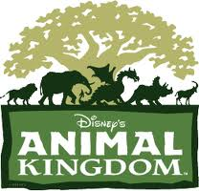
1. Name of Attraction #1: Name of attraction #6:
Directions from #1 to #6:

2. Name of Attraction #4: Name of attraction #13:
Directions from #4 to #13:


3. Name of Attraction #4: Name of attraction #9:
Directions from #4 to #9:

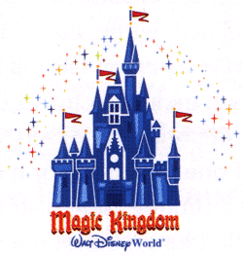
7. Name of Attraction #39: Name of attraction #33:
Directions from #39 to #33:

